Modular SEmi-smart construction vehicle

By Zil-E-Hasnain Shah (10588101)

December 16, 2021

University of Plymouth

Robotics Engineering MEng

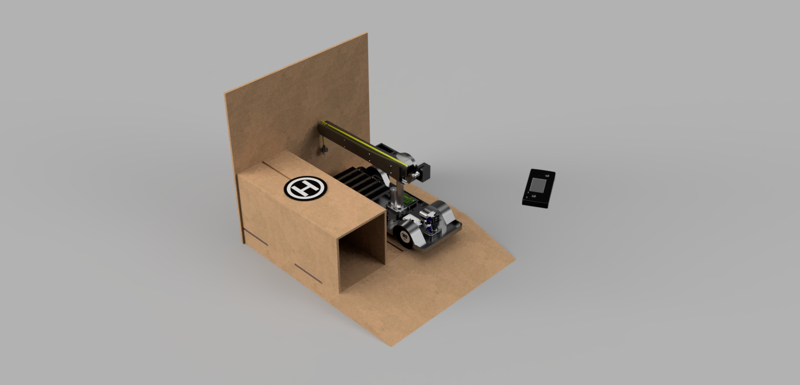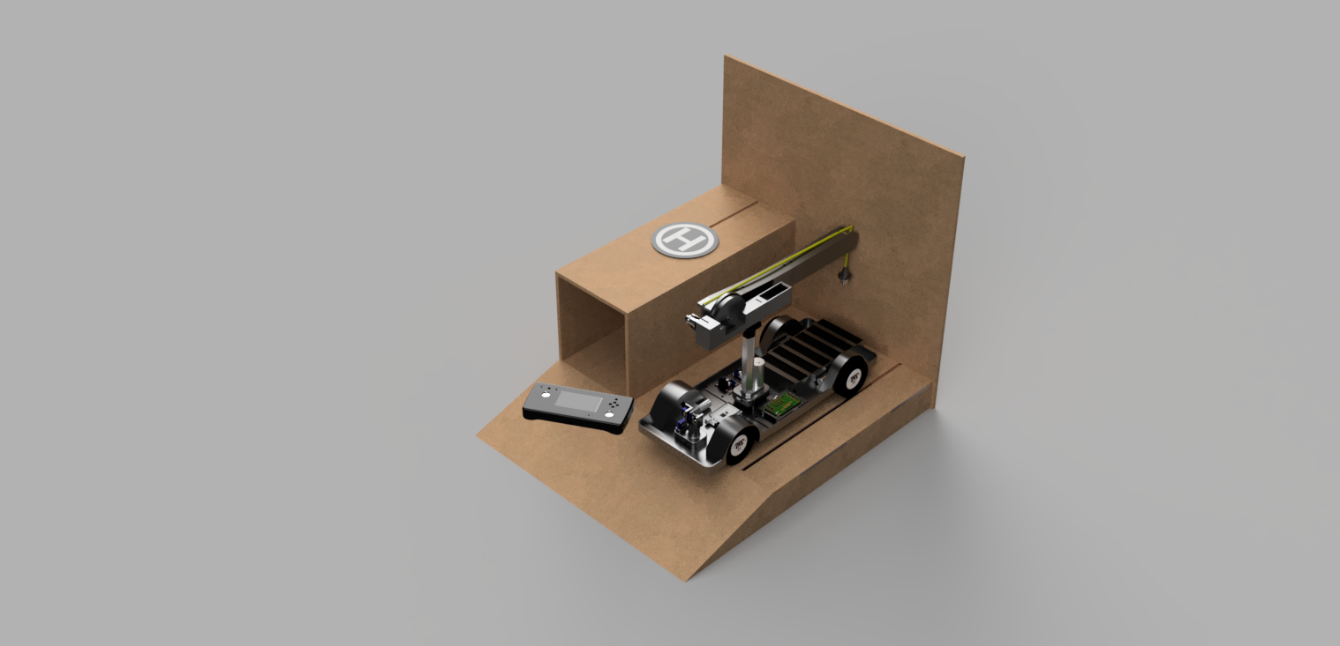

Table of Contents

Glossary 4

Glance 6

Abstract 6

Acknowledgements 7

Introduction 7

Alternate possibilities 9

Main overall objective 9

Open-Source 9

SCV-E 11

Abstract 11

Specifications 11

Research and Design 12

Power Delivery - Battery 13

Type of batteries 13

Main Modules and Parts 21

Designing the SCV-E 22

The Problem with the Tyre 26

Crane Design 32

Camera Design 35

Controller Design 38

Base station 44

Power Supply of the Buggy. 46

Suspension system – Future Improvement. 47

Conclusion 48

Future Improvements 49

Appendices 50

Appendix 1 – Gantt Chart 50

Appendix 2 – Budget Overview 54

Appendix 3 – List of expenses Equipment 55

Appendix 4 – List of expenses Materials 56

Appendix 5 – List of expenses Buggy 58

Appendix 6 – List of expenses Controller 59

Appendix 7 – List of expenses Base Station 59

Appendix 8 - List of expenses All 60

Appendix 9 – Controller Circuit V2 61

Appendix 10 – Controller Circuit V1 62

Appendix 11 – Base Station V1 63

Appendix 12 – Base Station V2 64

Appendix 13 – Circuit of SCV-E 66

Appendix 14 – Power Supply Board SCV-E 67

Appendix 15 – Power Supply Schematic SCV-E 68

Appendix 16 – Controller V1 Board 69

Appendix 17 – Controller V2 Board 70

Appendix 18 – MIT App inventor Bluetooth Controller 71

Appendix 19 – Bluetooth program code 72

Appendix 20 – Controller Code 75

Appendix 21 – Source code for SCV-E 78

Appendix 22 – Source code on GitHub 87

Appendix 23 – Motor gear broken. 89

Figures 90

Datasheets 91

Datasheets are all stored in the folder /Datasheet 91

Meetings 94

Meeting 1 – Shakil Awan 94

Meeting 2 – James Rogers 94

Meeting 3 – James Rogers 94

Meeting 4 – Nicholas Outram 95

Meeting 5 – Shakil Awan 95

Meeting 6 – Shakil Awan 95

Meeting 7 – Shakil Awan 95

Meeting 8 – Shakil Awan 95

Meeting 9 – James Roger 95

Meeting 10 – Shakil Awan 96

Meeting 11 – Shakil Awan 96

References 97

# Glossary

A –Ampere

BMS – Battery Management System

C++ - Object Orientated programming Language  
  
CAD – Computer Aided Design

DC – Direct Current

g – gram

GHz – Giga Hertz

Kg – Kilogram

L – Liters

LCD – Liquid Crystal Display

M – Meters  
  
mAh – Mili-Ampere per hour

mm - millimeters

N – Newton Force

NiCd – Nickel-cadmium

NiMH – Nickel-metal-hydride

OS – Operating System

PWM – Pulse Width Modulation

R – Resistance

R# - Revision number #

R&D – Research and development

RF – Radio Frequency

RX – Receive

SCV-E – Smart Construction Vehicle – Electric

SMT – Surface Mount Technology

TX – Transmit

UK – United Kingdom

V# - Version number #

V- Voltage

# Glance

## Abstract

This report investigates the design of a modular electric construction vehicle to be used in the construction and mining industry (miniaturised). The design’s focal point is the use of open-source resources based on the Atmel microcontrollers. The respective elements discussed in this report are as follows:

Modular semi-smart construction electric vehicle (SCV-E) comprising of a custom battery pack made up of lithium-ion cells, Servo motors and DC motors with their respective controllers, 2.4GHz Radio frequency transmitter used to communicate with the controller, 5.8GHz RF camera transmitter for video output, an actuator crane along with an electromagnet used for picking up objects, and in the center of the heart is the Arduino mega 2560 as the brain of the vehicle.  
  
Charging unit for the SCV-E along with a wireless charging technology QI to charge a drone or other vehicles. (Drone is not included)

Wireless controller consisting of an Arduino heart, joysticks, buttons and a 2.4GHz transmitter for communication with the SCV-E.

## Acknowledgements

* I would like to thank the personal supervisor support provided by Dr Shakil Awan who agreed to oversee my project and discuss the project and its shortcomings. The support is greatly appreciated.  
    
  I would also like to thank James Rogers for his technical advice and support. Again I am grateful for his help, especially during covid-19 lockdown as the labs were inaccessible.  
  The support came in the form of small discussion regarding components and diagnostic errors.  
    
  Additionally I would like to thank Mr. Syed Naqvi, co-owner of Tech Tree Solutions ltd for allowing me to carry out the project while he worked, this included expertise advice from himself regarding the project’s firmware.  
    
  Finally I would like to thank my father, director of PiyamTravel Ltd for the ongoing financial support and faith in me which kept me motivated and allowed this project to be completed.

*“To be successful,   
 you have to believe yourself when no one else will.”   
 ~ Bruce Wayne*

## Introduction

The construction sector is the most integral part of a country’s economy. Construction is what builds the nation, and as the population increases, demand increases for buildings and infrastructure services. As the sector investigates autonomous operation which can be increasingly costly and quite difficult as the terrain and environment is not particular kind unlike the automotive industry. Therefore, an idea is introduced for a modular Vehicle model that is between the two and offers modular system choices as required by each terrain/environment and or clients.

Currently the market offers a few of the largest construction vehicles;  
Caterpillar 6090 FS [[1]] shown in figure A, an excavator type vehicle that weighs 100,000 kg. Liebherr LTM11200-9.1 [[2]] shown in figure B, is the world’s largest mobile crane with a maximum lifting capacity of 120,000 kg and maximum hoist height of 188m. Liebherr T 284 [[3]] shown in figure C, is the world’s largest ultra-class dump truck with a carrying capacity of 496,000 kg.

The main thing these have in common are large combustion engines which have a large negative environmental greenhouse impact, the industry is looking towards a neutral carbon solution as fossil fuel is costly especially as of now in 2021 with diesel costing £215.00 GBP [[4]] per barrel (159 L) and with each machine consuming 1,300 litres of fuel every 100 km (60 miles) [[5]]. However due to the nature of the industry and the power requirements of the vehicle needed in their respective function, it is difficult to come with a solution feasible enough to change the industry standard, this is mainly due to the enormous size of the vehicle and weight as the amount of force needed to move the vehicle is 1.5 times relative to the weight of the vehicle itself.

A proposal can be made to go electric with looking into potential limitations of the battery system that could be possible. Regarding the three vehicles mentioned above, another proposal can be made to investigate a modular vehicle for this industry, such as the “modular vehicle construction and transportation system” patent by Gordon E. Dower 1998 [[6]] which looks into a standard undercarriage module that does not require maintenance and can be coupled with an over-carriage module resulting in a fixes undercarriage skeleton that can be modulated in construction of vehicles such as saloons, vans, trucks and buses alike.

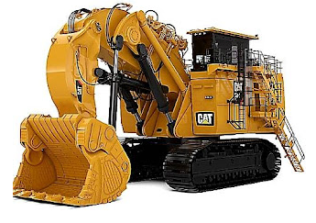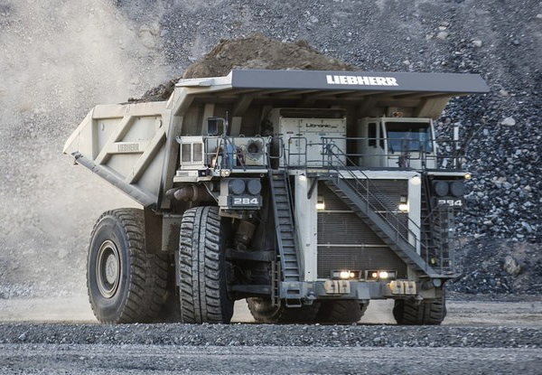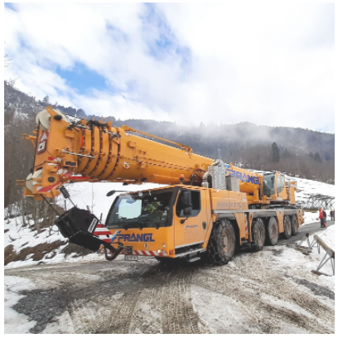This project aims to create such a modular vehicle model that can be adapted to the client’s requirement per se. although the project’s scale is that of a miniature version consisting of the Vehicle model, Battery system, charging system and a controller unit.

Figure B - LTM11200-9.1 [2] Figure C – Liebherr T 284 [3] Figure A – Caterpillar 6090 FS [1]

### Alternate possibilities

Industries are moving into automated supply chains where human interference is reduced to a minimum. This project allows remote use of the vehicle in areas where automated devices may not respond accurately. The industries this Project has a use or could be used for are;

* Construction zones – Enlarge this carrier buggy to a real-life size as this is a scaled down version.
* Warehouses or loading zones for construction or waste disposal
* Airport Baggage – Grouped baggage can be carried in one trip
* Site Surveillance – remote view of sites
* Rescue missions – Any vehicle or crash sites to be cleared or to rescue a person in harsh climates

### Main overall objective

According to the final project proposal the staged deliverables agreed with the supervisor are;

* Completely Open-Source
* Wirelessly controlled Truck
* A custom controller to control the Truck
* Option of a magnetic crane with the ability to lift at least 100 grams of weight.
* Base station that can charge the drone or phone via the capability of wireless qi charging.
* Operational Controller not necessarily connected as it is universal. Can be shown working with a simple test circuit.
* Controller able to switch from Buggy to Crane via a switch.
* Use low-cost manufacturing process that is accessible to the public.

### Open-Source

Open source is a license that allows anyone to access the software’s source code and modify to further enhance or alter it to their needs. As the source code is open to the community it establishes a standard to building sustainable projects. “*This wasn’t contributing back out of altruism. It was engineering economics. It was the right thing to do, and contributed back to the hardening of the compiler suite we were using ourselves. It was what makes well run open source projects work.” [[7]]* A quote by John Nash, Famous mathematician known for winning the Nobel prize on an economical cooperative game that is the best real-world example of an open-source project. Contributing work to the community is the best investment one can make in terms of adaptability and survival of a niche start-up software.

Open-Source software allows users to modify, adapt and enhance the source code further, creating a train of thought that further improves the software, Linux OS is one famous open-source software supported by the entire community growing bigger day by day. Propriety software on the other hand is locked, only the authors of the source code have access to it, any other person wanting to use the software would be subject to the terms and license of the author of the project. One such software is Microsoft Windows, A pay to use software unlike Linux OS that is free and available to use for the public.

Therefore, by allowing this project to be open source allows others to modify and enhance this research project further. Fulfilling the main condition of the construction industry to modify and enhance the project to suit their environmental needs and resources.

# SCV-E

Smart Construction Vehicle Electric

## Abstract

## Specifications

Initial requirements:

1. SCV-E must be modular and electric. In terms of modular, parts should be swappable and not permanently fixed in position.
2. Have a run time of 30 minutes.
3. Be controlled wirelessly.

Additional Requirements:

1. Video feedback for far distance control.
2. Controllable up to 20M far.
3. Have one of the following crane/excavator/cargos
4. Be able to carry at least 100g of weight.

## Research and Design

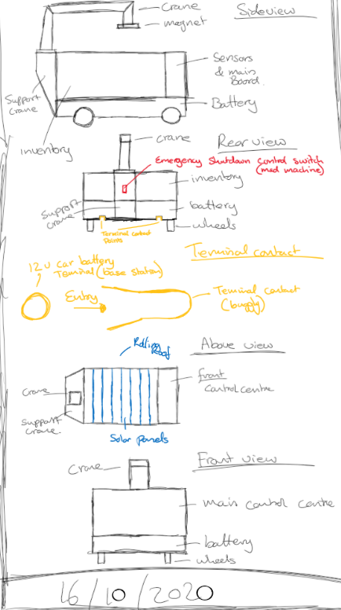

Initially the idea was to have a under chassis like a Tesla model car, where the centre of gravity is balanced at the bottom, creating a model that prevents roll overs. However, as it is a truck, this won’t be applied due to the cargo load.

The truck’s features would be to have an electromagnet which would make it easier to lift items. A crane connected to the electromagnet, A battery to support and run the truck. A control unit area where the electronics can be stored to run the truck. Solar panel to charge the battery

Limitations of the design

Researching further, it has been noticed that solar panels are out of question due to efficiency of the weather in the UK. And due to the battery size and capacity required.

Figure 1 – Initial design idea drawn on MS whiteboard.

### Power Delivery - Battery

From the initial design, an outline of possible parts can be listed that requires to be powered up by the internal battery of the SCV-E, these are;

* Arduino Mega R3
* Servo 30 kg x4
* Servo mg x2
* DC Motors x4
* DC Actuator 1x
* DC Motors Controllers x3
* Servo Controller x1
* Camera x1
* Possibility of future upgrades or parts to be added.

### Type of batteries

NiCd is a super popular type of battery that stores electrical energy by allowing itself to fast charge via pulse charging, it is a cheap option, allows to be rechargeable and has a five-year long shelf life. However even if has good load performance, it contains toxic metals, has a high discharge rate after storage and has a low energy density. NiMH on the other hand has higher energy density up to 40%[8] more than NiCd. However, it has a shorter shelf life of 3 years and has a much more complex charging algorithm. Finally, Lithium-Ion batteries combines both strong points of NiCd and NiMH, also does not require any maintenance at all unlike NiHM and NiCd which overtime crystallize. Unlike the ones before, Lithium-ion batteries require a protection circuit to main voltage and currents to be within safe limits, it is also expensive to manufacture.

Regarding the last matter, University of Harvard’s researchers have designed a long lasting stable solid state lithium battery that is able to substantially hold more energy in the same volume and charge in a fraction compared to traditional lithium-ion batteries [[9]]. Since lithium batteries have become more in demand in the automotive industry especially lately because of the Tesla model vehicles switching from 21700 cells to 4680. These numbers are the dimension of the battery cell, such as 21700 being 21 mm in diameter and 700 mm in length. *“We estimate that the majority of the cost decline, more than 50 percent, came from research-and-development-related activities.” [[10]]* A quote by MIT postdoc Micah Ziegler about the reduction cost of lithium-ion batteries due to R&D.

#### Lithium-Ion Battery

Since the first criteria is to achieve 30 mins of run time minimum, it would be ideal to be able to re-use the batteries in a design that would allow the battery to be hot swappable for the SCV-E. This would allow the battery pack to be charged off-site, decreasing wait time, and increasing efficiency to the level of fossil fuel refill times as a full tank (50L) would take around five to ten minutes to refill.

Currently there are two major sizes of lithium-ion batteries, the 18650 and the 21700. The 21700 has a bigger capacity and a higher energy density it is also much more efficient. For this criterion the Samsung 30T 3000 mAh was selected as it provides 4.2V per cell as shown on the Batemo datasheet for this cell.

Having the following data of the cell;  
Voltage of one cell = 4V  
capacity of one cell = 3Ah  
Discharge max current = 30A  
run-time of one cell at maximum discharge rate = energy stored Ah / discharge current  
t = Er / I == 3Ah/30A = 0.1 hours x 60 minutes = 6 Minutes of run time  
  
However based on the specifications of the SCV-E, 12V DC would be the required supply voltage with some modules being able to be supplied higher voltage. It is also required to have a run time of at least 30 mins. Therefore,

4 cells in a series = 16 Volt and 5 cells in parallel to the series will equal to 15Ah stored energy with a maximum supported discharge current of 150A. using the equation t = Er / I, the run time is then calculated as 15Ah/30A = 0.5 hours x 60 minutes = 30 minutes at peak performance, realistically this won’t be possible as the battery pack will require a BMS for protection. Repeating the calculation with a charge rate of 5A would equal the charging time to be t=Er/I == 15Ah/5A = 0.6 hours x 60 minutes = 36 minutes, allowing us to be able to use fast charging technology at no issues. The battery pack is a system of 4S 5P, with a weight of 68.3g per cell x 20 cells = 1.366 kg.

#### BMS

A Battery management system provides full protection to the battery pack designed by limiting discharge and charge rates, overcurrent protection and discharge voltage protection. While charging it balances the batteries voltage enabling it to last much longer and giving a higher performance when required.   
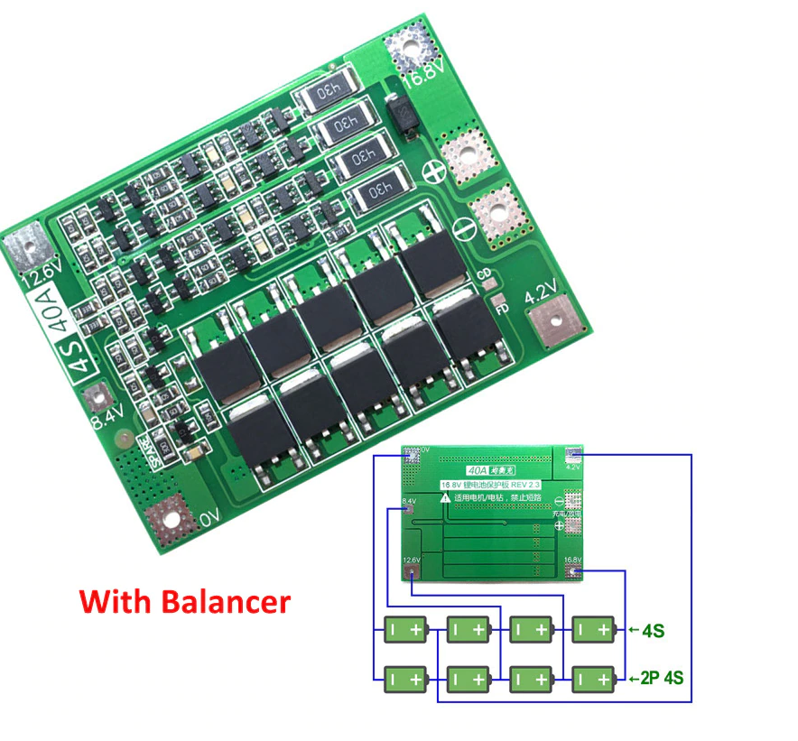

Figure 2 - 4S5P BMS board for the battery pack.

Figure 2 shows the required BMS according to the calculation of the battery pack, this BMS supports 4 series cells, parallel cells do not have a limit as they are more of a capacity thing rather than provided values. However, the more parallel cells in a system the longer the charging time will be. (This image is taken from the BMS datasheet). Since the Samsung 30T21700 has a supply voltage range between 3.7V-4.2V, the BMS will be able to give an output voltage in the 4S5P balanced voltage of 14.8V-16.8V where 14.8V is the indicated cut-off voltage, however the actual cut-off voltage is 11.2V (due to 2.8V being the actual cut-off voltage per cell) and 16.2V being the nominal voltage after charged.

#### Battery Pack CAD

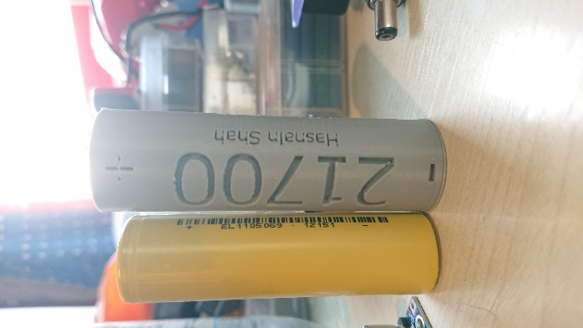Unable to get any cells on time due to Covid lockdown restrictions, A suitable substitute was used to design the battery pack in mind, however this did later give some slight issues as the 3D printed part shrank ever so slightly.

The first battery bay was a complete failure, it would damage the cells resulting in possible sparks and shorting.  
  
Pictures taken of the First Failed Battery Bay, the issue was that there was no space to add in connectors since the cells are flat at both sides.

Figure 3 – 21700 cell next to 18650 cell

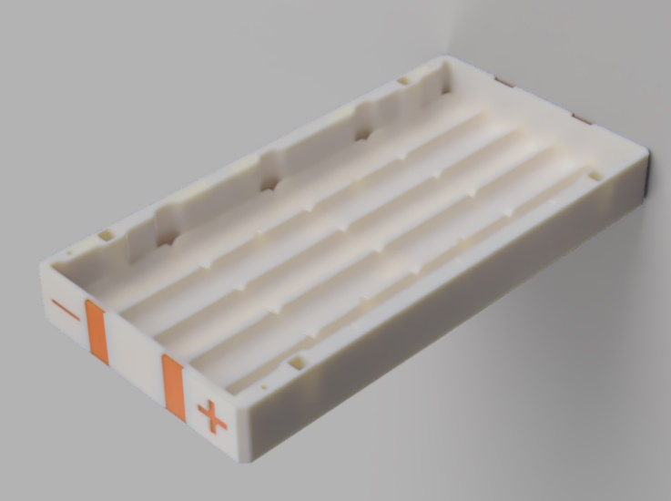

Figure 3B – Battery Bay without any 21700 cells.

The new designed battery bay came as a solution to the problem, creating enough space for the copper dented plates to adhere connections between cells.

##### Battery Bay Assembly - Images

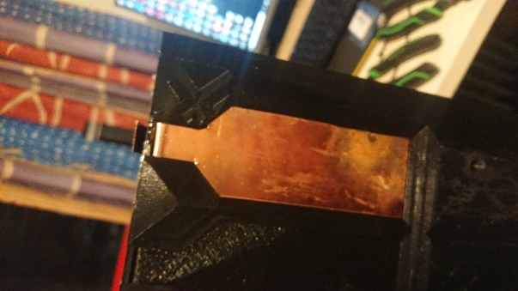

Figure 9 – Charging and Discharging plates added to battery bay.

Figure 6 – Solder paste to join banana pin and the copper plate

Copper plate has been cut using a saw in shape that fits the battery bay, the second version has a more modern sharp design that is far easier to cut. Whereas the first version had safety in mind and less sharp corners but due to time constraint was adjusted to version two.  
  
Banana pins had been soldered to the copper cut plate which would allow the terminal to be easily disconnected from the BMS when required for maintenance.

Figure 8 – First contact plate added

Figure 7 – Banana pin joined to the copper plate.

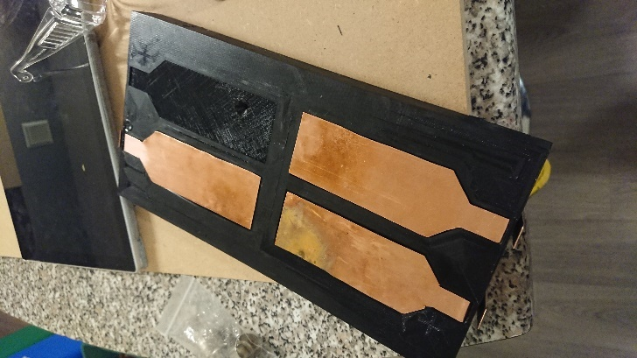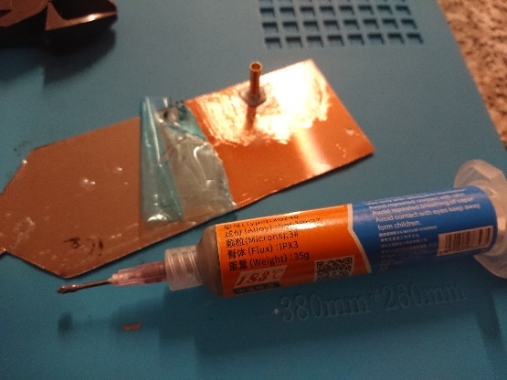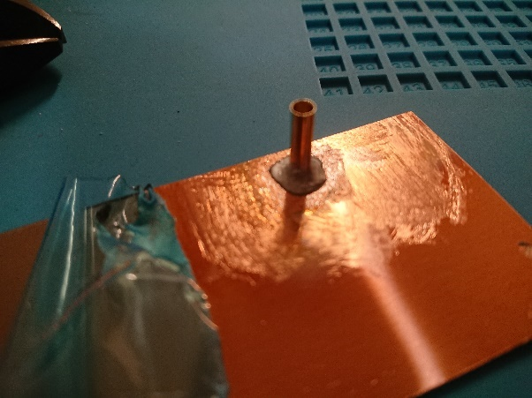

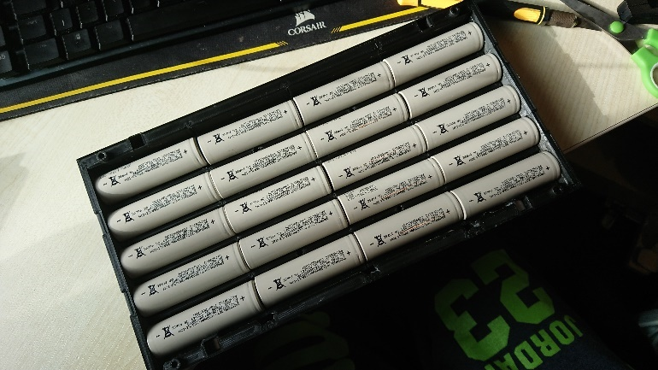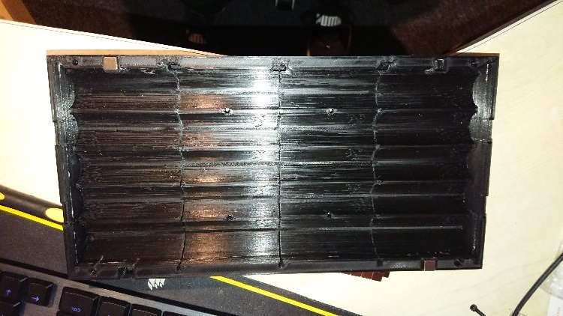

Figure 5 – Battery Bay filled 21700 cells to see if they fit.

Figure 4 – Freshly printed battery bay

Following up a re-design of the pack has been made due to the dimensional constraint of the battery bay, Version two has been improved as shown in figure 10.  
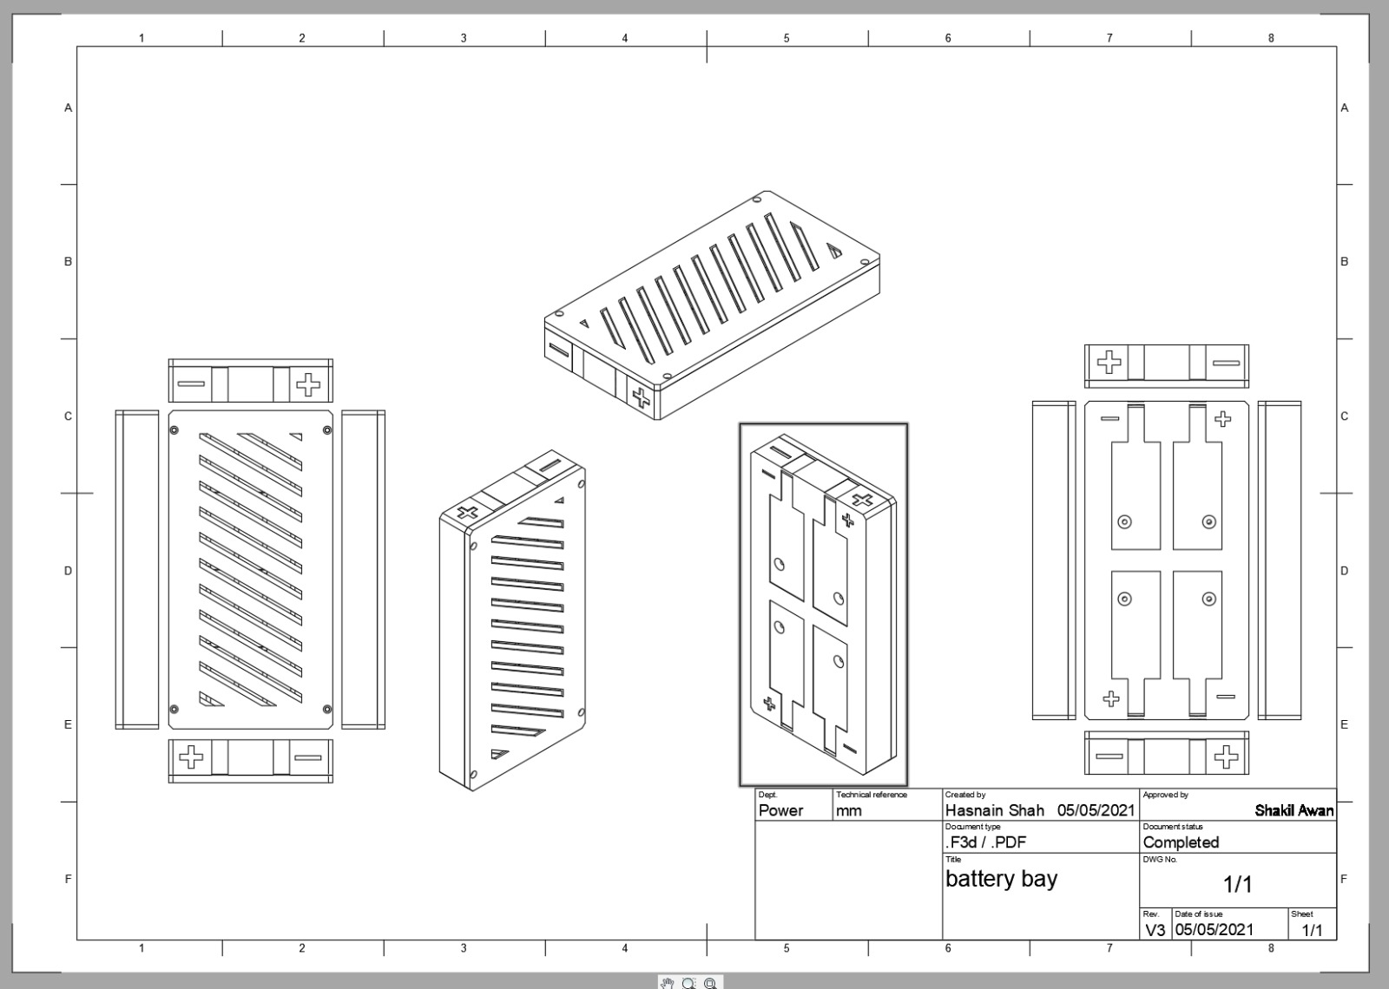

Figure 10 – 2D CAD design of the Battery Bay.

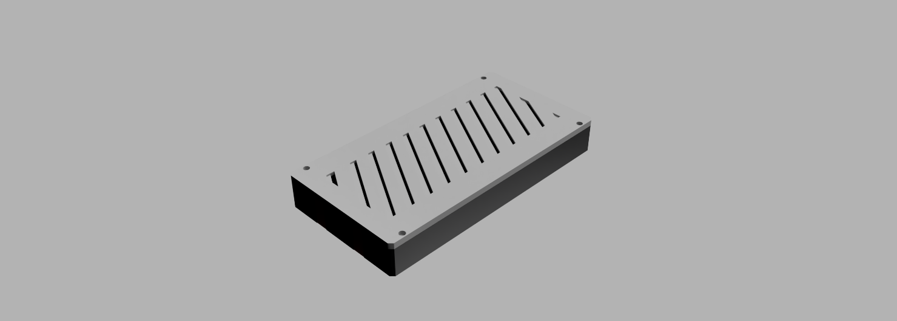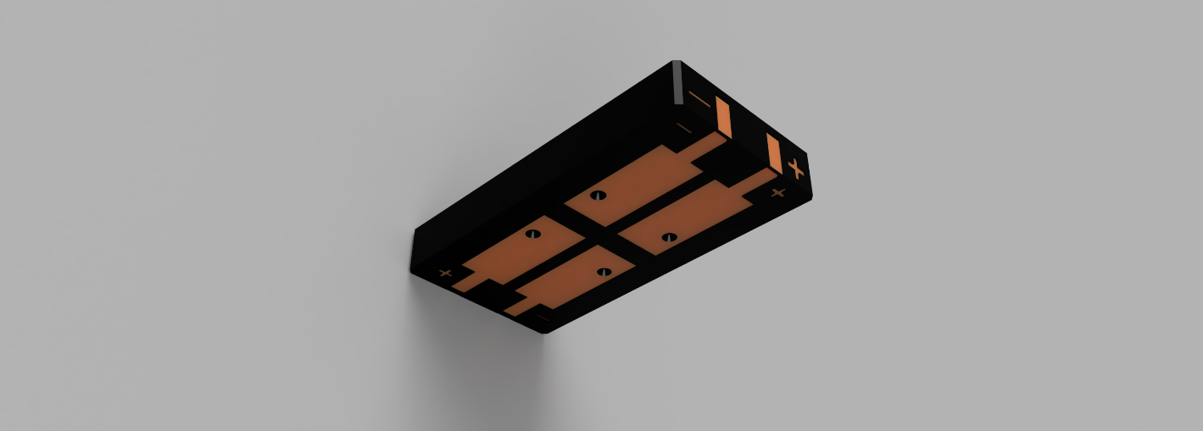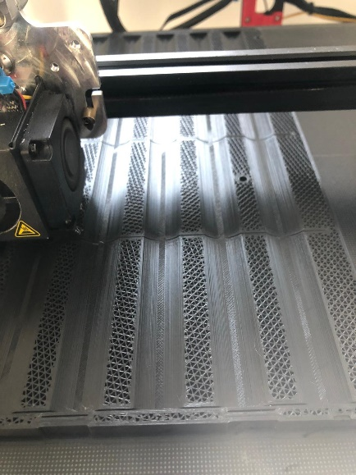A drawing the new battery pack, upgraded to have room for silicone pads for cooling performance.  
New pack being printed at good quality, more images are shown as the process developed further.

Figure 13 – Top View of the V2 Battery Bay.

Figure 12 – Bottom View of the V2 Battery Bay

Figure 11 – new bay being printed

The design process was straightforward, omni-directional input on the pack would allow it to be used without any user errors, it would also meet the criteria of being fully modular for the SCV-E.

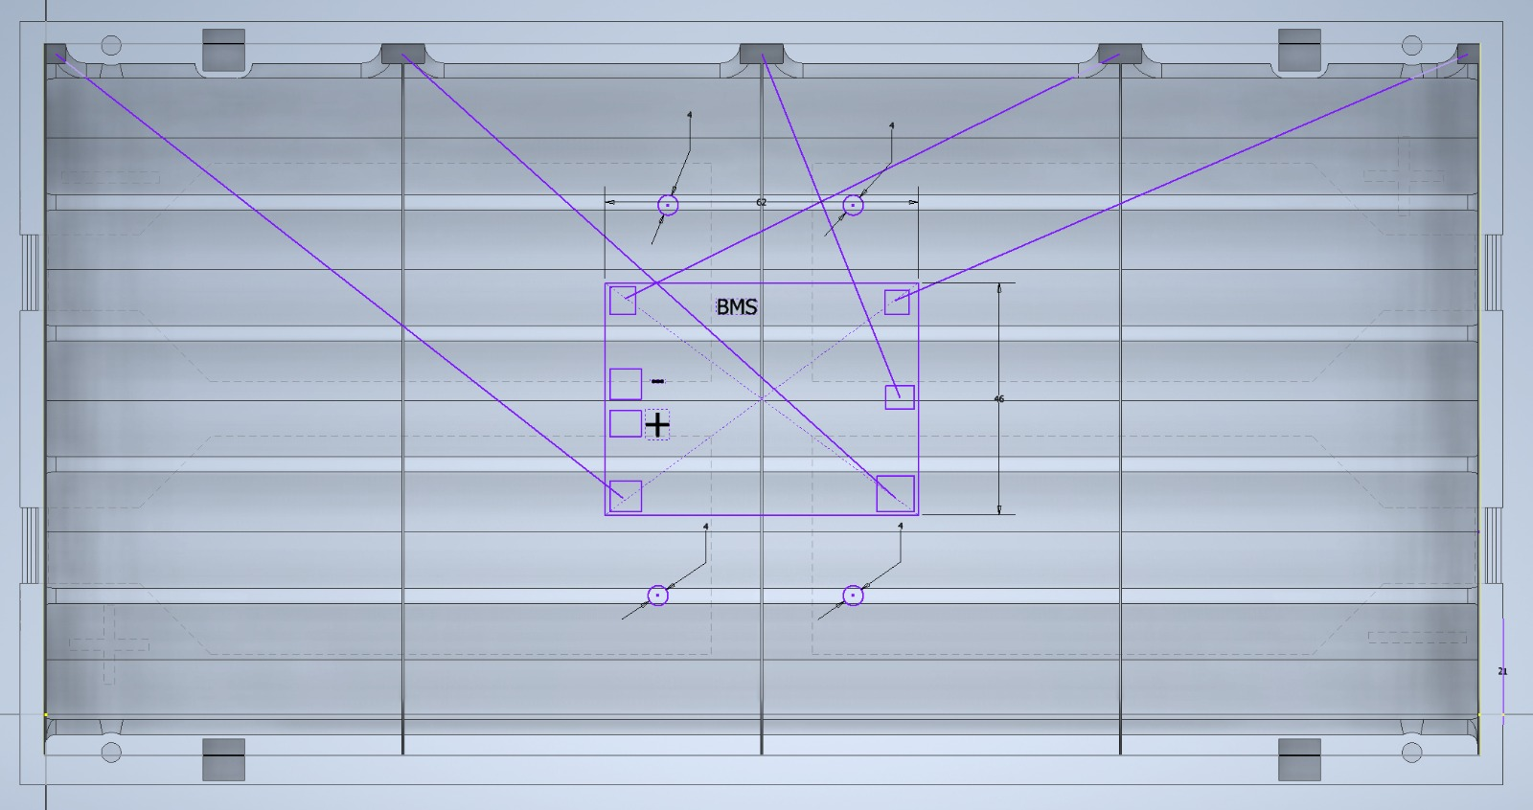

Figure 14 – BMS Layout on the CAD, showing where to connect.

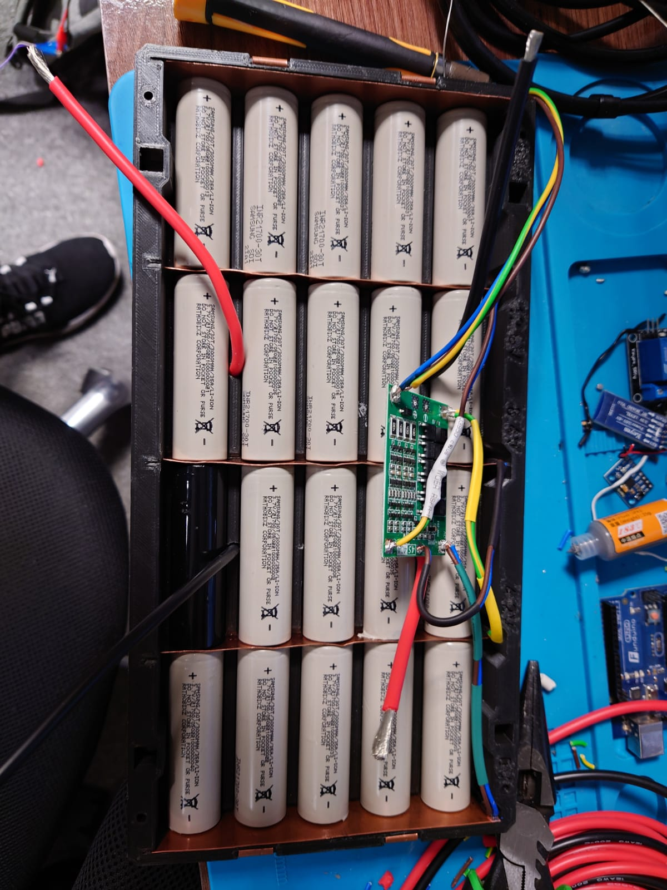

Figure 15 – Batteries installed in Battery Bay V2, Ready to be connected to the BMS.

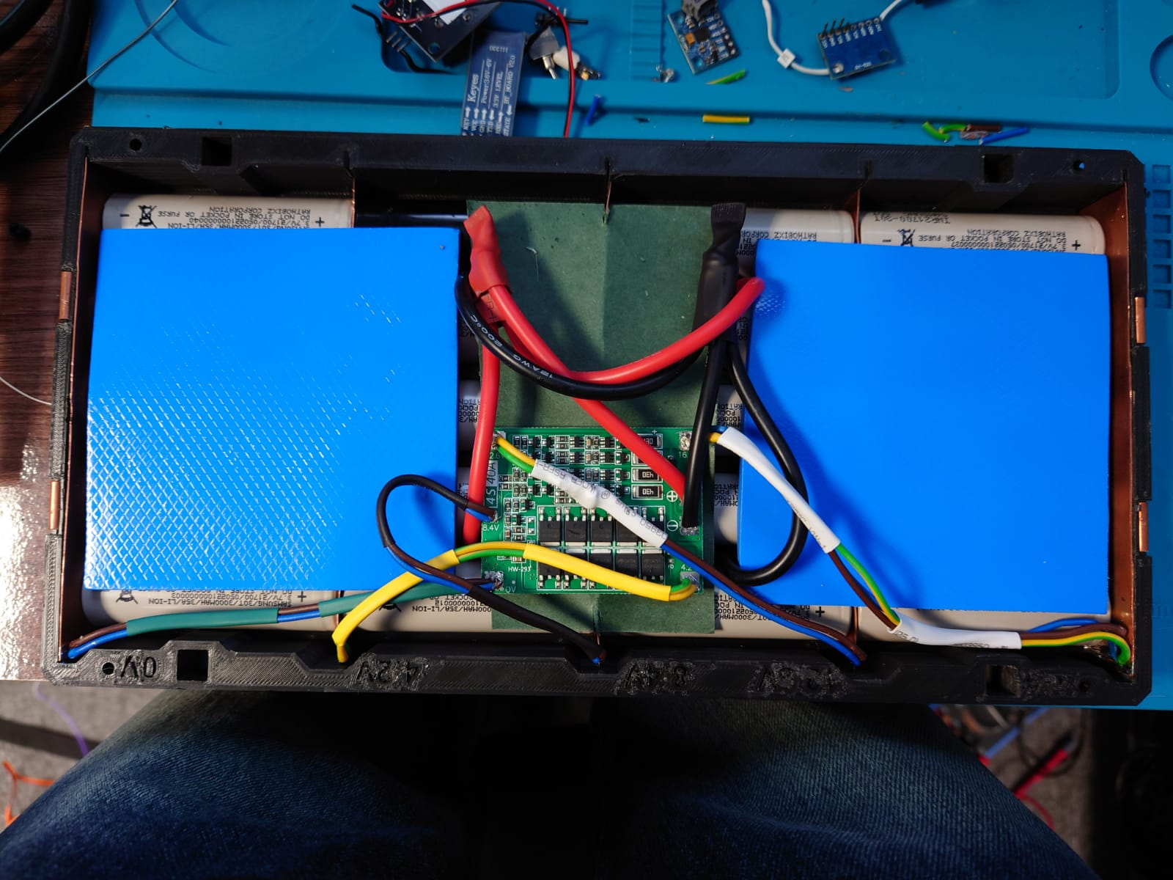

Figure 16 – Battery Bay V2 fully connected to BMS and Operational at 16.2V. Added Silicone pads for passive cooling through the air vents.

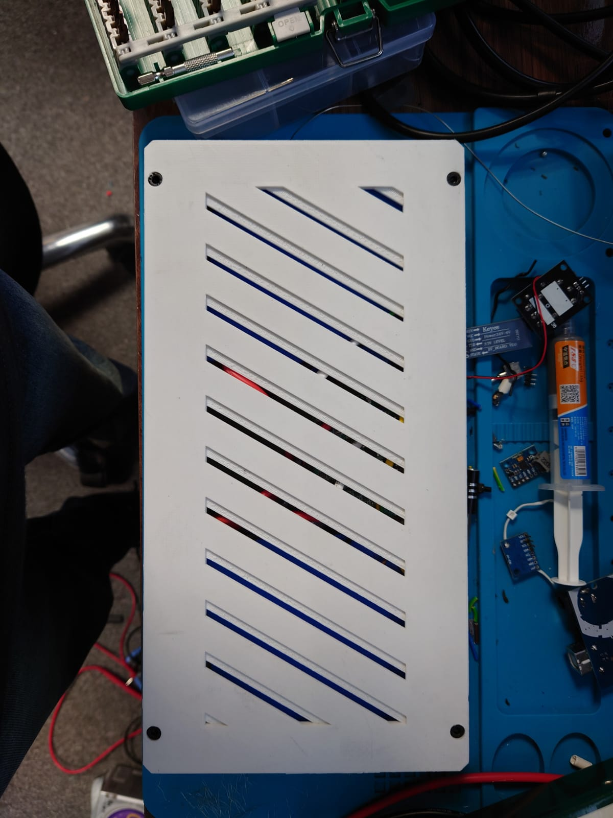

Figure 17 – Sealed and packed Battery Bay V2. To charge connect the outer side terminals or the bottoms terminals

#### Charging the Battery Pack

Fast charging technology is available in the format of Power Delivery (PD) USB-C. Allowing the battery to charged quickly through the PD output capability of 20V at 5A. perfect to charge this pack fully in 36 minutes. More on PD see RavPower’s blog detailing great features of PD’s technology. [[11]]

### Main Modules and Parts

#### L298N Motor Driver

A double H bridge module using the ST L298N dual full-bridge chip, it can accept standard TTL logic levels and allowing DC motors to change direction by digitally swapping the input values from high to low.  
Appendix 21 shows the code for the motor and the way it should behave. Further elaborated below.  
This is an open-source circuit board designed by Adafruit

#### Linear Actuator

A Linear Actuator controlled by a DC motor that allows it to go up or down in a linear motion, Appendix 21 shows the code which is simple.

#### PCA9865

The Open-source Adafruit 16 channel servo driver using PWM to control each servo.

#### Arduino Mega 2560 R3

The brain of this system, A complete opensource microcontroller using the Atmel 2560 chip.

### Designing the SCV-E

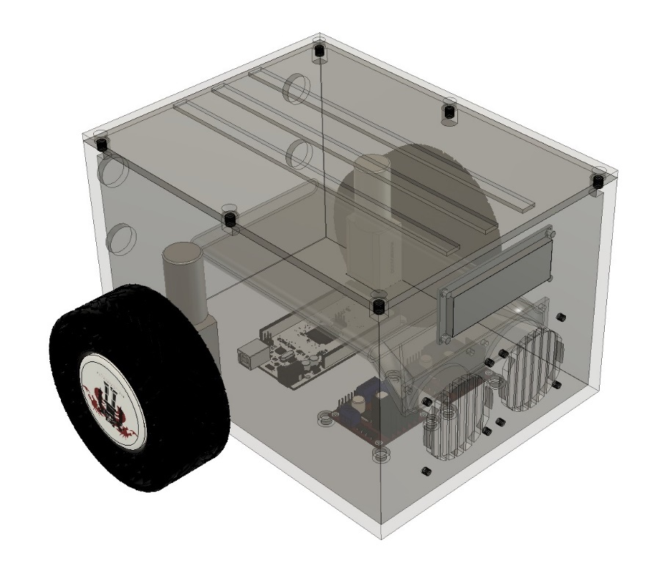

Figure 18 – Initial design, realization that it’s too big.

Figure 18 shows the initial design concept with the main parts being inside the design, the main problem is that the 3D printer print volume is 300 mm x 300 mm x 300 mm, and this would not fit due to its enormous size and the weight displacement. Figure 18 is the truck head, like the commercial freight trucks seen on roads, with an carrier attachment at the rear which was not designed.

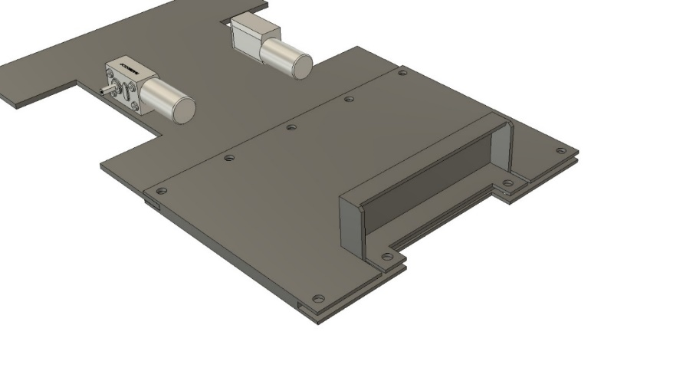

Figure 19 – Secondary design, looks promising, A joint has been designed due to the size limitation of the 3D printer.

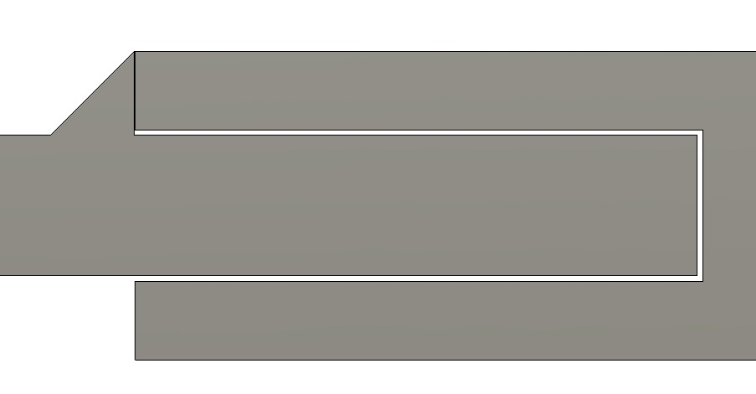

Figure 30 – Joint structure from Figure 19.

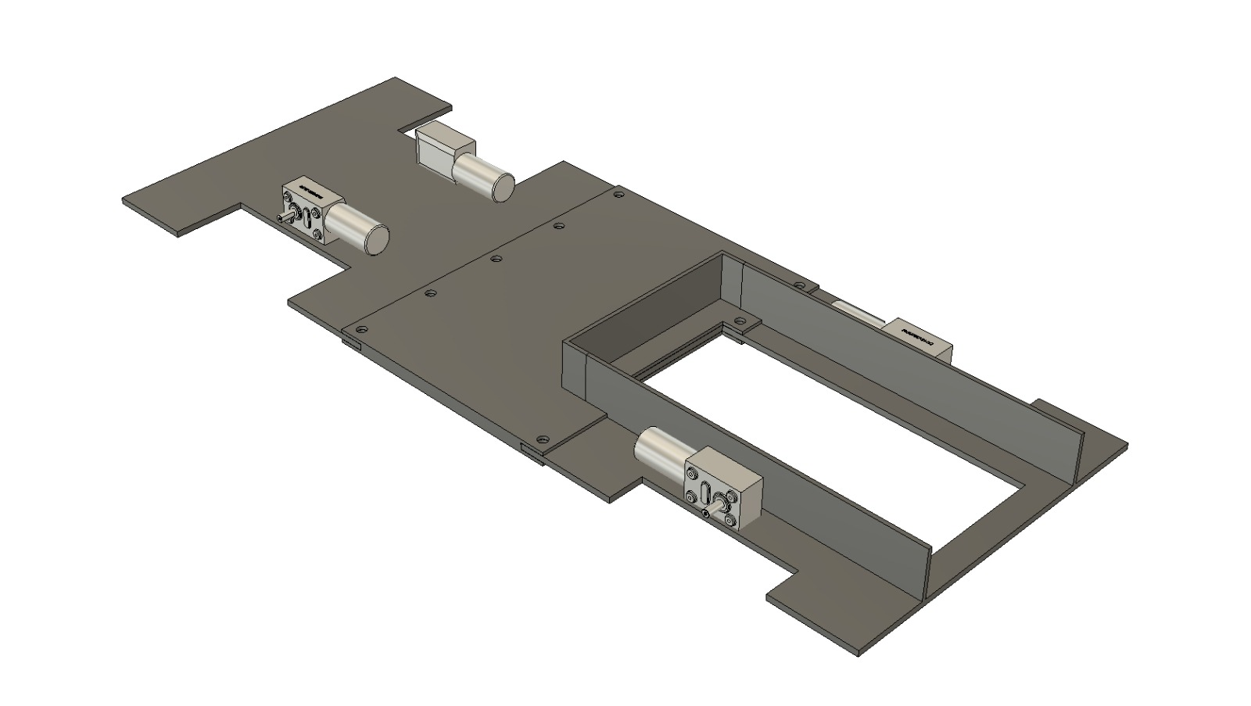

Figure 21 – Base of the SCV with Battery slot.

Figure 21 shows the secondary design concept which is more based on an automotive frame structure. The only issue regarding this design is the weight displacement being too back instead of an even proportional. Figure 30 shows the joint structure that would prevent weight warping at the middle centre due to excessive weight on the rear end of the vehicle.

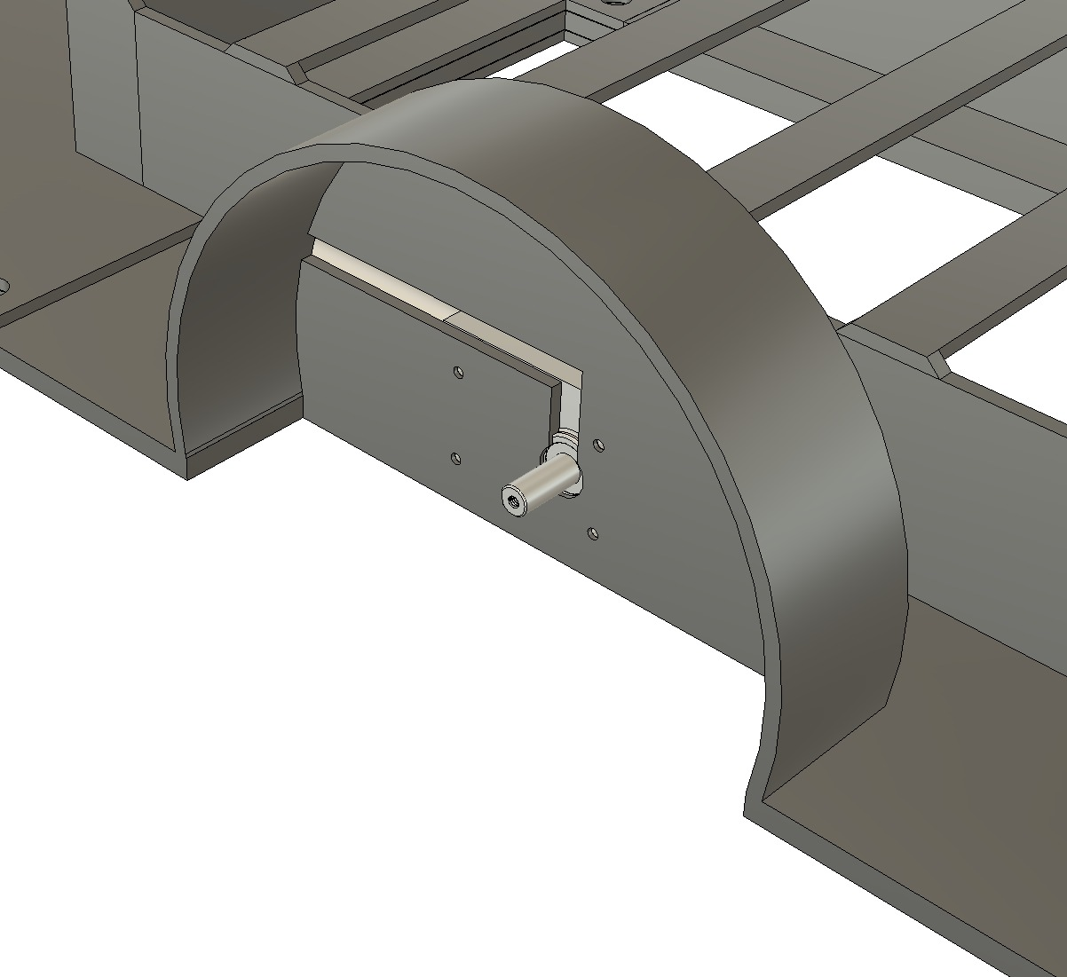

Figure 22 – Tyre Guard to prevent liquids or mud coming inside.

Figure 22 shows the tyre guard made to prevent any mud or terrain dirt to enter the vehicle which would expose it to environmental hazards such as corrosion and electronics being fused.

The weight of the vehicle is calculated by the weight of the printed material estimate on the printer’s software. Which resulting in the vehicle frame weighing at 946 grams. The battery pack fully assembled weighing at 3.46 kg. motors weighing at 235 grams each along with the L298N boards at 172 grams.  
  
The total calculated weight is to be estimated at 5.52 kg. The Motors have a torque force of 290Nm with a power of 36W (12V 3A).  
Using the equation;

*F = μt W = μt m ag* , *where*

*F = traction effort or force acting on the wheel from the surface (N)*

*μt= traction - or friction - coefficient between the wheel and the surface*

*W = weight or vertical force between wheel and surface (N)*

*m = mass on the wheel (kg)*

*ag = acceleration of gravity (9.81 m/s2)*

the traction coefficient of a rubber tire on pavement is 0.75-0.85 when dry [[12]] and the traction of coefficient of rubber on carpet is 0.8-0.9, therefore on this basis 0.85 is selected as it’s higher than required but also a mid-range value for testing purposes.  
the maximum traction force of all wheels can be calculated by;  
  
Force = 0.85 * ((weight of vehicle 5.52 kg)(acceleration of gravity 9.81 m/s2 ) = 46.03 N  
What this number implies is that the pulling force required to move the vehicle is 4.7 kg (Force/gravity)  
Since each motor has a torque force of 290 Nm, a calculation is required to show an expression of motion capable on the mass value of the vehicle.  
  
since there are 4 motors, 290 Nm x 4 = 1160 Nm. Using the equation F = t / (r*sin(a)), where t is the torque force, r = radius and a is the angle of to the force.  
total motor Force = 1160 / (30 mm * sin (90)) since surface is perpendicular to the tyre.  
F = 38666 N / gravity 9.81 = 3.944 kg is the capable pulling force.  
This would make the vehicle overweight by 4.7-3.944 = 0.756 kg which would either need to be solved by replacing the motors with more powerful ones or creating a gearbox system.

However due to time constraint, equipment issues and covid-19 disruption. Parts would not be able to arrive on time at all.

### The Problem with the Tyre

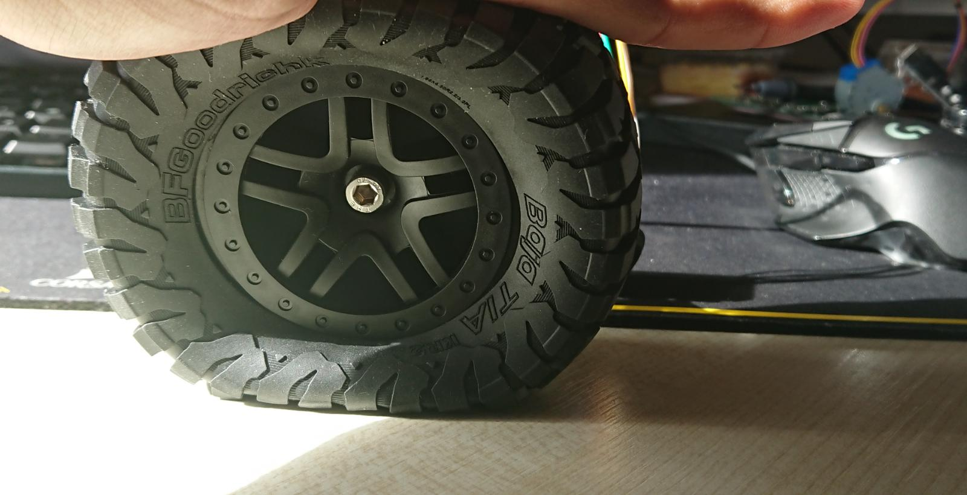

Figure 23 – The tyre is too soft since it is filled with foam instead of air.

Originally tyres bought from the vendor that matched the size required for the design, as a large clearance was required between the chassis of the vehicle and the ground. The vendor tyres are the traditional tyres used by vehicles, filled with foam and air. However, as it is a tyre for a toy vehicle due to the size of the project, this is not feasible as it could not support the weight of the vehicle in question. To tackle this issue, explored the design research of airless tyre designs influenced by Michelin tyres.

Figure 24 shows some key airless tyre designs in the industrial market. As it is still in its research phase, these tyres are not available for the consumer market. The main idea of the airless tyre design is being airless, normally tyres have an air tube inside them that supports the mass of the vehicle through internal air tyre pressure. The airless tyre on the other hand supports the mass by mechanical pressure relative to gravity.

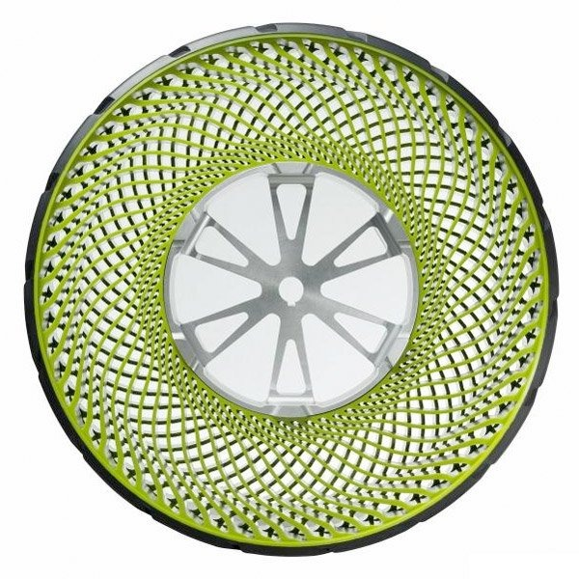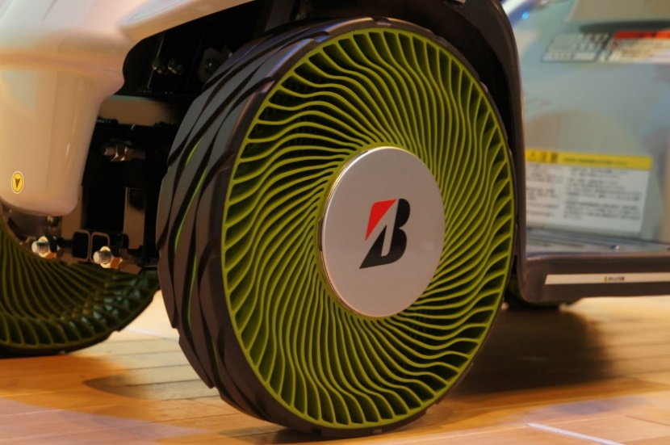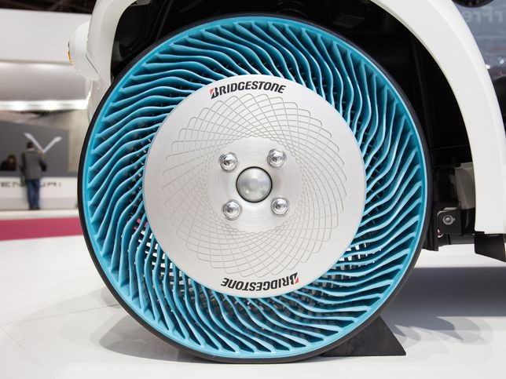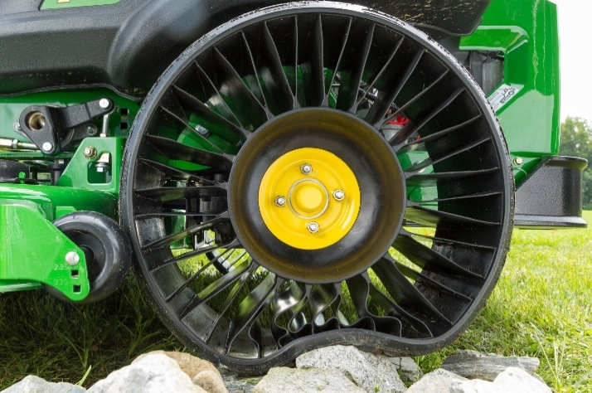

Figure 24 – Different Airless Tyre Designs, [Lost sources]

Based on these, a creative design had been made, one focusing on straight lines like the green tractor tyre as shown in figure 24. And another of a custom honeycomb design.

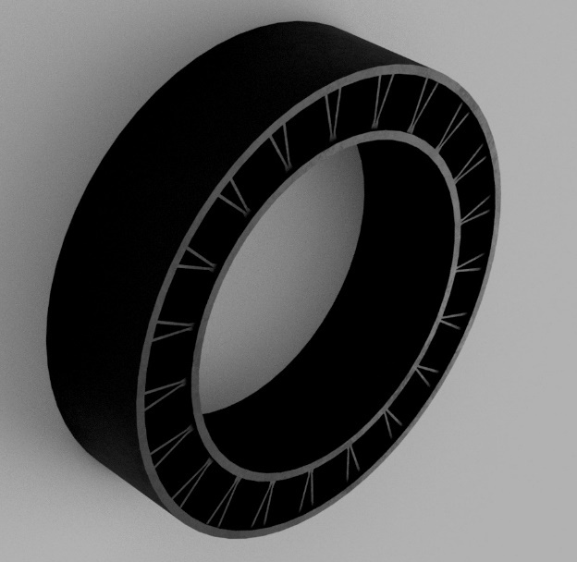

Figure 25 – Straight Airless tyre design

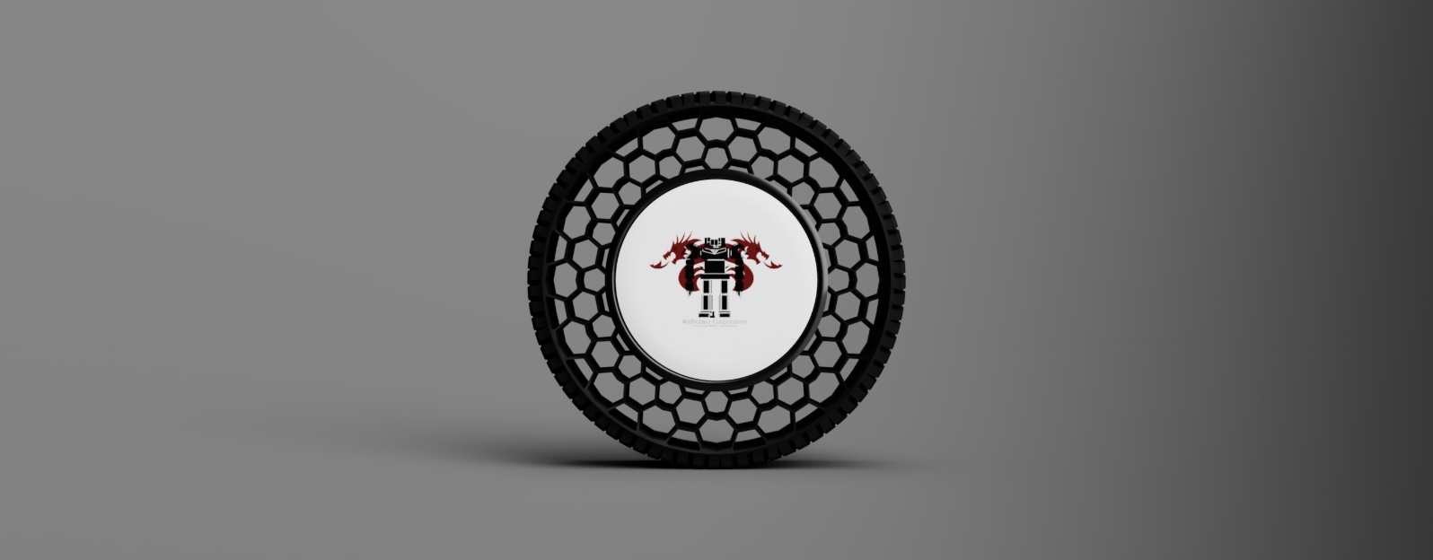

Figure 26 – Honeycomb Airless tyre design



Figure 27 – Force on the straight airless tyre design, shows the tyre being centrally weak. This is further shown on the video demonstration.

Looking through the demonstration video, the honeycomb tyre design has significant durability and strength to be able to support the weight of the SCV-E.

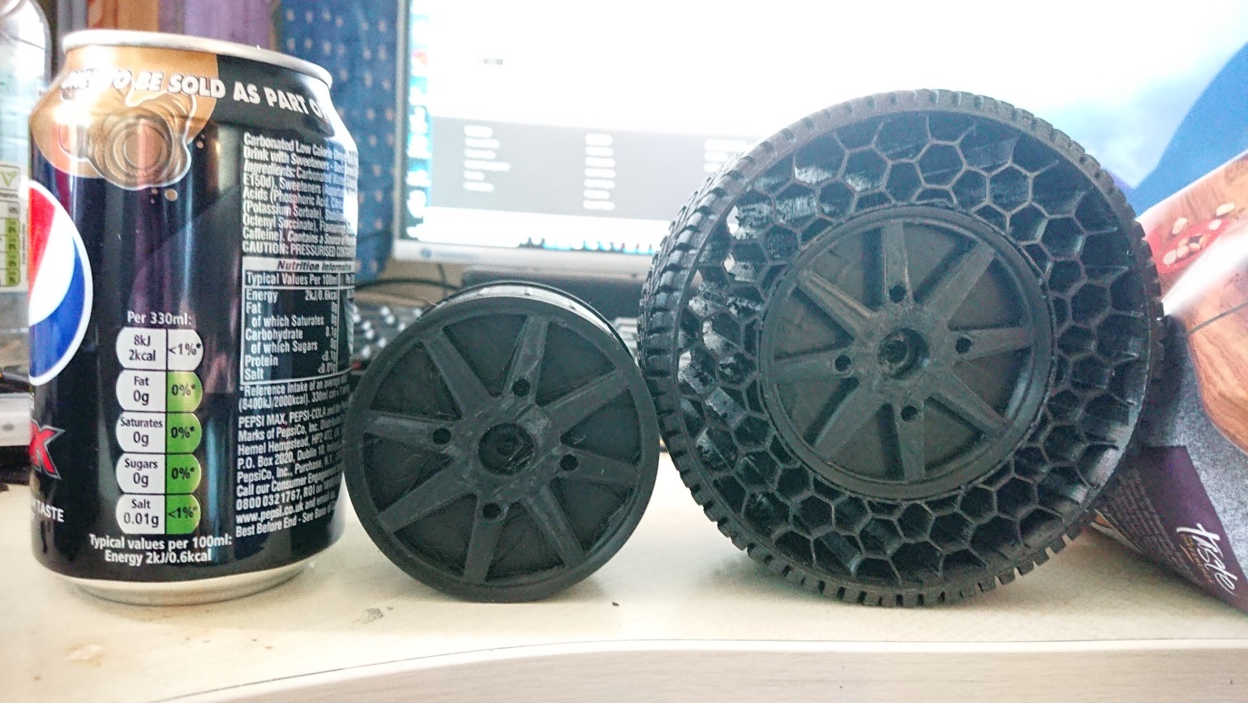

Figure 28 – Honeycomb Tyre design next to soda can for size.

#### Completing the SCV-E

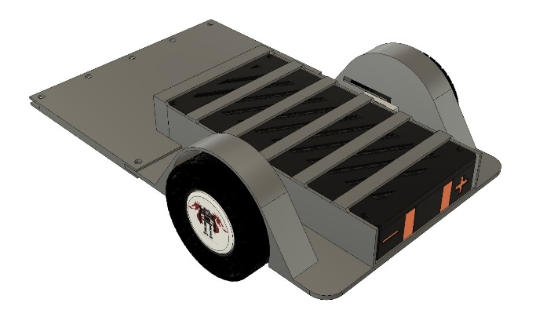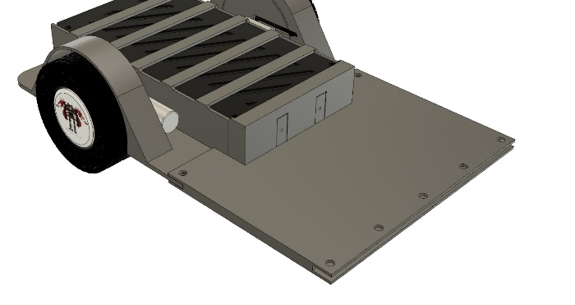

Figure 29 – SCV-E rear side, showing Tyres and Battery Bay connected.

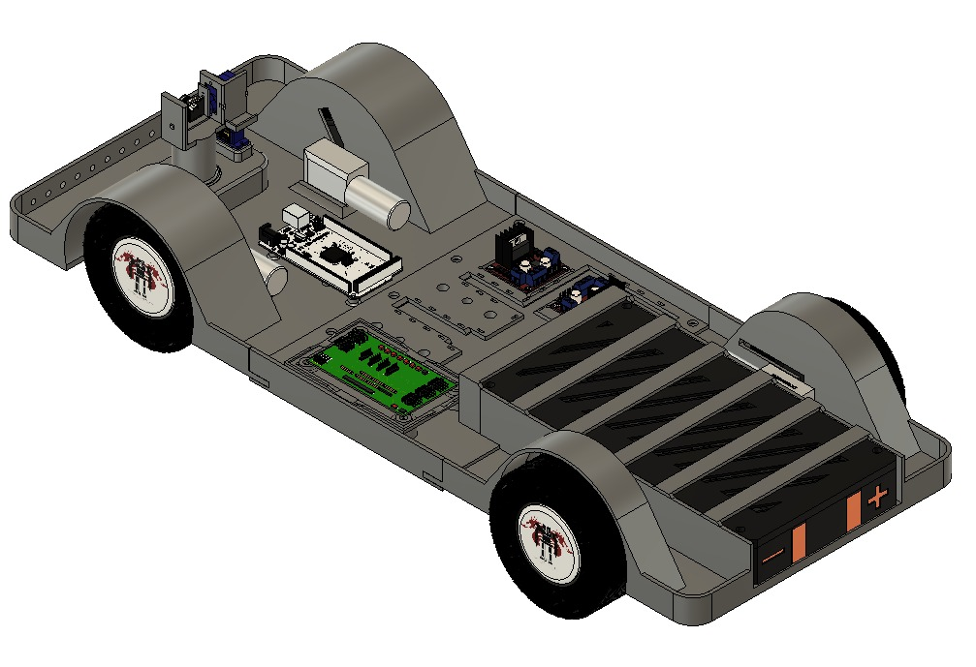

Figure 40 – Completed SCV-E With Allocated Electronics.

### Crane Design

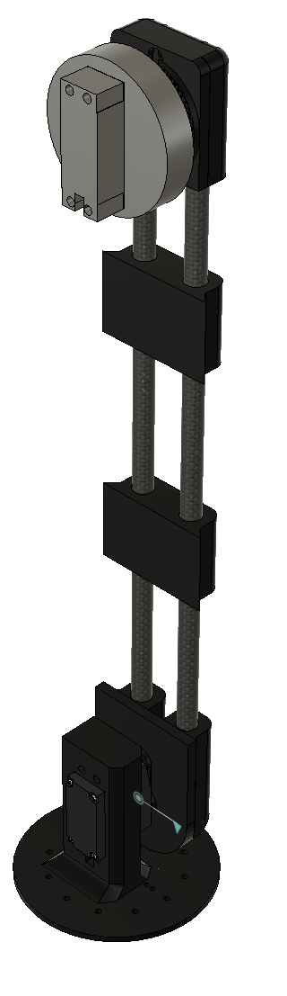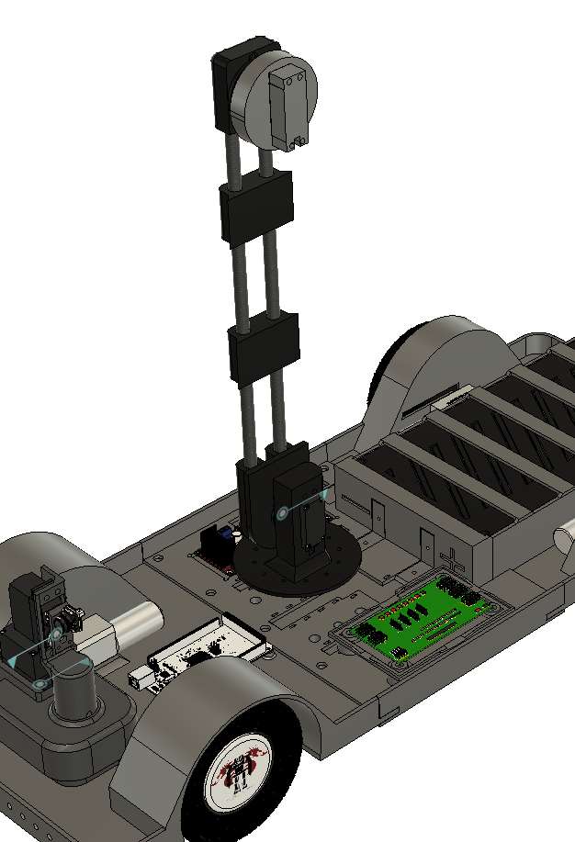

Figure 31 – Initial Crane Design, Has a lot of weak points where the servo and the joint meet.

As the initial crane design this should have been lighter however it was too flimsy which was not capable of lifting anything.

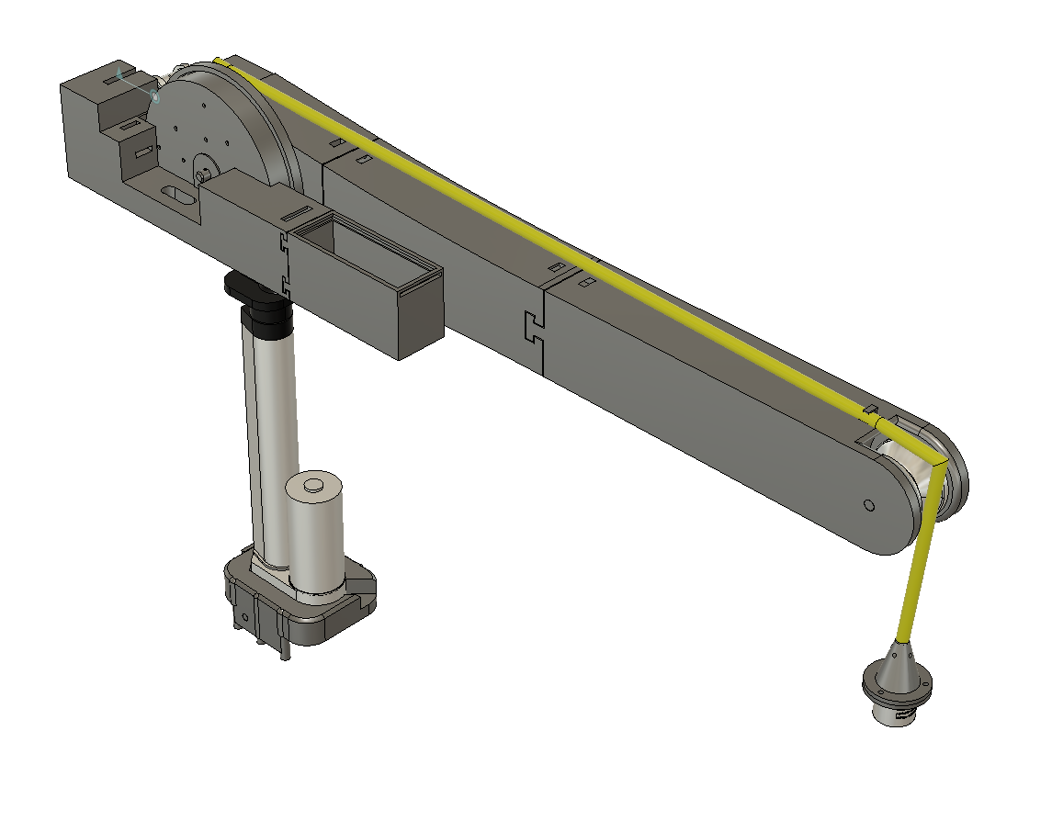

Figure 32 – New iterated design, supporting an Actuator and Crane for lifting, Weak points have been reduced by implementing a Gear System.

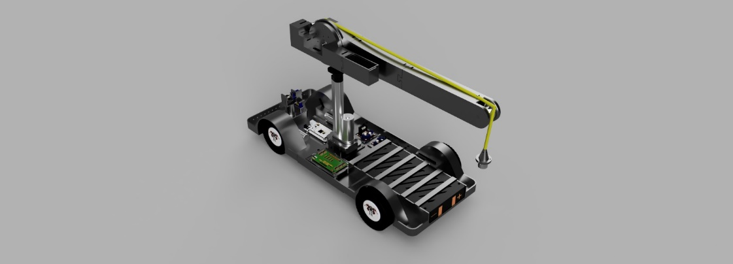

Figure 33 – Competed view of the SCV-E

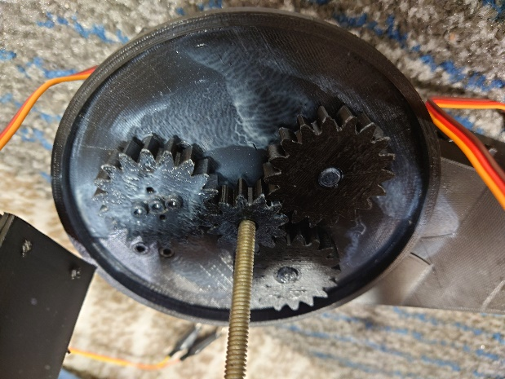

Figure 34 – The gear system instead the new Crane. The Demonstration video shows the 2D cad design of this working.

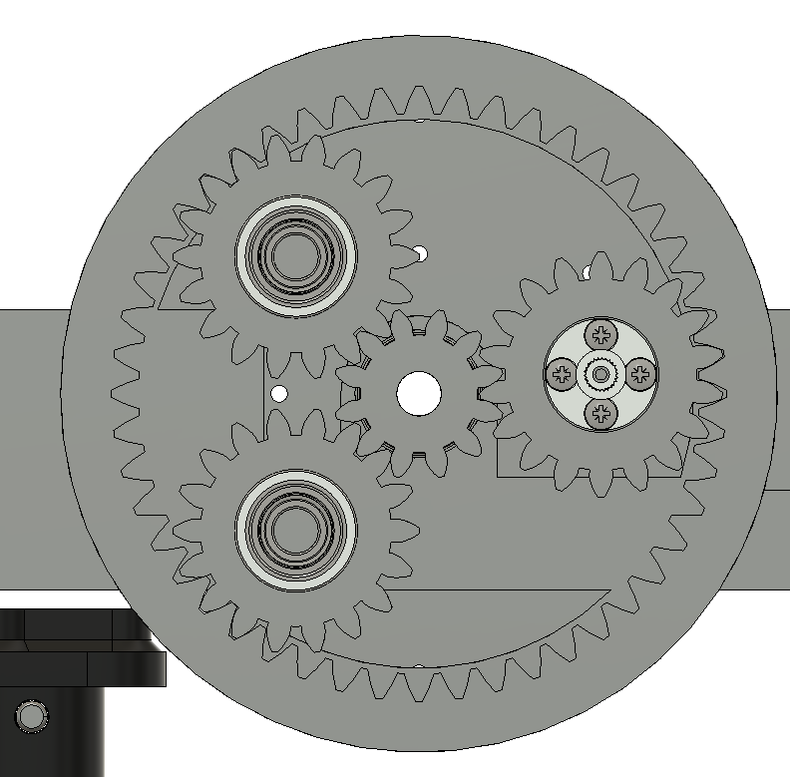

Figure 34 B - The Planetary gearbox system inside the new crane. It allows for a much more sturdier movement.

### Camera Design

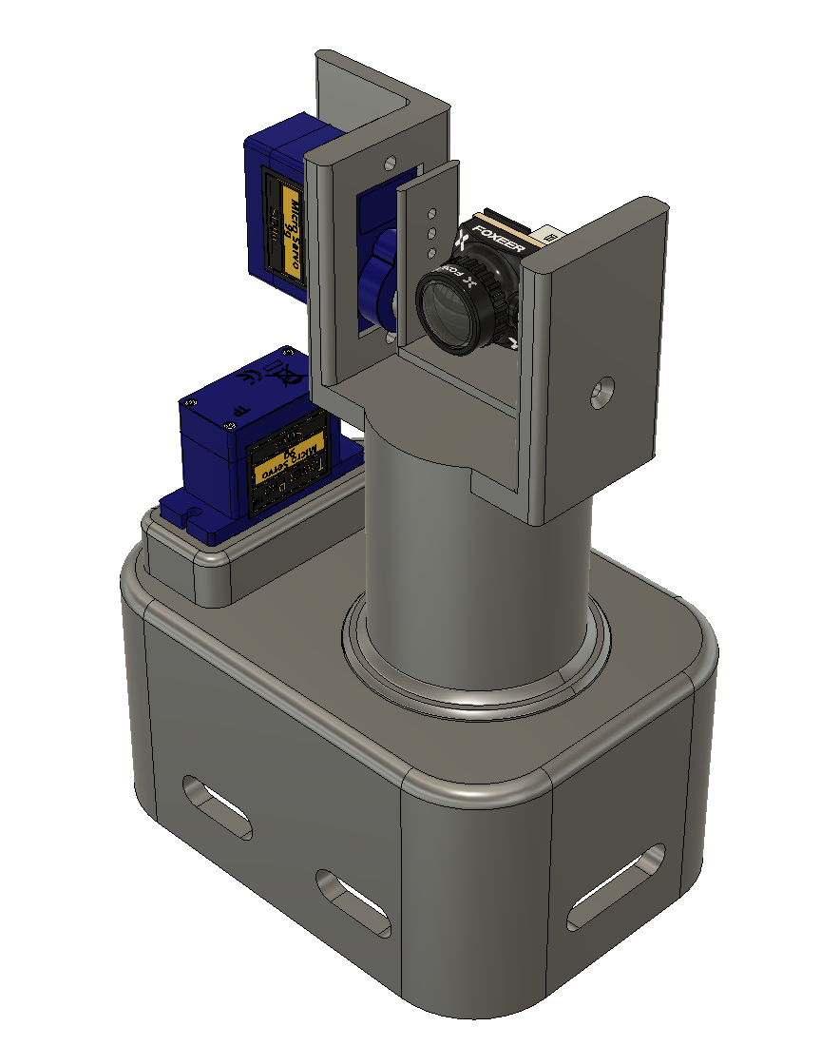

Figure 34 – Initial Camera design was implemented using two pulleys and a belt.

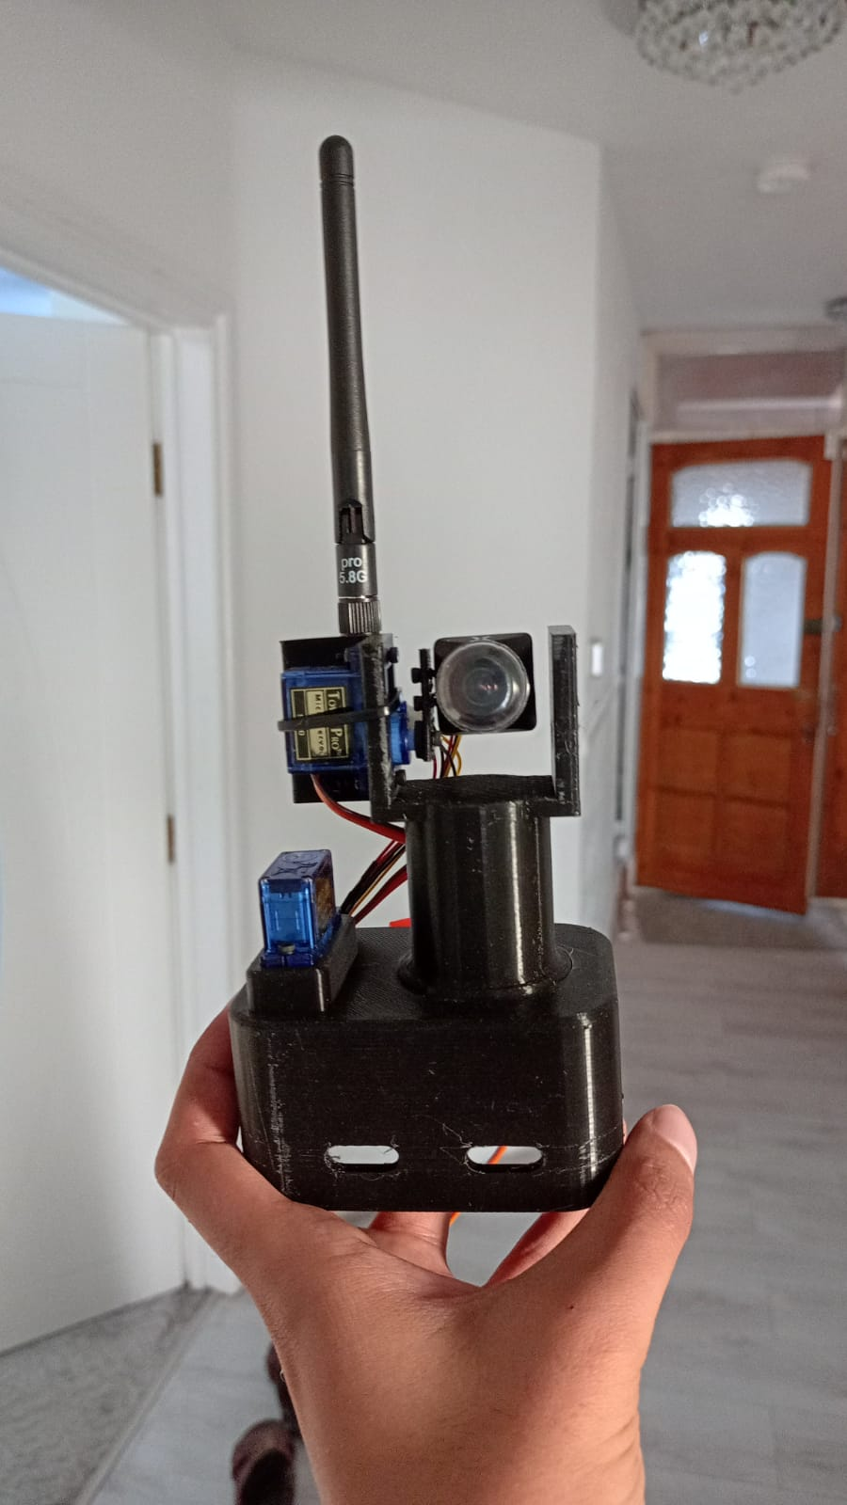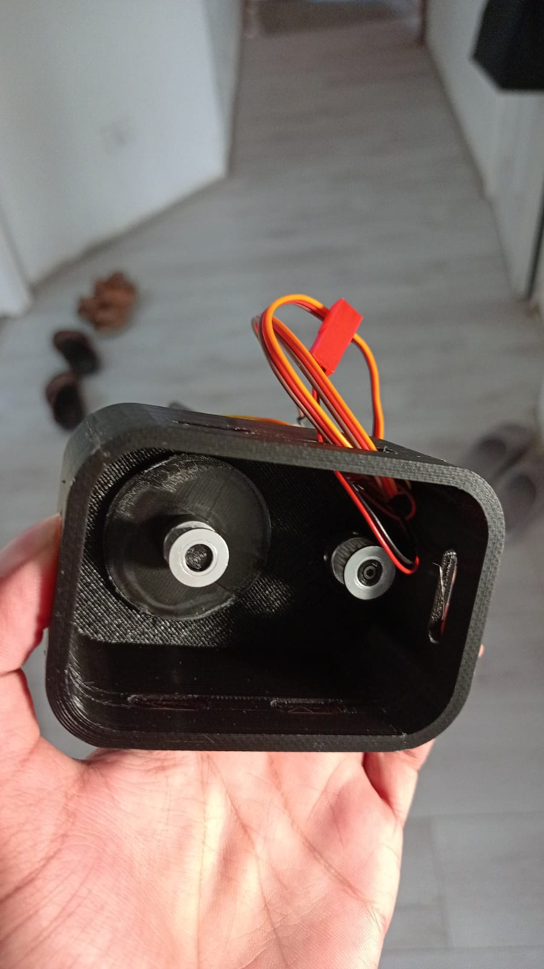

Figure 35 – Initial Printed Camera Design.

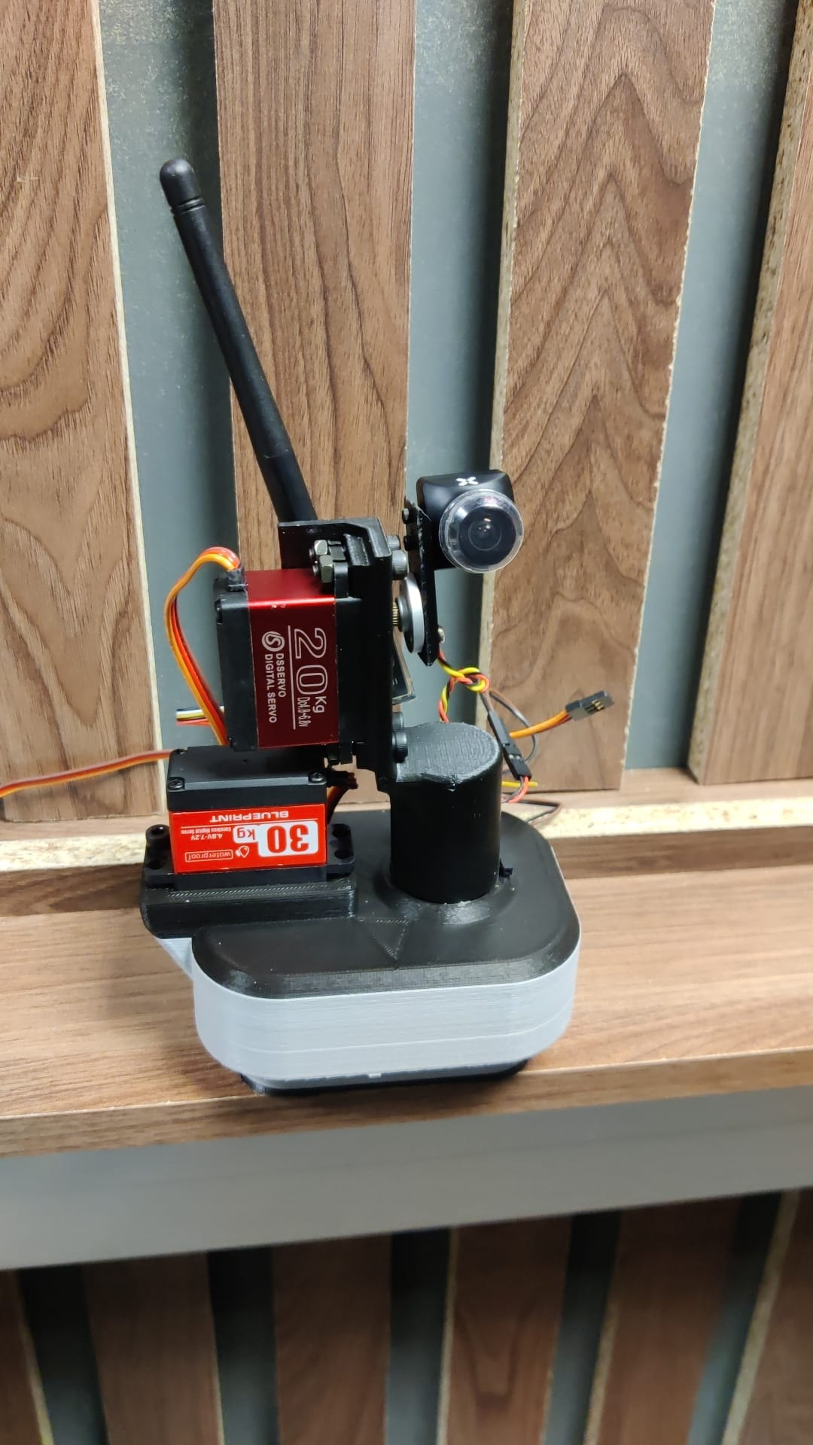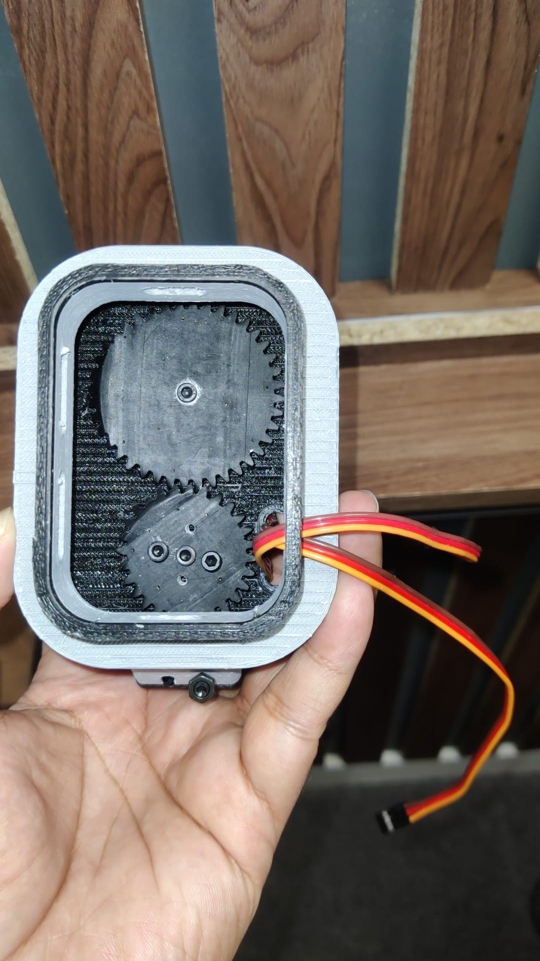

Figure 36 – V2 of the camera design, reinforced using bigger servos and gearing to prevent skipped steps.

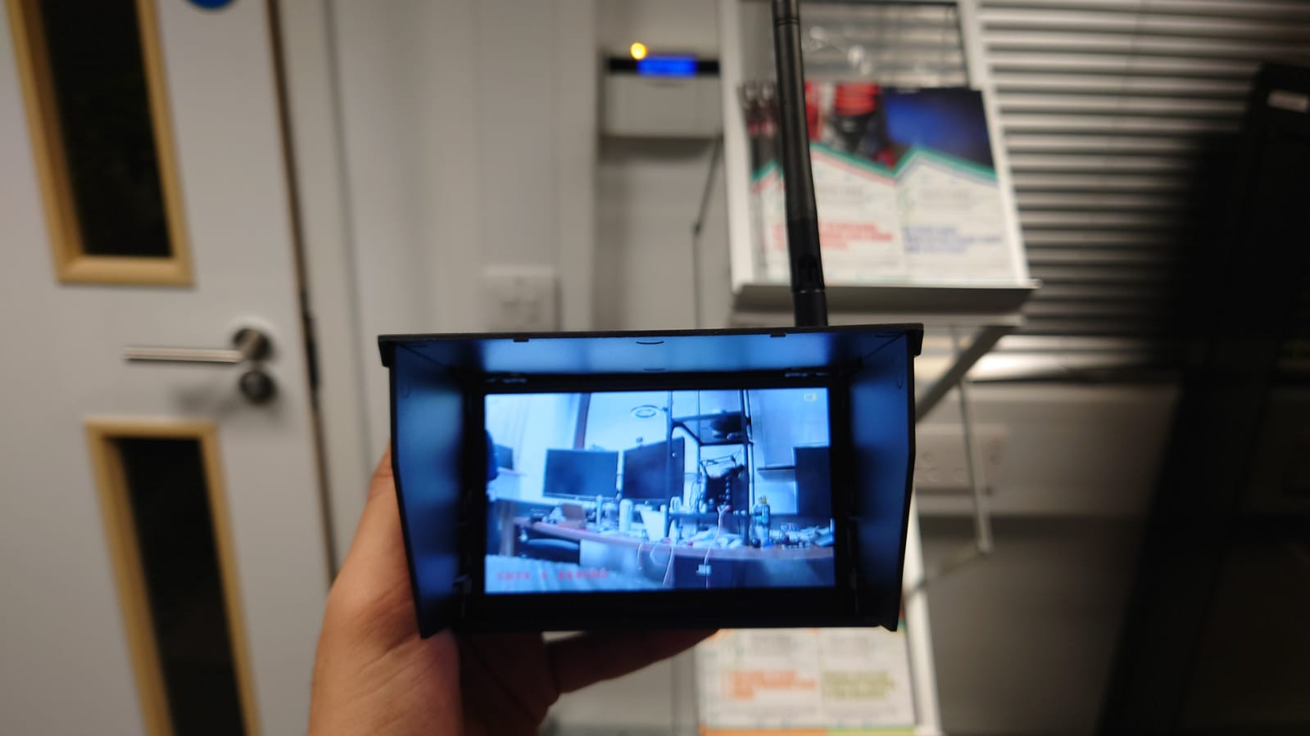

Figure 37 – Live Video Feedback through the 5.8GHz Frequency bandwidth.

### Controller Design

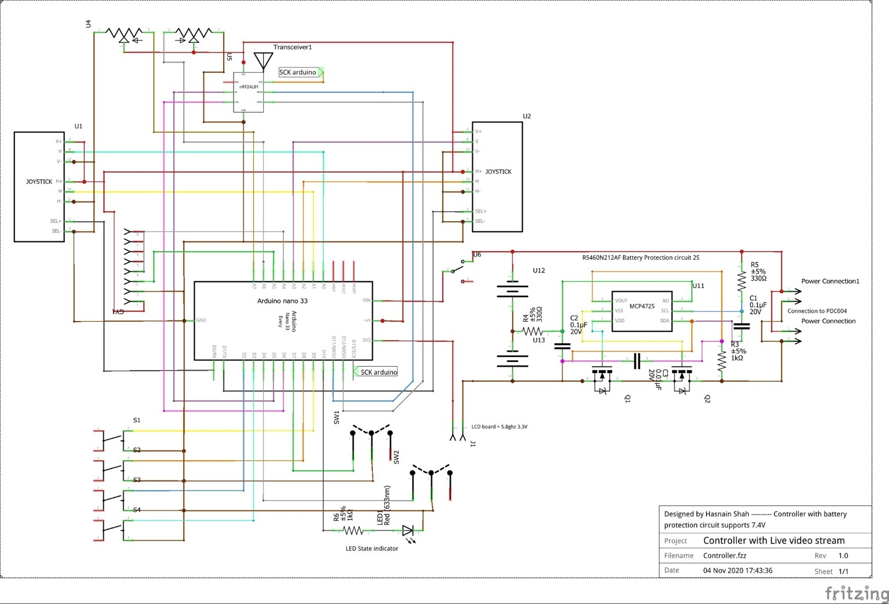

Figure 38 – Initial Schematic of the Controller.  
Arduino MCU as the heart of the system. Along with a BMS (Battery Management System) and a 2.4GHz RF transceiver.

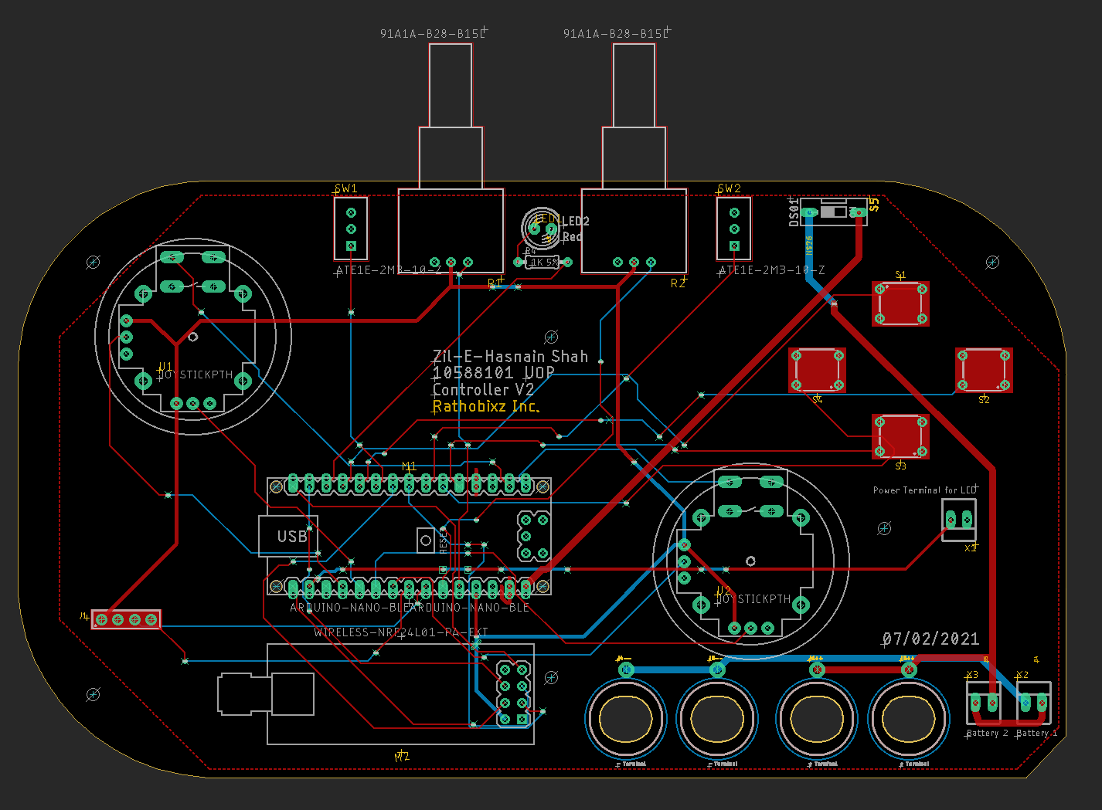

Figure 39 - Initial iteration of the controller schematic. Due to feature creep and design flaws, several iterations have been made.

Initial design concept of controller influenced by the Nintendo DS. Huge design flaw are the hinges as it creates limited product life.

The unique feature of this Controller is that it can connect to any device via RF or Bluetooth. Similar controllers on the market cost above £200.

The idea was to create a controller that is universal and cheaper than the market cost of a new controller with video feedback.  
This criterion has been met, appendix 6 shows the total expenditure on the controller.

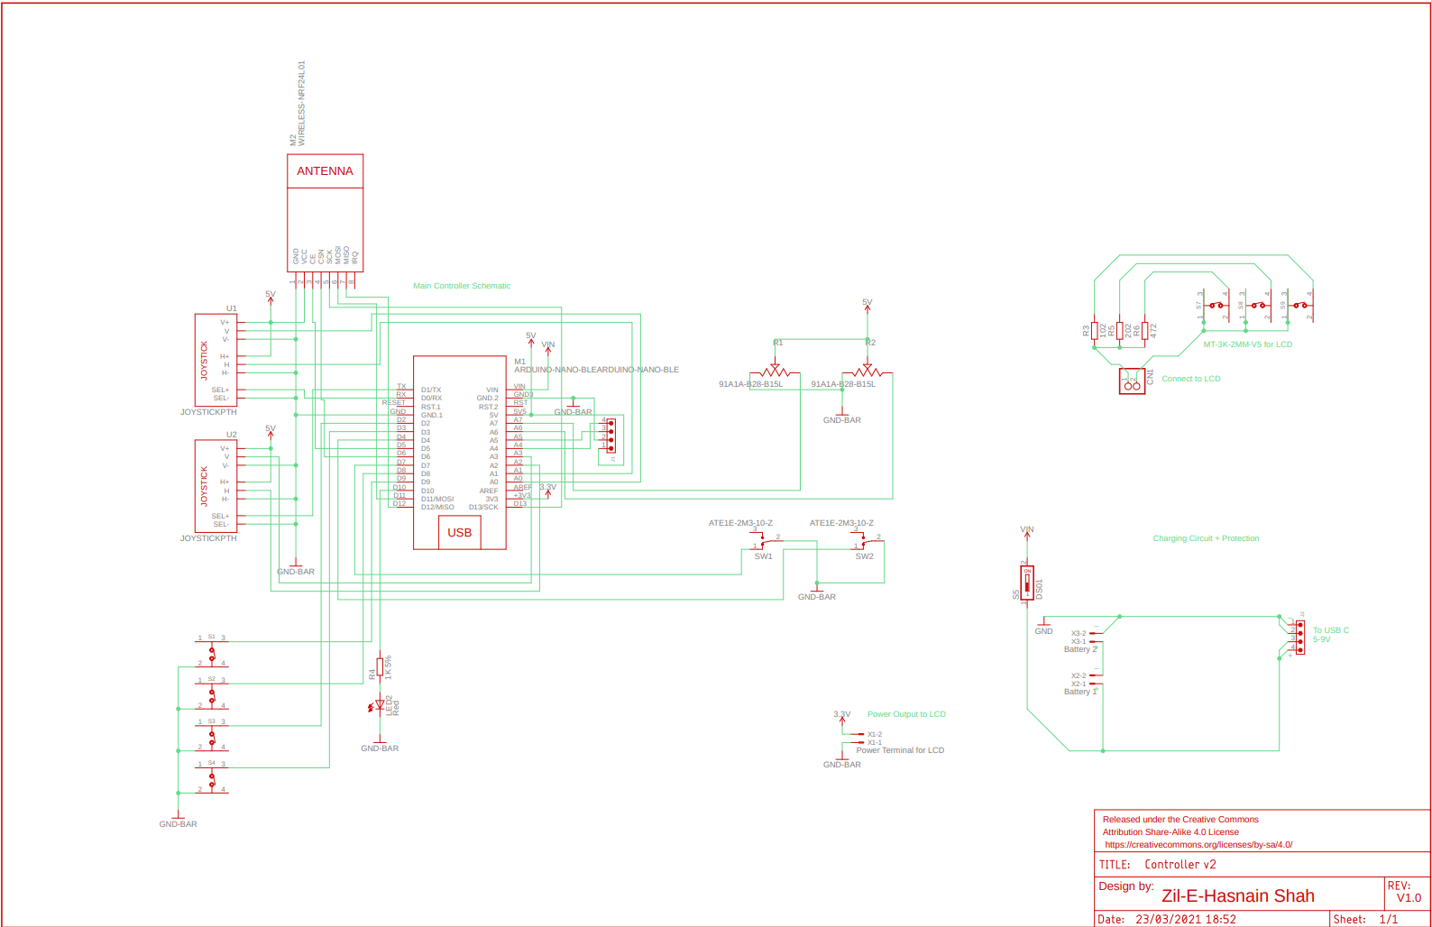

Figure 40 – V2 of the controller layout, creating a space for the video display.

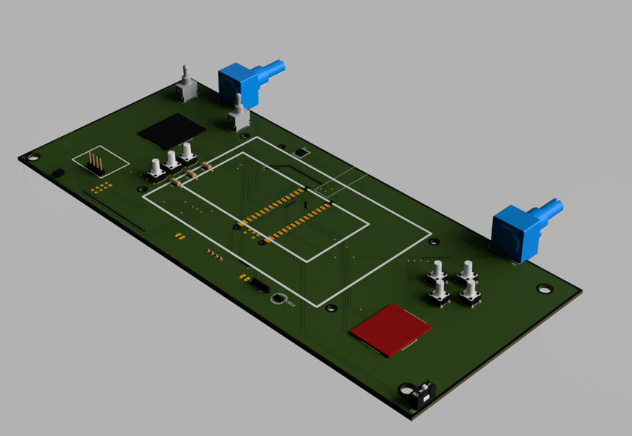

Figure 51 – V2 PCB 3D design of the controller.

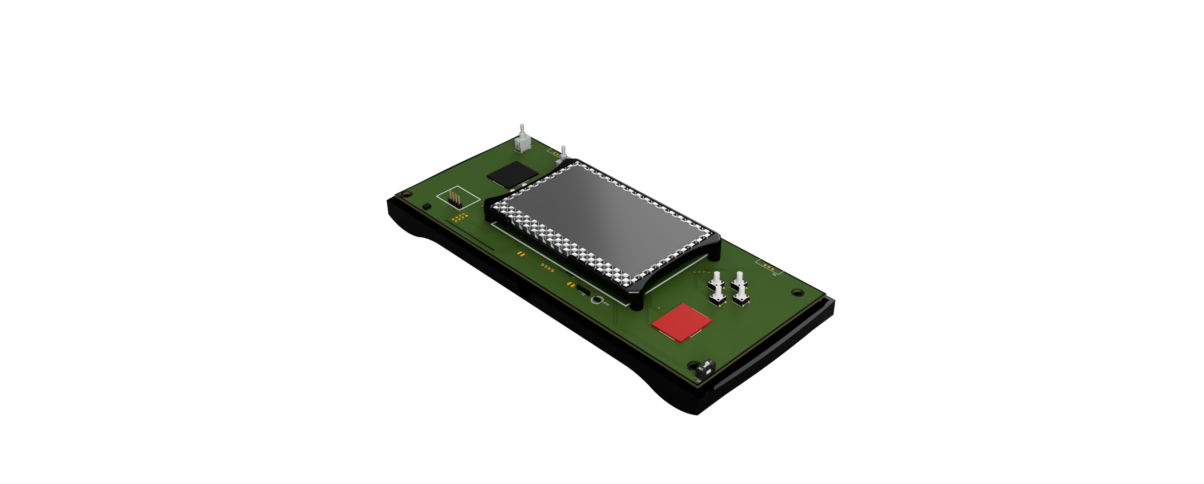

Figure 42 – V2 controller shown with LCD and body.

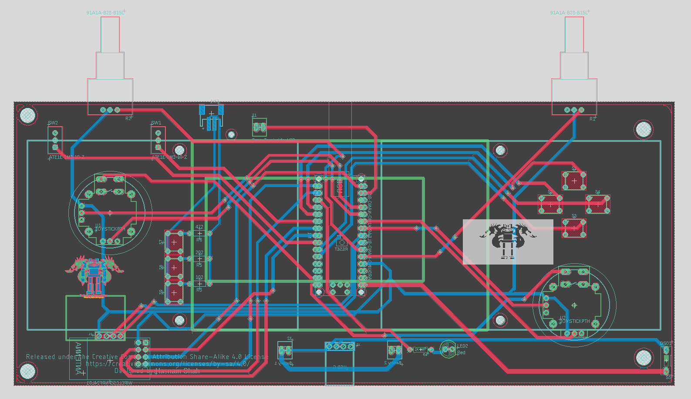

Figure 43 – V2 controller schematic pcb

The controller specifications

* Arduino Nano 33 BLE Sense, It’s a STM32 MCU.
* 2S Li-Po Cells (5Ah) @7.4V 2A
* Re-Programmable via USB-C, Charging port is also USB-C Fast charging @9V 3A
* 2.4GHz RF GT-24 for wireless communication with any device
* Bluetooth Enabled via the Arduino built in hardware.
* GY-521 for Gyroscope enabled motion (The Arduino has it built in too but to program it, this one required fewer pins)
* 4 Buttons, 2 Rocker Switches, 2 Variable Resistors (control knobs) and 2 Joysticks
* LCD Panel 480P for Live video transmission via the 5.8GHz Channel
* *THIS CONTROLLER CAN BE PROGRAMMED TO CONTROL ANY PROJECT DEVICE.*

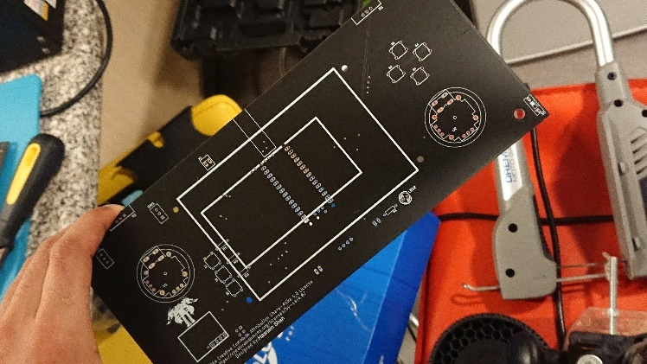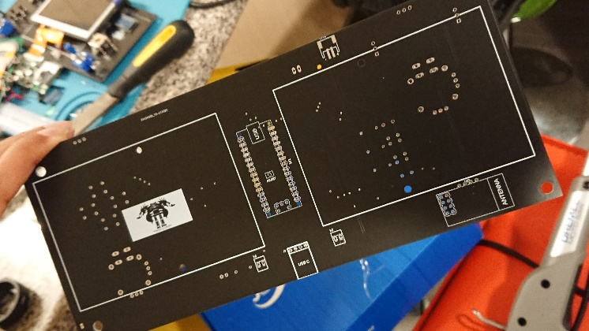

Figure 44 – PCB arrival from JCPCB

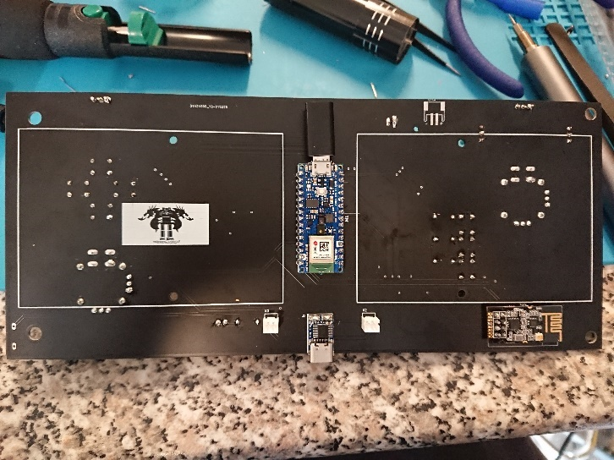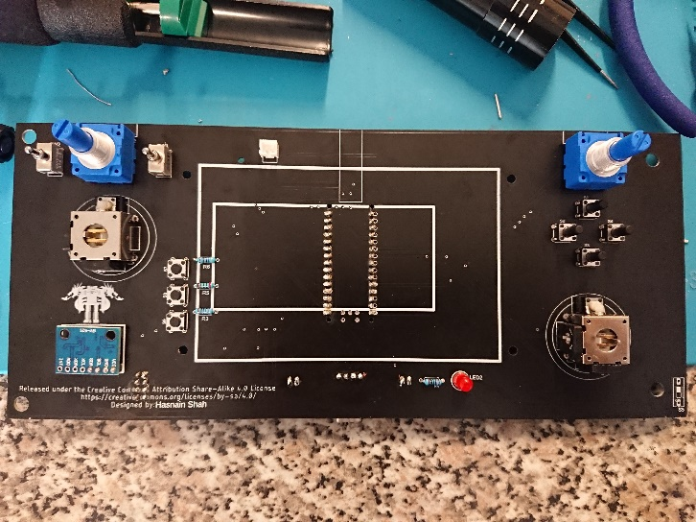

Figure 45 – PCB soldered controller

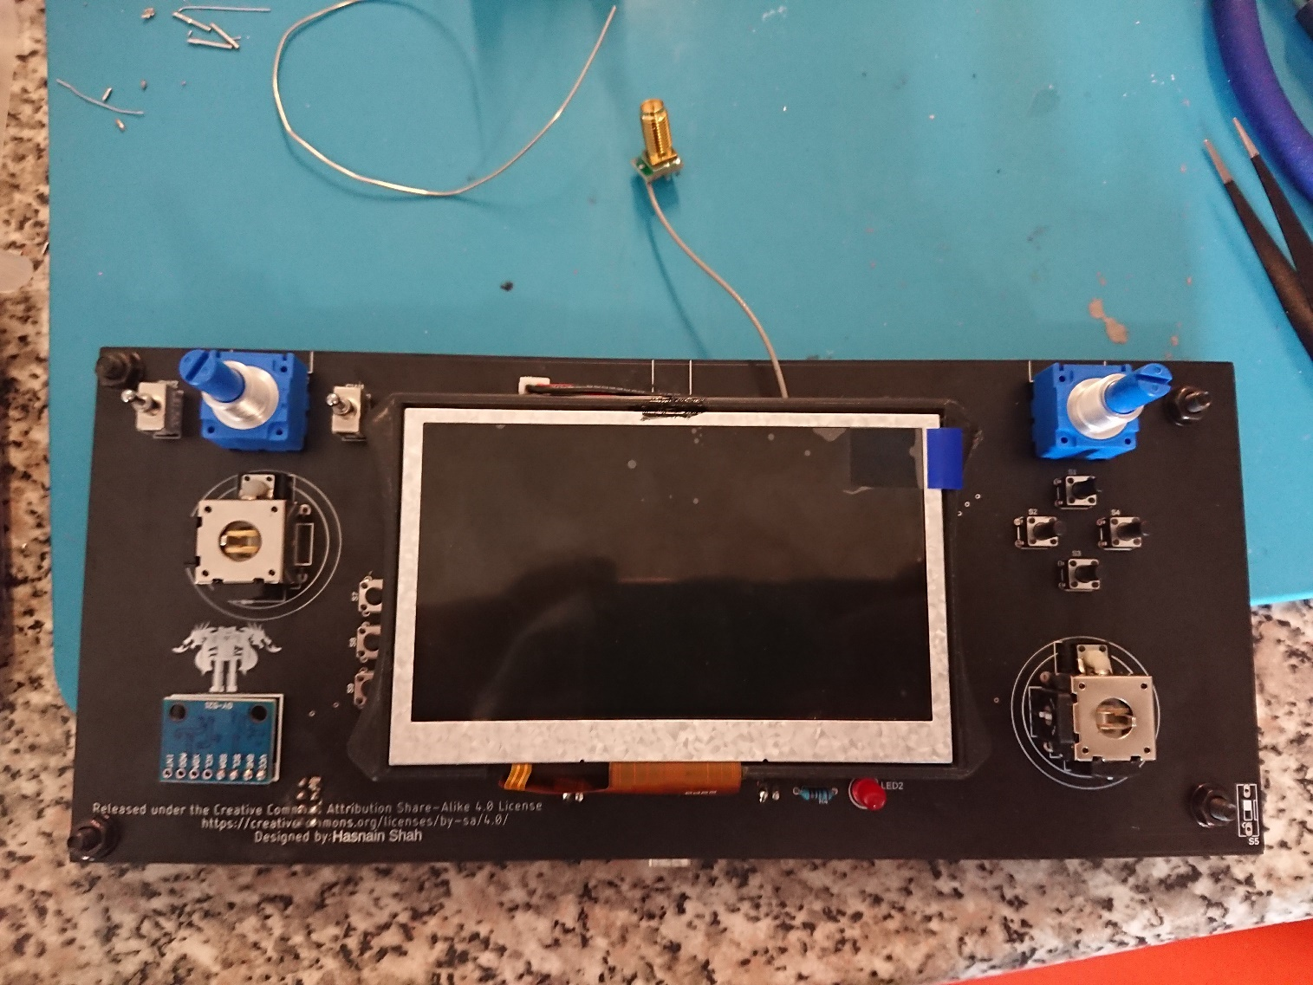

Figure 46 – Fully soldered Controller

The issue with the controller happened to be an short-circuit which was undiagnosable therefore a makeshift controller was made. Which is shown in the Video Demonstration.

### Base station

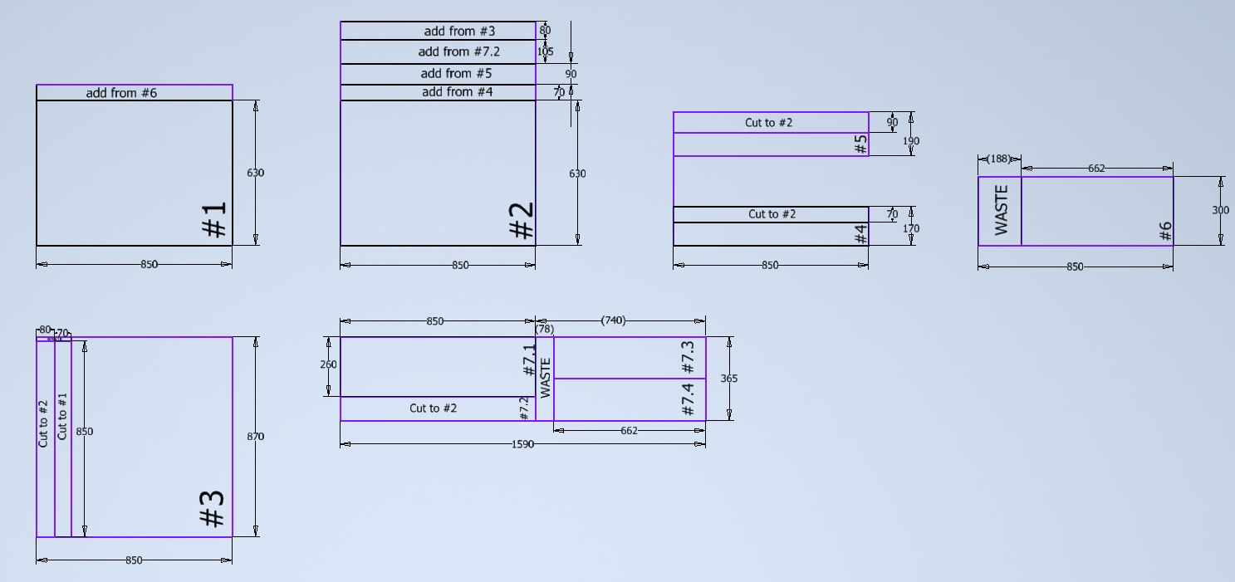

Figure 47 – Calculating size and dimension based on the Cad design.

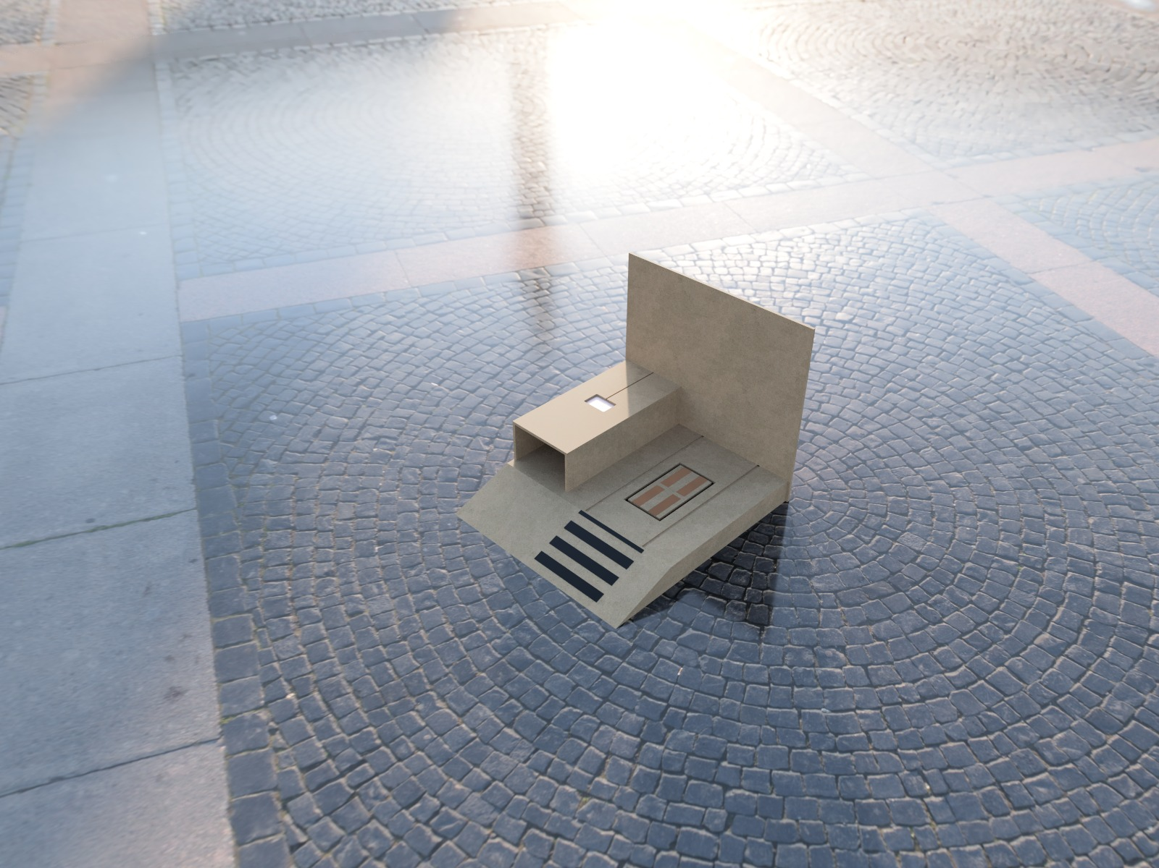

Figure 48 – Base station Final CAD design.

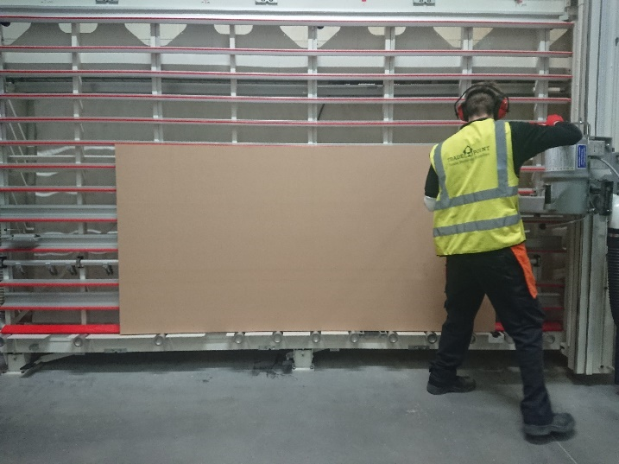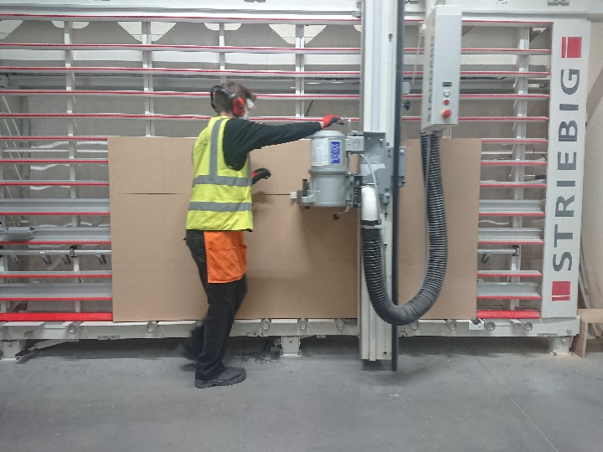

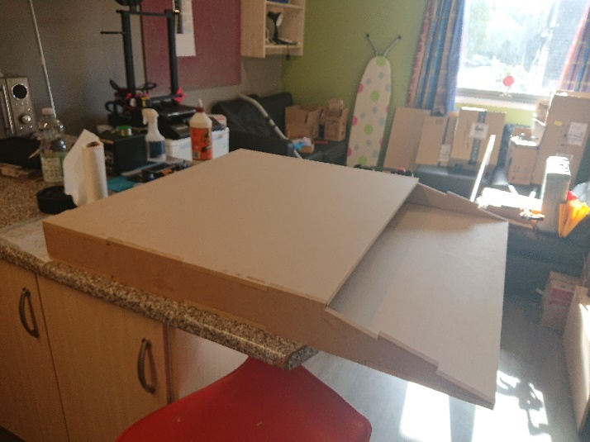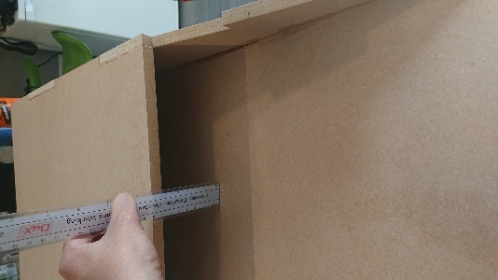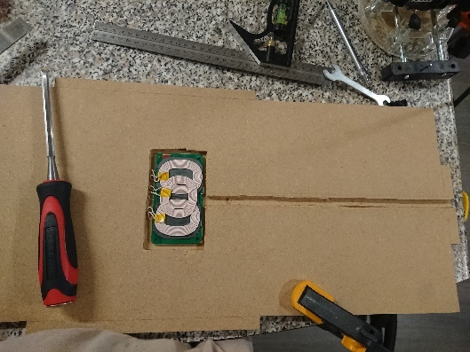

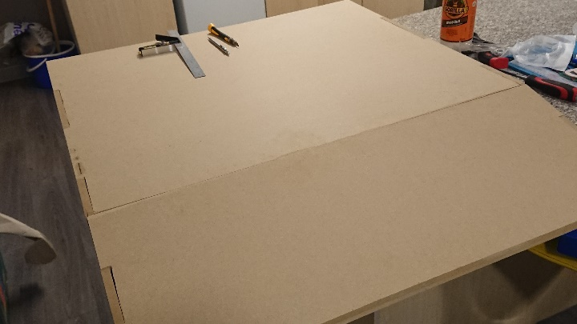

Figure 49 – Showing Completion of the Base Station.

### Power Supply of the Buggy.

See Appendix 14 for the schematic.

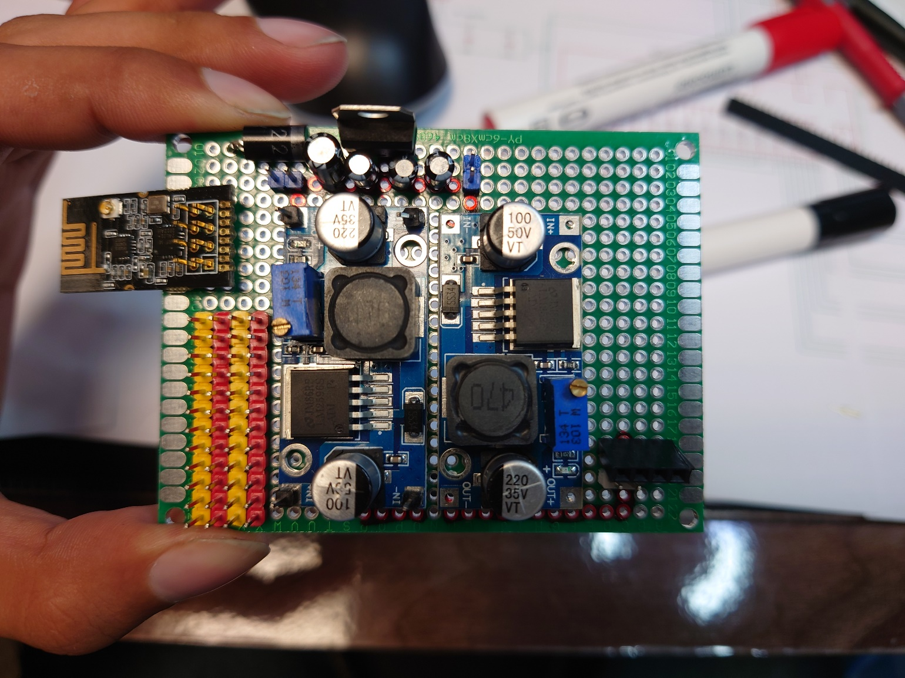

Figure 60 – Circuit shown, Requiring Input voltage of 15V+ to output a Voltage of 12V+ then 5V+. efficiency calculated to 78%.

### Suspension system – Future Improvement.

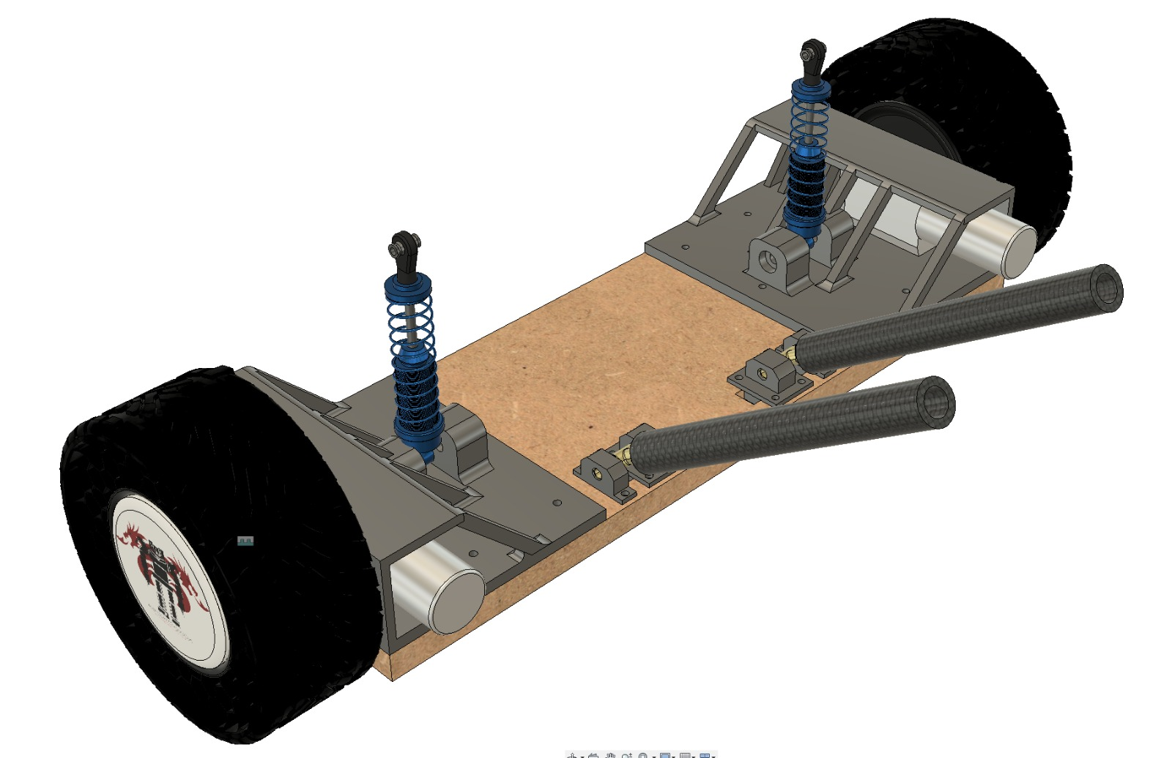

Figure 51 – showing a capable suspension system that could not be implemented due to time constraint.

# Conclusion

In conclusion, many objectives were met for this project, however due to covid situation and trial and error. A lot of the equipment and electronics malfunctioned, and replacement parts were near impossible to achieve. The prohibited access to the university facilities has set back a lot of the progress of this project. Through this project a lot has been learned, regarding gearing mechanism, RF transmit connections and so further on. The most challenging part was implementing a design that seemed possible yet required precision and effort.  
  
Due to the covid-19 disruption, delivery of parts took longer than expected. Since the lab was not available amidst covid-19. The author was left on his own in terms of machinery and instructions. However what lead to a newfound idea is to use what could be found on the local market with the possibility of home materials.

To see the success of this project, the controller required to be operated wirelessly, which as shown in the video is a completed element although minor mishap occurred and a makeshift design was introduced, the main concept is there that with 2.4GHz communication network protocol. It is possible. Another conclusively the design concept is cheaper than what is out there on the market. The market product costing £150 for a similar although limited functionality for RC drones. Whereas this one costed £99, please see appendix 6.

The SCV-E vehicle buggy also proved a success in its problem of electric vehicle possibility in the industry. The vehicle can be operated wirelessly through the 2.4GHz communication network. Has adaptable design elements that could be altered or adjusted to other devices. Fully modular concept with a removable battery design. Although it was not capable of driving on the surface due to the excessive overweight and broken motor of the vehicle. The weight was over by 3.2 kg which resulted in the motors not being able to push forward.

The crane being able to move up and down and turn. Has been great in the overall adaptive design element, however the excess weight which was uncalculated requires a much-needed improvement.  
The electromagnet was not able to lift anything more than 100g due to the electromagnetic wave interference. However, it has managed to fulfil the required mission.

The base station, although no drone was included in this project concept, it has proven that it’s not required, and the system is more feasible without it. The concept of removing the battery and charging externally is a much more romantic concept as it saves time. However, a full charging system that is already available on the current market electric vehicle can be adapted to this system at a large scale.

Overall, the idea and concept has been met and a new system that could be ideally used in the industry can be implemented, although a recommendation is to further research and improve this project. As this project is an open-source design, this allows other researchers and industry to implement it according to their requirements resulting in “no wrong answer” as it is completely adaptable.

### Future Improvements

The motor would need a much-required improvement or hardware change as the vehicle is overweight.  
The crane’s electromagnet requires much more power or a stronger electromagnet, the advertised 50N is not enough.  
  
If it wasn’t for covid-19 disruptions, the project as a whole could be much improved upon.

# Appendices

## Appendix 1 – Gantt Chart

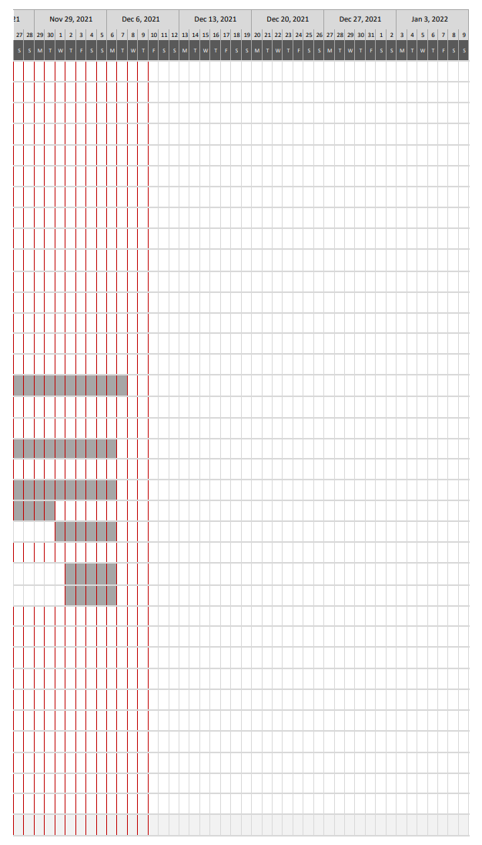

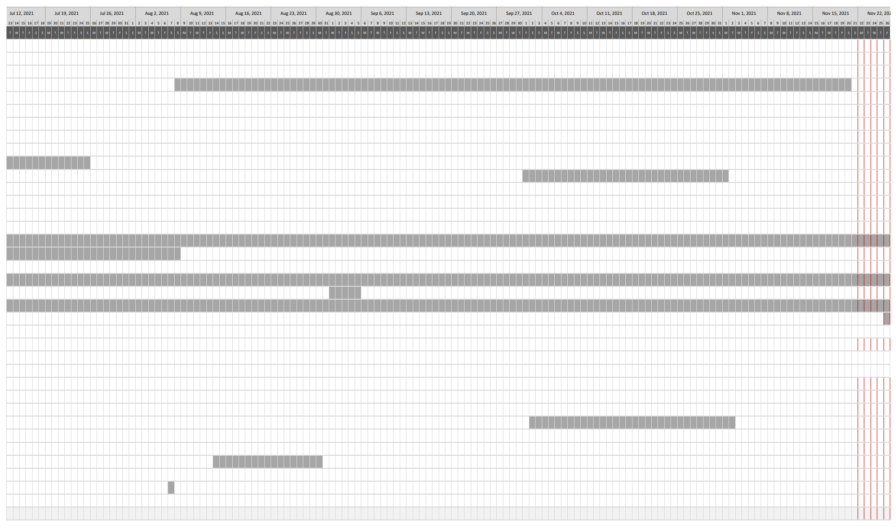

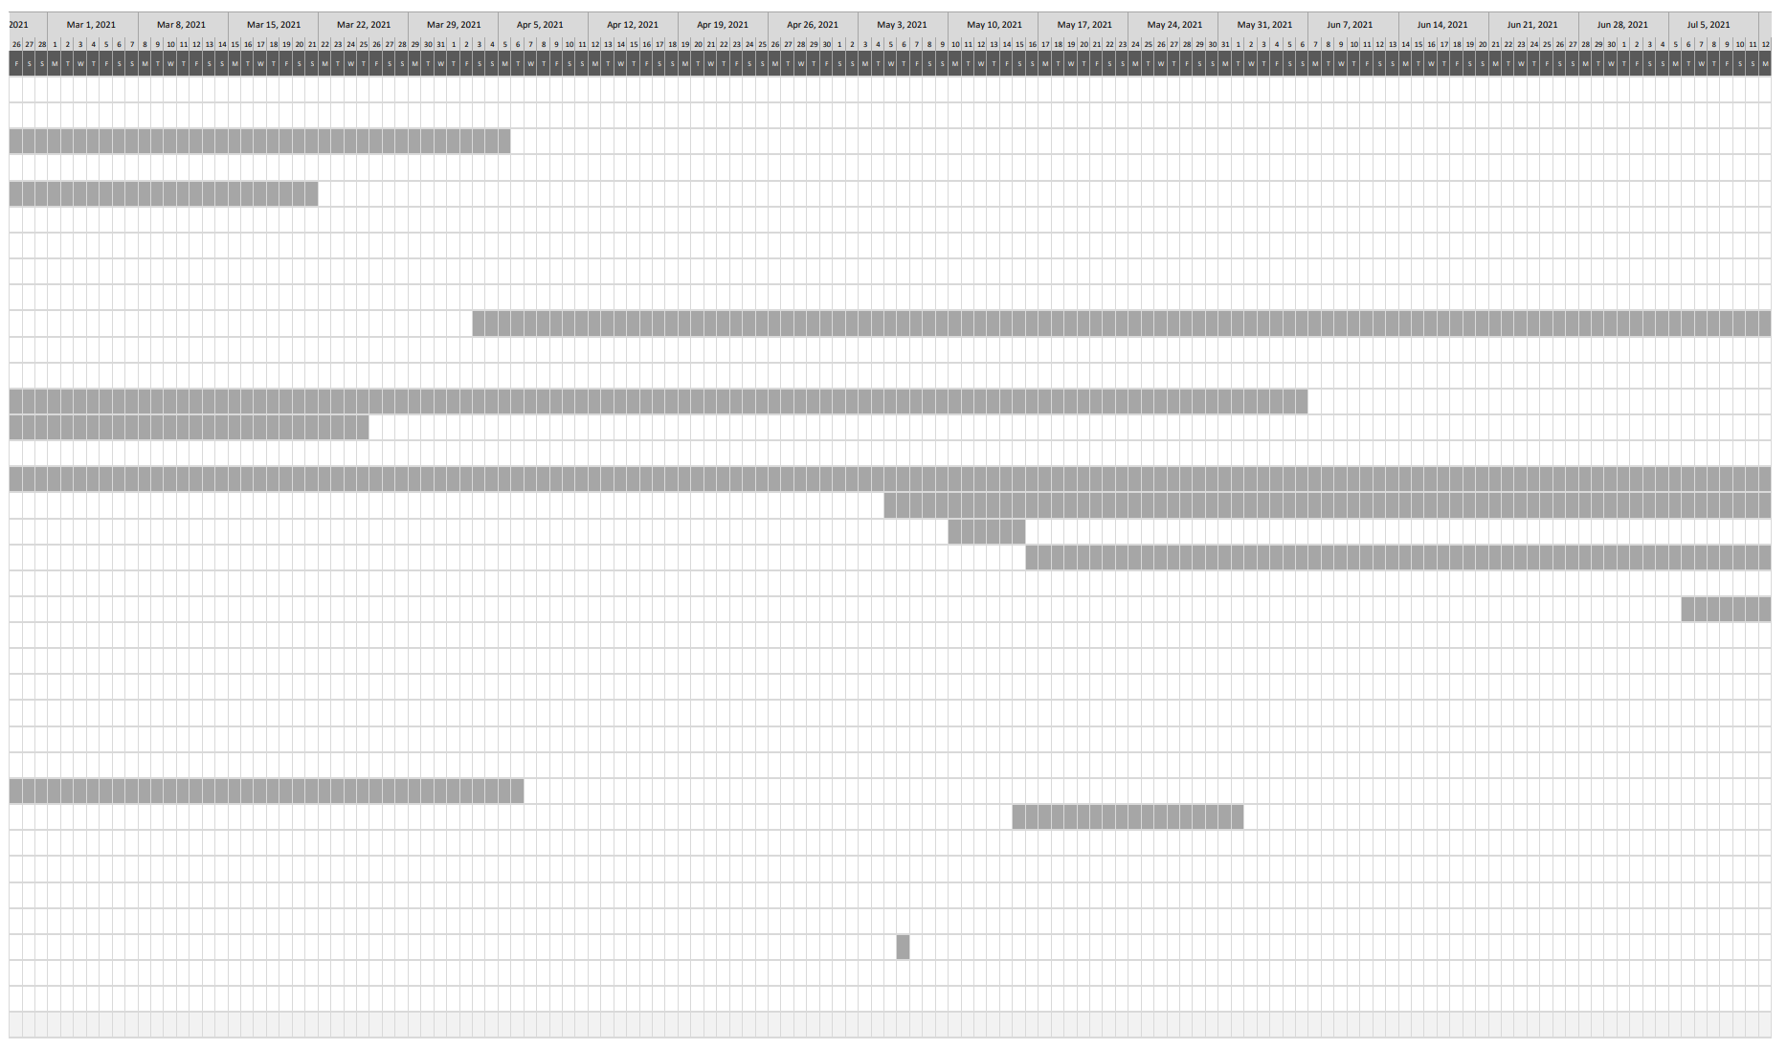

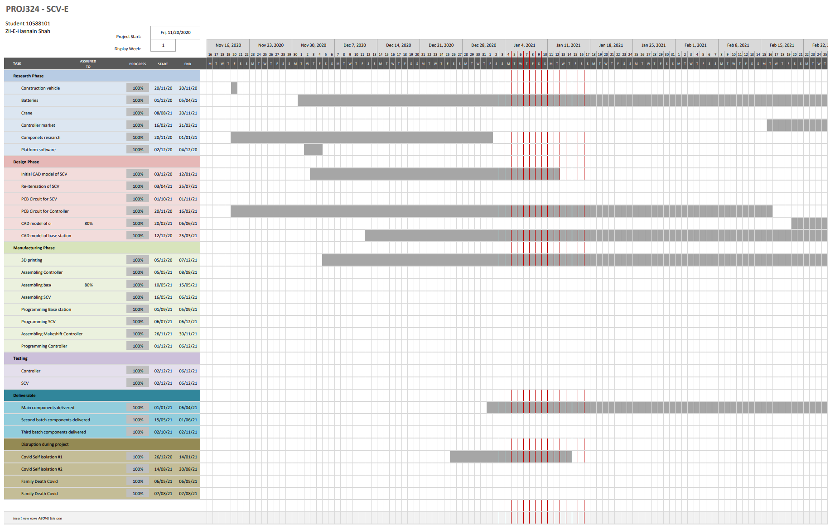

## Appendix 2 – Budget Overview

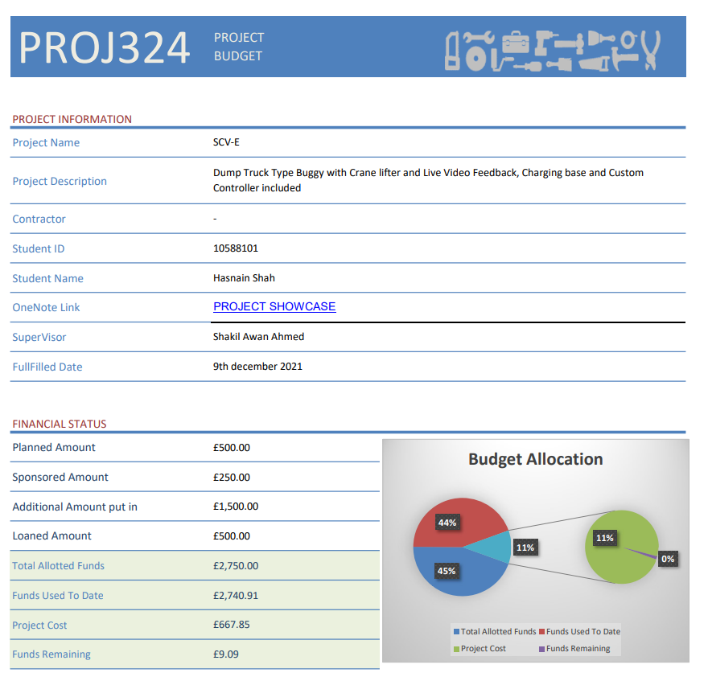

## Appendix 3 – List of expenses Equipment

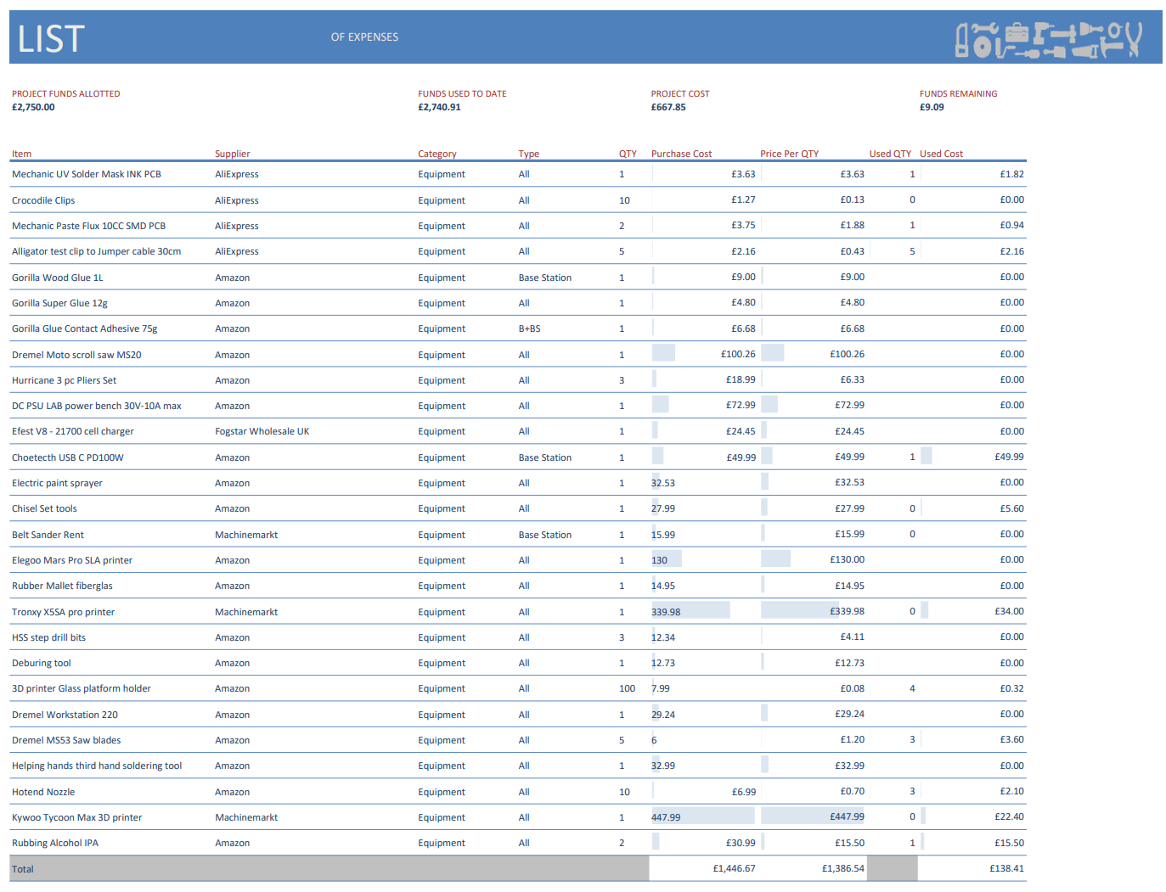

## Appendix 4 – List of expenses Materials

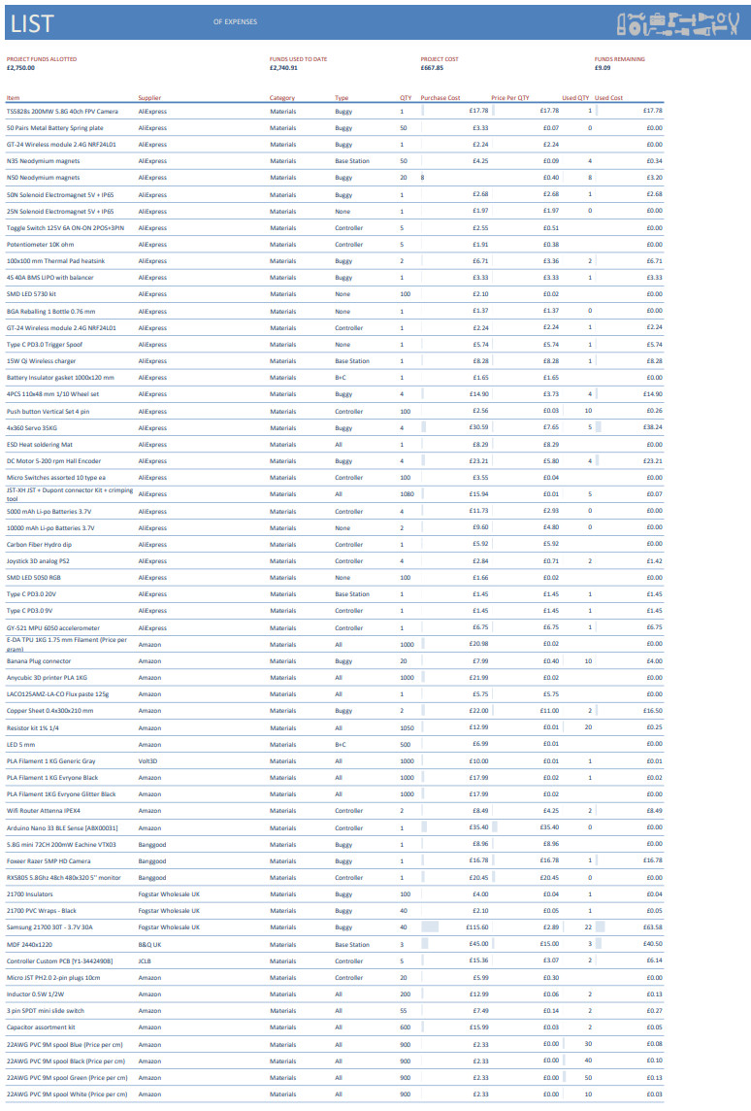

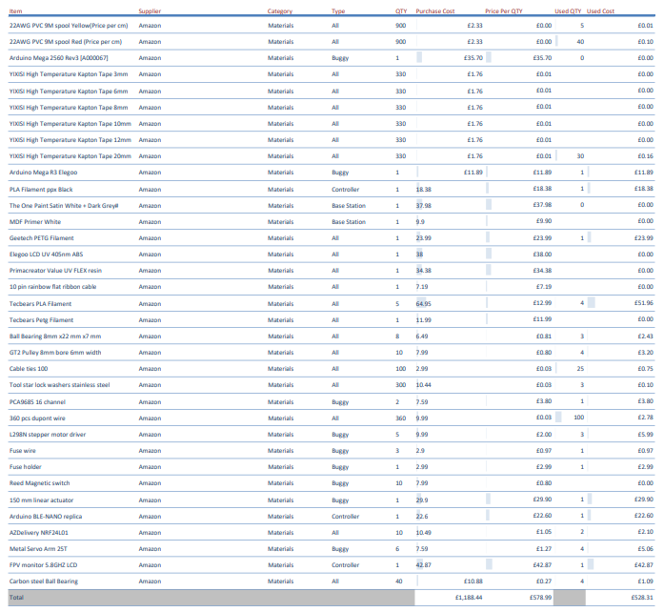

## Appendix 5 – List of expenses Buggy

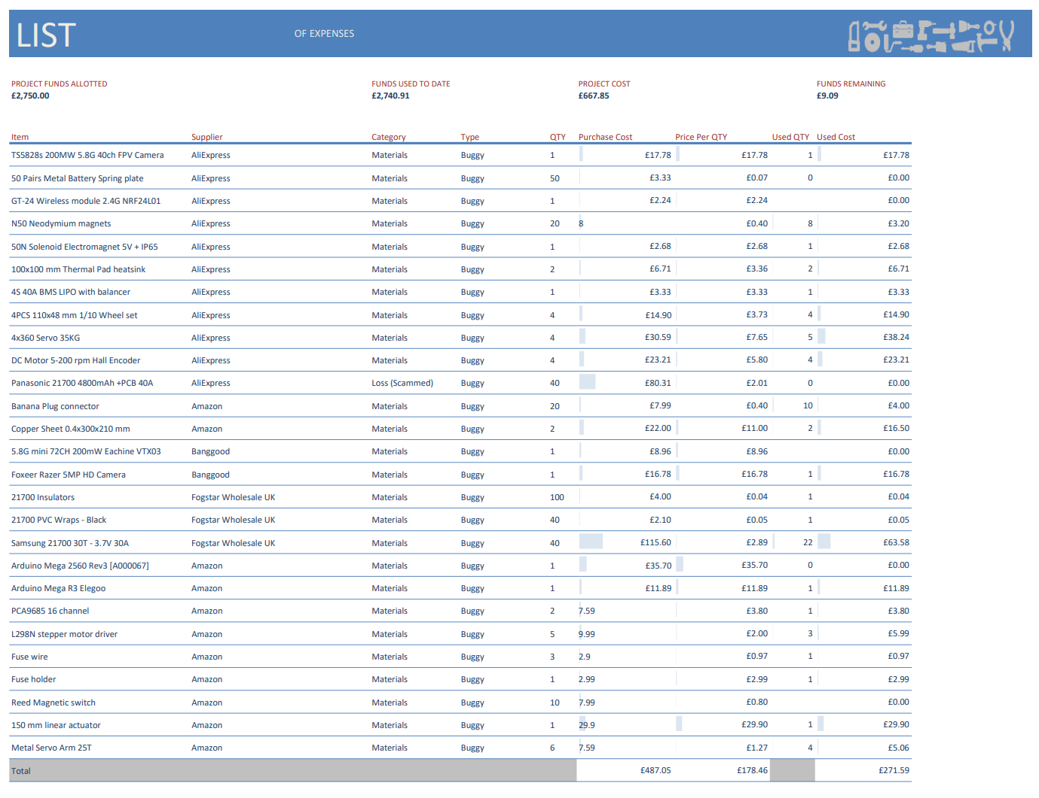

## Appendix 6 – List of expenses Controller

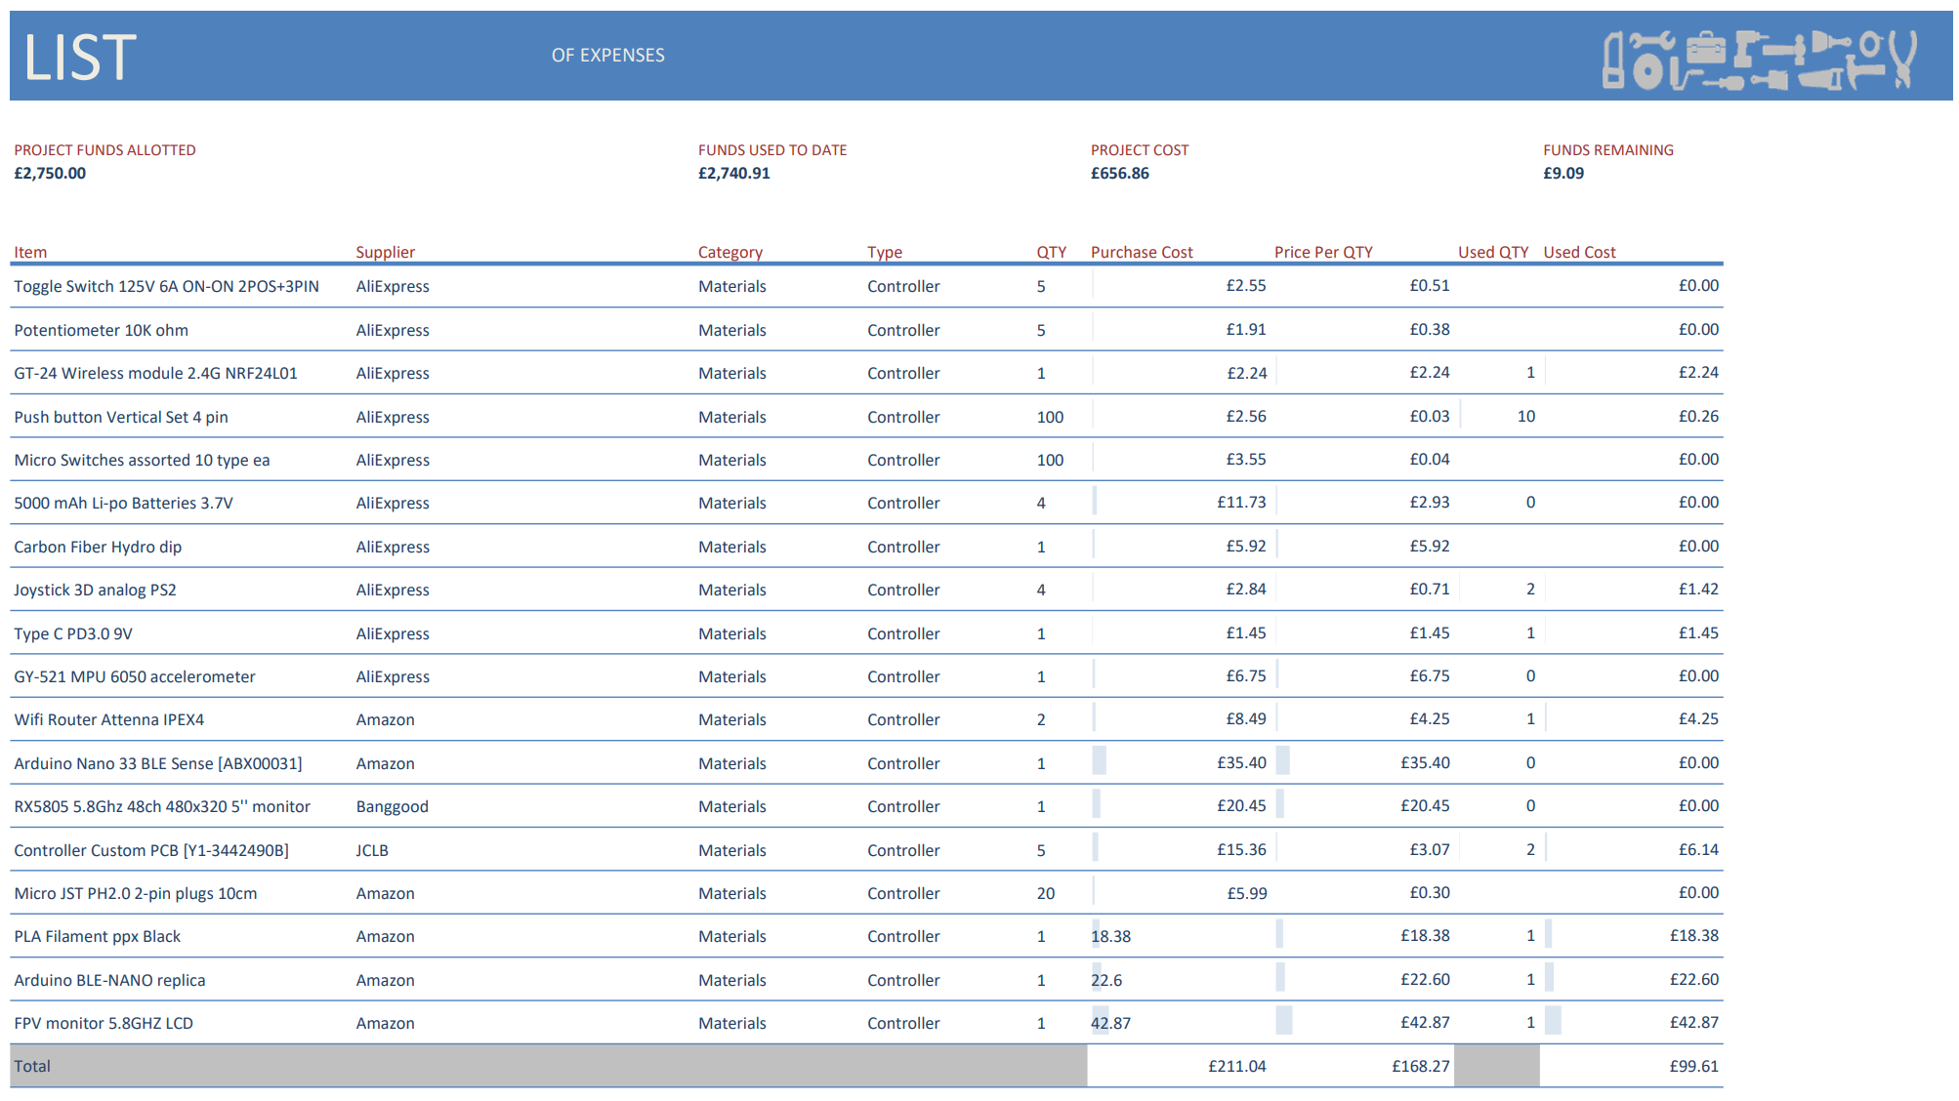

## Appendix 7 – List of expenses Base Station

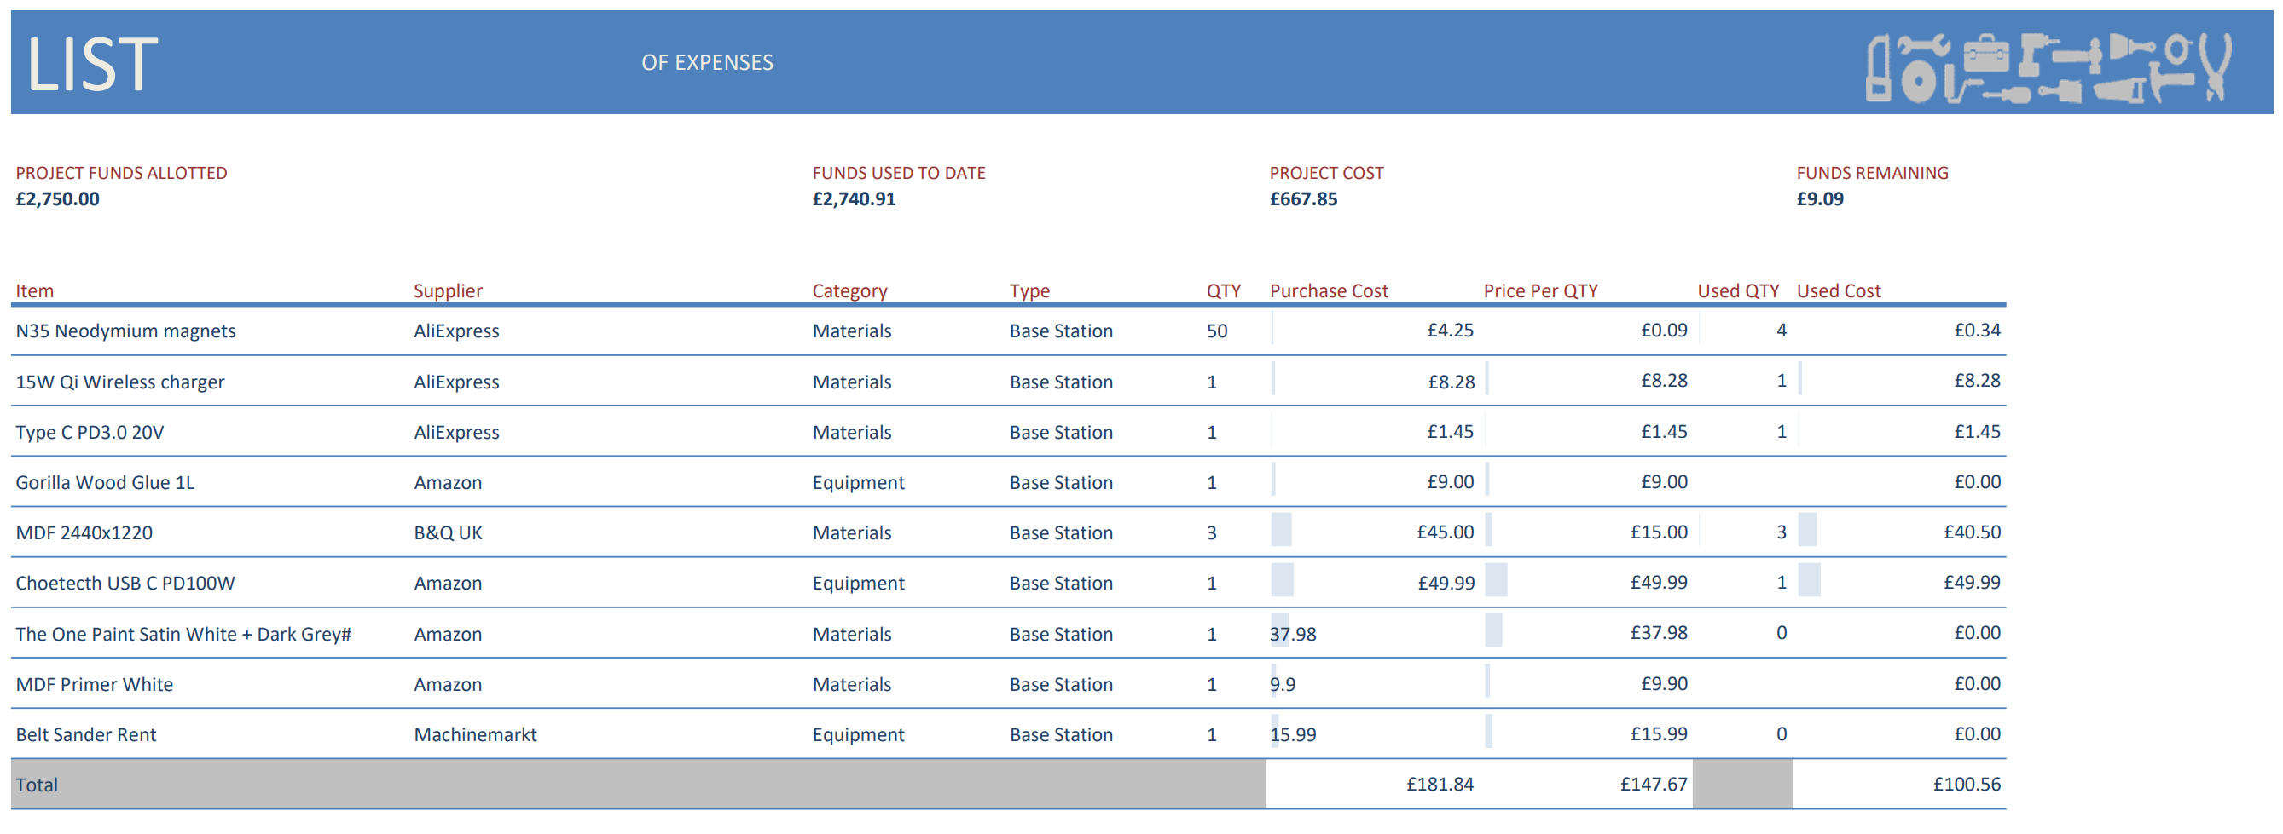

## Appendix 8 - List of expenses All

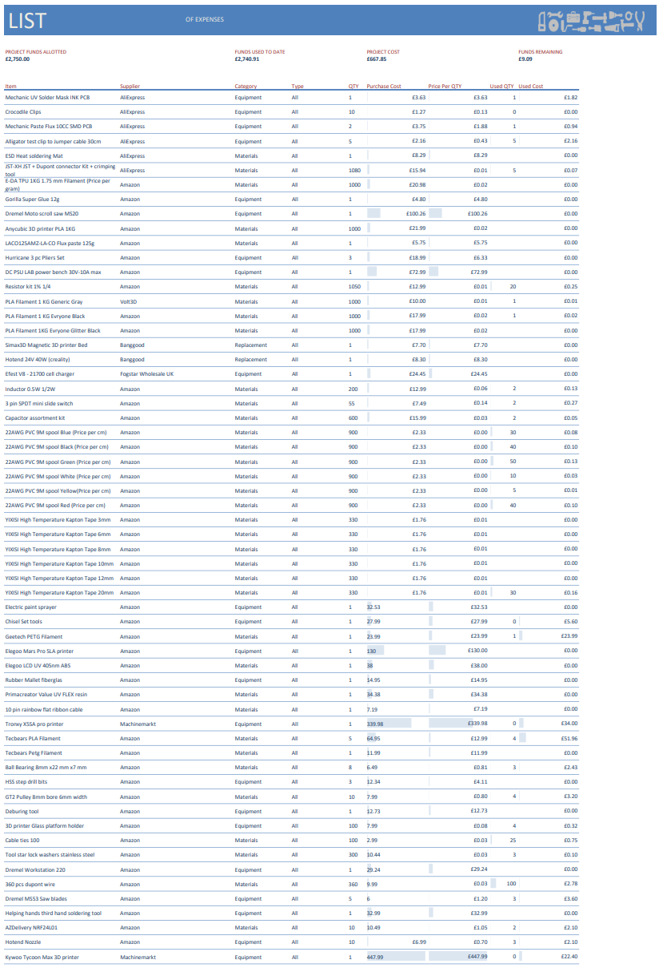

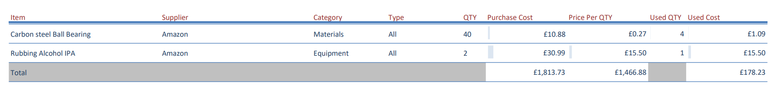

## Appendix 9 – Controller Circuit V2

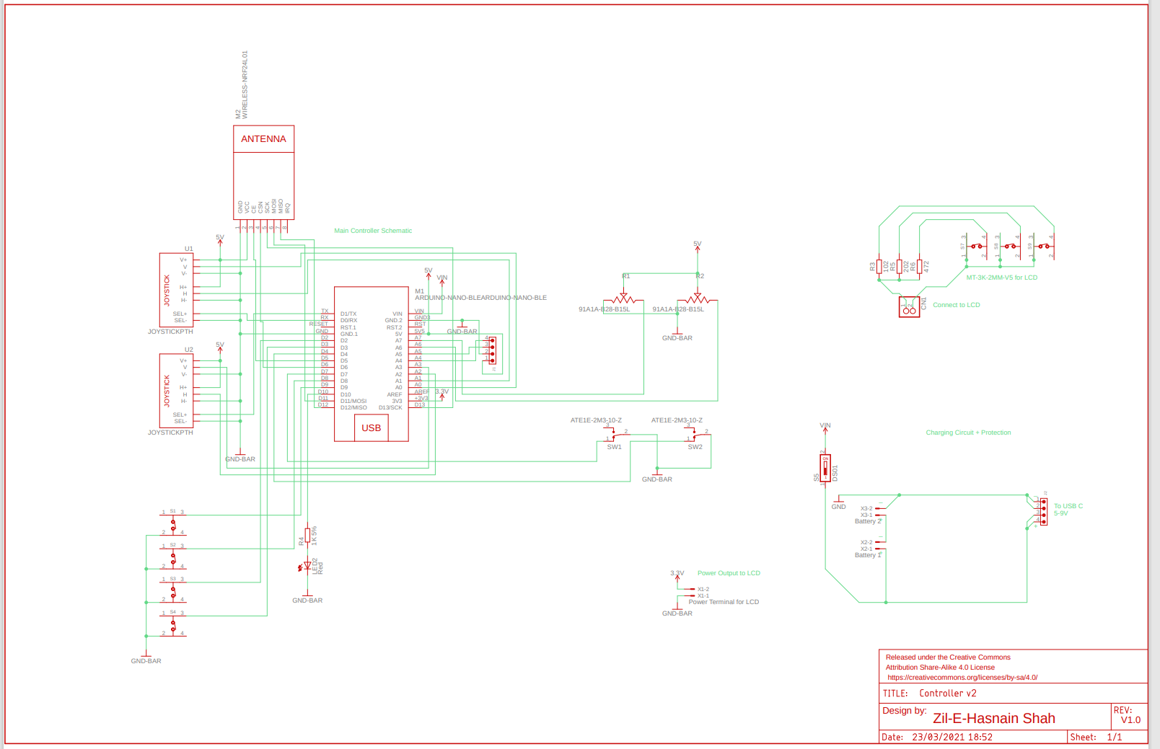

## Appendix 10 – Controller Circuit V1

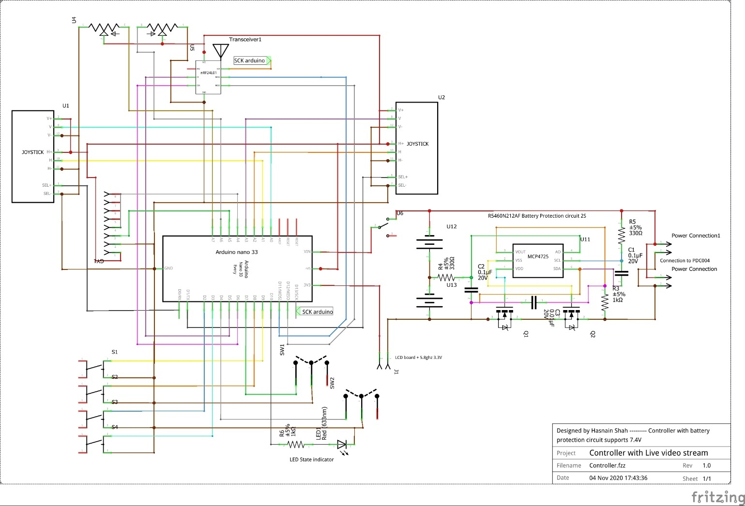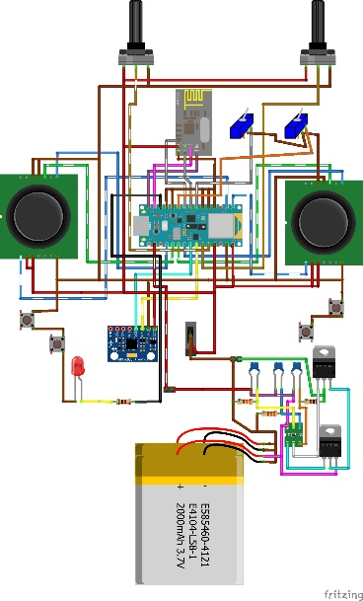

## Appendix 11 – Base Station V1

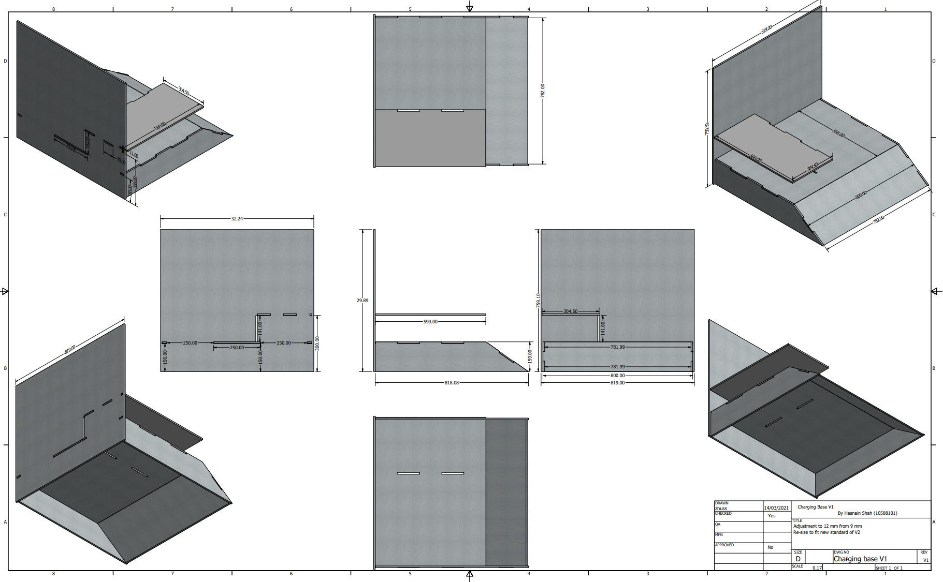

## Appendix 12 – Base Station V2

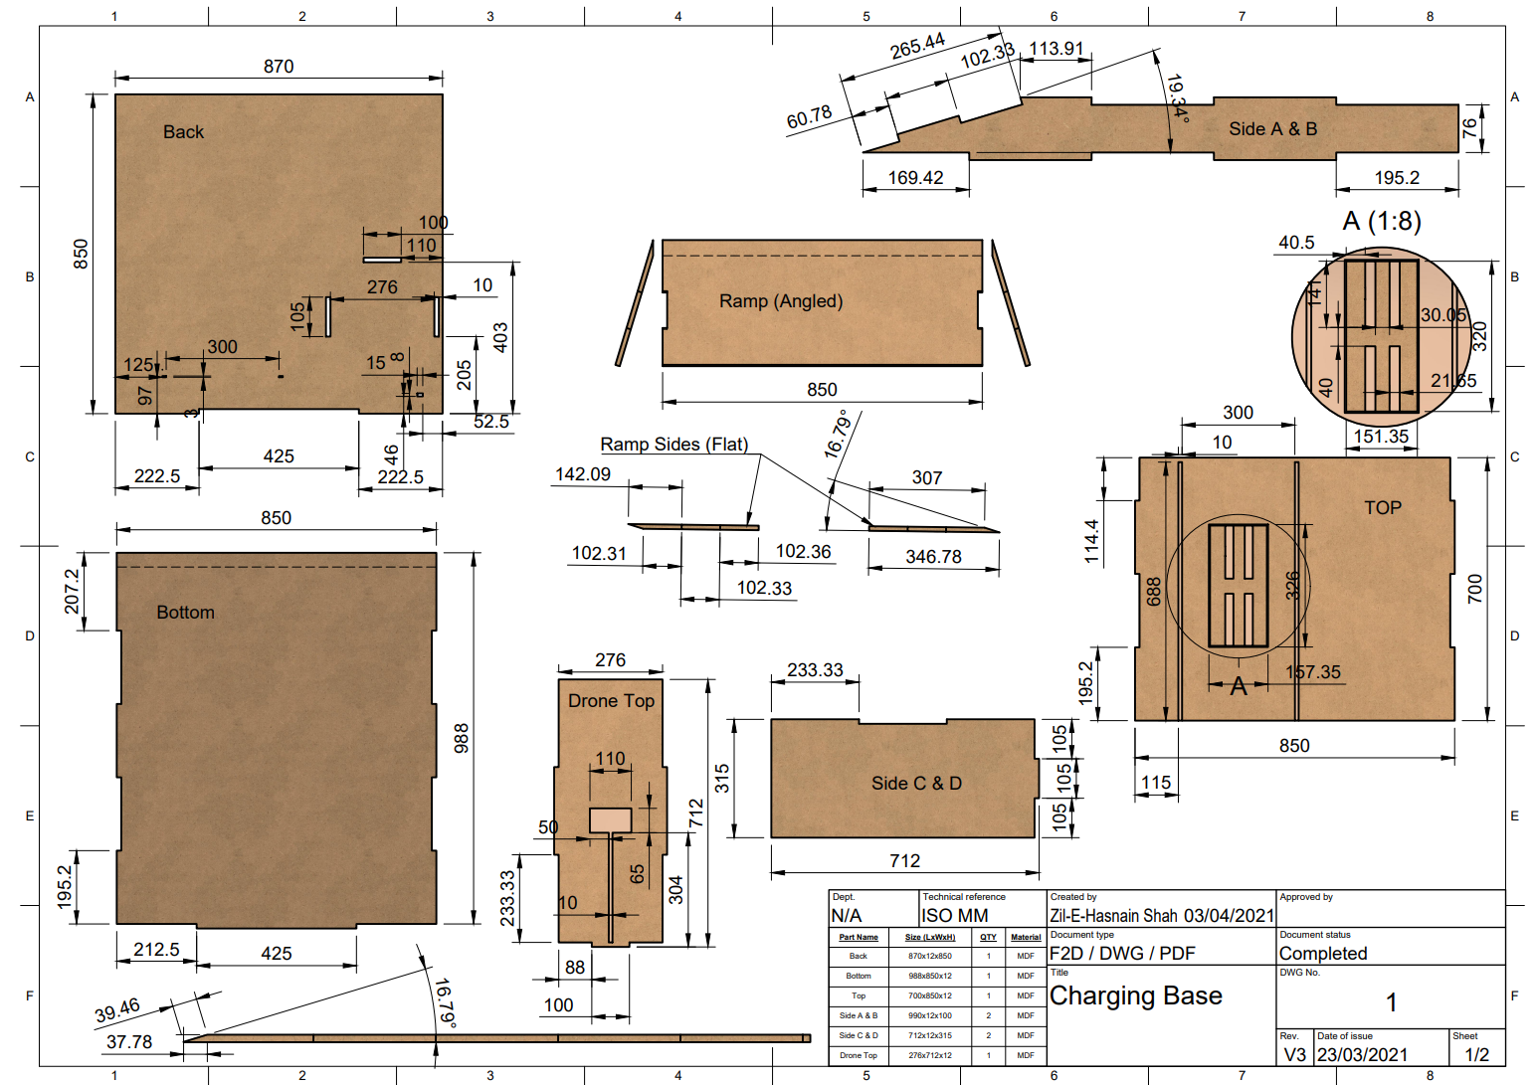

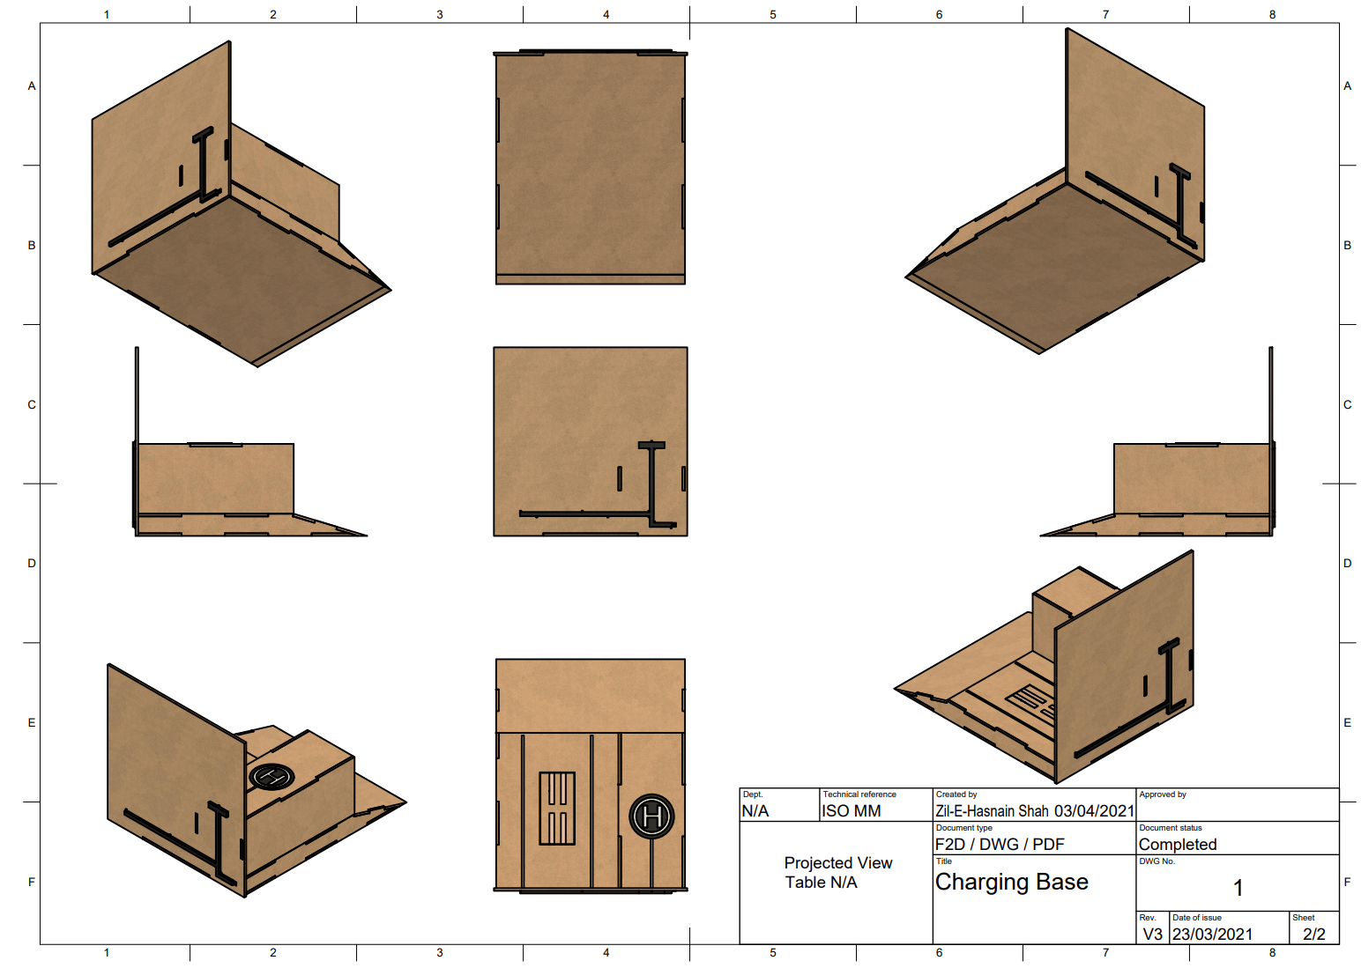

## Appendix 13 – Circuit of SCV-E

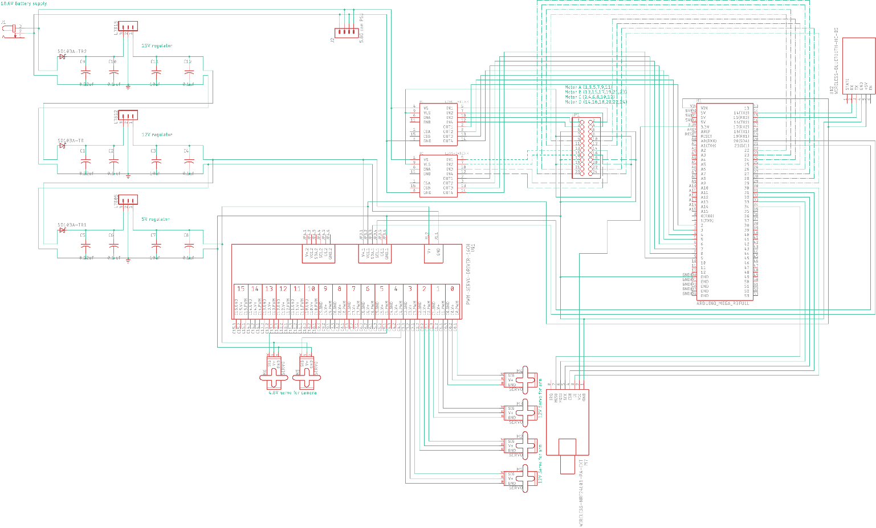

## Appendix 14 – Power Supply Board SCV-E

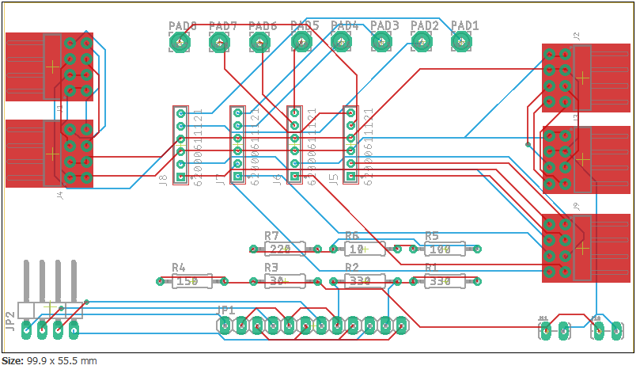

## Appendix 15 – Power Supply Schematic SCV-E

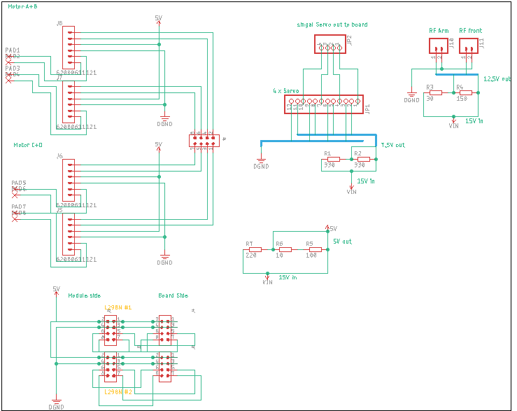

## Appendix 16 – Controller V1 Board

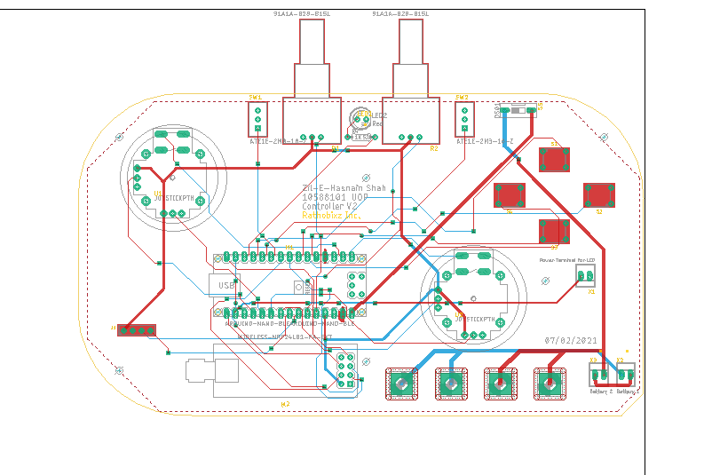

## Appendix 17 – Controller V2 Board

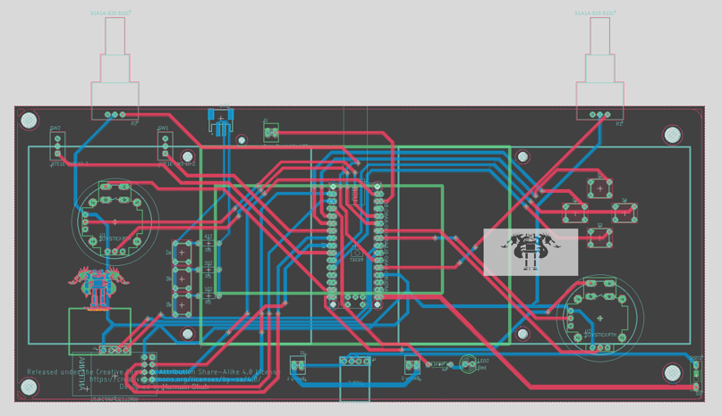

## Appendix 18 – MIT App inventor Bluetooth Controller

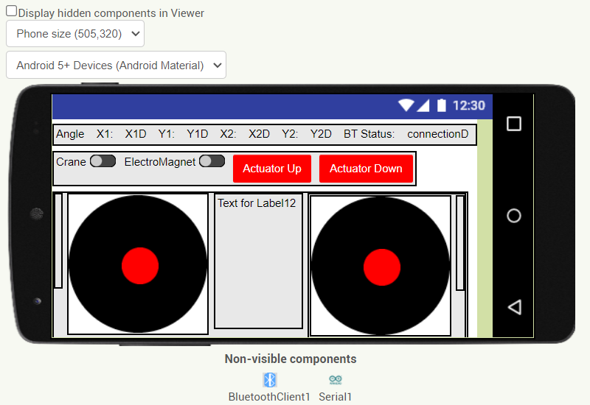

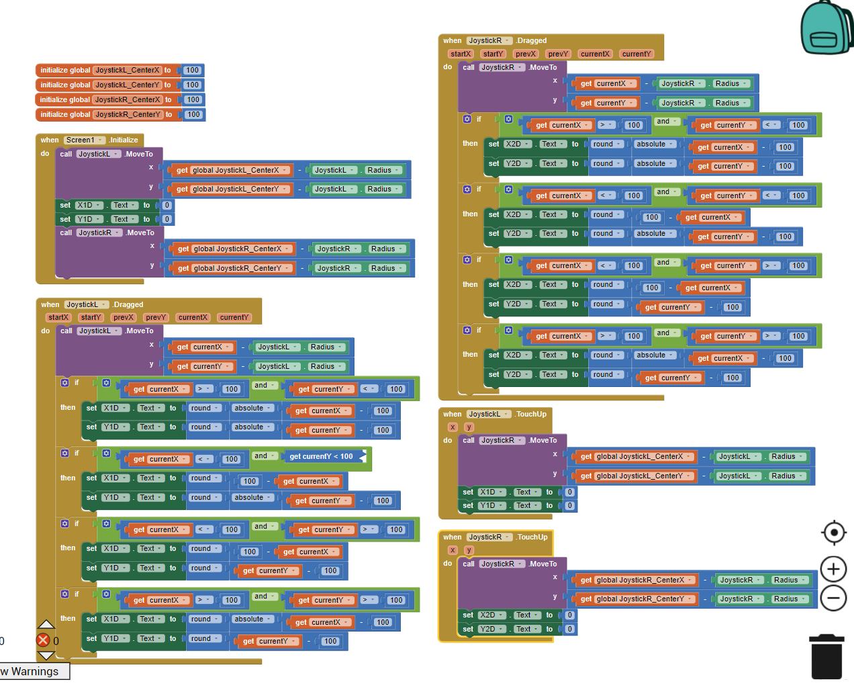

## Appendix 19 – Bluetooth program code

/*

Source code for the SCV-E Bluetooth connection.

It was not implemented due to lag communication

 ~ Zil-E-Hasnain Shah (10588101)

# License-Identifier: MIT for University of Plymouth

*/

//--------------------------------------------------

//--------------------------------------------------

#include <Arduino.h>

#include <Adafruit_PWMServoDriver.h> //https://github.com/adafruit/Adafruit-PWM-Servo-Driver-Library

String blueToothVal;           //value sent over via bluetooth

char lastValue;              //stores last state of device (on/off)

Adafruit_PWMServoDriver pca = Adafruit_PWMServoDriver(0x40);

boolean servo14 = false;

boolean servo15 = false;

void setup()

{

  Serial.begin(9600);

  Serial1.begin(9600);

  pinMode(13, OUTPUT);

  pca.begin();

  pca.setPWMFreq(60); // Analog servos run at ~60 Hz updates

}

void survoGoLeftABit(int n) {

     int  MIN_IMP = 2300;

     int  MAX_IMP = 2500;

       for (int pos = MAX_IMP; pos > MIN_IMP; pos -= 10)

        {

            pca.writeMicroseconds(n, pos);

            delay(10);

        }

       pca.setPin(n, 0, true);

}

void survoGoRightABit(int n) {

      int MIN_IMP = 500;

      int MAX_IMP = 700;

       for (int pos = MAX_IMP; pos > MIN_IMP; pos -= 10)

        {

            pca.writeMicroseconds(n, pos);

            delay(10);

        }

       pca.setPin(n, 0, true);

}

void loop()

{

  if (Serial1.available() > 0)

  {

    while(true)

     {

    blueToothVal = Serial1.readS();

    Serial.println(blueToothVal);

    if (blueToothVal == "left")

    {

      if (servo14) {

        survoGoLeftABit(14);

      }

      if (servo15) {

        survoGoLeftABit(15);

      }

    } else if (blueToothVal == "right")

    {

      if (servo14) {

        survoGoRightABit(14);

      }

      if (servo15) {

        survoGoRightABit(15);

      }

    }  else if (blueToothVal == "14")

    {

      servo14 = true;

      servo15 = false;

    } else if (blueToothVal == "15")

    {

      servo14 = false;

      servo15 = true;

    }

     else if (blueToothVal == "1415")

    {

      servo14 = true;

      servo15 = true;

    }

  }

  }

}

## Appendix 20 – Controller Code

/*

Source code for the controller.

 ~ Zil-E-Hasnain Shah (10588101)

# License-Identifier: MIT for University of Plymouth

*/

//--------------------------------------------------

//--------------------------------------------------

#include <SPI.h>

#include <RF24.h>

/**

 *  Controller mode button pins

 */

#define button1 2

#define button2 3

#define button3 4

#define button4 5

#define button5 6

/**

 * Radio setup pins and address to send the data to

 */

const byte address[6] = "00001";

RF24 radio(9, 10);

bool radioReady = false;

int currentMode = 1;

/**

 * setup analogstick/joystick pins

 */

#define joyX A0

#define joyY A1

int xValue, yValue;

void setup() {

  // Initialise Serial first

  Serial.begin(9600);  // Baud rate

  // Pin modes

  // Configure the Radio

  setupButtons();

  setupRadio();

}

void setupButtons() {

  pinMode(button1, INPUT);

  pinMode(button2, INPUT);

  pinMode(button3, INPUT);

  pinMode(button4, INPUT);

  pinMode(button5, INPUT);

}

void setupRadio() {

  int failCount = 0;

  while (!radioReady && failCount < 10) {

    radioReady = radio.begin();

    if (!radioReady) {

      failCount++;

      Serial.print("Radio Initialisation Failed ");

      Serial.print(failCount);

      Serial.println(" times.");

    }

  }

  if (!radioReady) {

    Serial.println("Radio could not be initialised!");

    return;

  } else {

    Serial.println("Radio Ready!");

  }

  radio.setPALevel(RF24_PA_MIN); // Maximum Range

  radio.openWritingPipe(address); // For Outgoing Data

  radio.stopListening();

}

void loop() {

  if (digitalRead(button1)) {

    currentMode = 1;

    Serial.println("Button 1 PRESSED");

  } else if (digitalRead(button2)) {

    currentMode = 2;

    Serial.println("Button 2 PRESSED");

  } else if (digitalRead(button3)) {

    currentMode = 3;

    Serial.println("Button 3 PRESSED");

  } else if (digitalRead(button4)) {

    currentMode = 4;

    Serial.println("Button 4 PRESSED");

  } else if (digitalRead(button5)) {

    currentMode = 5;

    Serial.println("Button 5 PRESSED");

  }

/**

 * Read the value out from the joysticks and create a command for the buggy in the following format:

 * M=1X=1Y=1

 *

 * M = 1-5

 * X = 1-9 (4 = center)

 * Y = 1-9 (4 = center)

 */

  xValue = analogRead(joyX);

  yValue = analogRead(joyY);

  int x1 = map(xValue, 0, 1023, 0, 9);  // 0 is our minimum speed and 9 is the maximam

  int y1 = map(yValue, 0, 1023, 0, 9);

  String command = "M=" + String(currentMode) + "X=" + String(x1) + "Y=" + String(y1);

  Serial.println(command);

  int command_len = command.length() + 1;

  char command_array[command_len];

  command.toCharArray(command_array, command_len);

  radio.write(&command_array, command_len);

}

## Appendix 21 – Source code for SCV-E

/*

Source code for the SCV-E.

 ~ Zil-E-Hasnain Shah (10588101)

# License-Identifier: MIT for University of Plymouth

*/

//--------------------------------------------------

//--------------------------------------------------

//Library Header Files

#include <SPI.h>

#include <nRF24L01.h>

#include <RF24.h>

#include <Adafruit_PWMServoDriver.h>

#include <Wire.h>

#include <Servo.h>

const byte address[6] = "00001"; // address of the radio to receive the data on

RF24 radio(10, 11);

bool radioReady = false;

int mode = 1;                    // The default controller mode is set to 1. This can be changed by pressing other buttons on the remote.

String directionX = "CENTRE";    // Default analog stick position on the X axis

int directionXSpeed = 0;         // The speed of that direction. e.g a bit to the left will be speed 1. More to the left will increase the speed. Max speed is 4.

String directionY = "CENTRE";    // Default analog stick position on the Y axis

int directionYSpeed = 0;         // The speed of that direction. e.g a bit downwards will be speed 1. Fully downwards stick will increase the speed. Max speed is 4.

Servo craneservo;

Servo magnetropeservo;

bool magnet_state = false; //(FALSE IS OFF)

// Components output pins on the arduino Board

#define MAGNET_INPUT 26

#define LINIER_ACTUATOR_A 36

#define LINIER_ACTUATOR_PIN_1 30

#define LINIER_ACTUATOR_PIN_2 28

//#define MOTOR_RIGHT_TOP_A 13

#define MOTOR_RIGHT_TOP_1 37

#define MOTOR_RIGHT_TOP_2 35

#define MOTOR_RIGHT_BOTTOM_1 49

#define MOTOR_RIGHT_BOTTOM_2 45

#define MOTOR_LEFT_TOP_1 43

#define MOTOR_LEFT_TOP_2 47

#define MOTOR_LEFT_BOTTOM_1 39

#define MOTOR_LEFT_BOTTOM_2 41

//Setup

int pos = 0;        // variable to store the crane servo position

int ropepos = 0;    // variable to store the magnet rope servo position

void setup() {

  // Initialise Serial first

  Serial.begin(9600);  // Baud rate

  /**

     The functions below allows to setup the components with their respective pins. It sets also the pins to their default state

  */

  setupRadio();

  setupMotors();

  setupActuator();

  setupServo();

  setupMagnet();

}

void setupServo() {

  // Setting up pins for the servos

  craneservo.attach(22);

  magnetropeservo.attach(24);

}

void setupRadio() {

  // Pin modes

  // Configure the Radio

  int failCount = 0;

  while (!radioReady && failCount < 10) {

    radioReady = radio.begin();

    if (!radioReady) {

      failCount++;

      Serial.print("Radio Initialisation Failed ");

      Serial.print(failCount);

      Serial.println(" times.");

    } else {

      Serial.println(" radio ready.");

    }

  }

  radio.openReadingPipe(0, address);   //Setting the address at which we will receive the data

  radio.setPALevel(RF24_PA_MIN);       //You can set this as minimum or maximum depending on the distance between the transmitter and receiver.

  radio.startListening();              //Setting the radio in the receiving mode

}

void setupMotors()

{

  /**

     setup motors on their respective pins and set the initial values to off

  */

  pinMode(MOTOR_RIGHT_TOP_1, OUTPUT);

  pinMode(MOTOR_RIGHT_TOP_2, OUTPUT);

  digitalWrite(MOTOR_RIGHT_TOP_1, LOW);

  digitalWrite(MOTOR_RIGHT_TOP_2, LOW);

  pinMode(MOTOR_RIGHT_BOTTOM_1, OUTPUT);

  pinMode(MOTOR_RIGHT_BOTTOM_2, OUTPUT);

  digitalWrite(MOTOR_RIGHT_BOTTOM_1, LOW);

  digitalWrite(MOTOR_RIGHT_BOTTOM_2, LOW);

  pinMode(MOTOR_LEFT_TOP_1, OUTPUT);

  pinMode(MOTOR_LEFT_TOP_2, OUTPUT);

  digitalWrite(MOTOR_LEFT_TOP_1, LOW);

  digitalWrite(MOTOR_LEFT_TOP_2, LOW);

  pinMode(MOTOR_LEFT_BOTTOM_1, OUTPUT);

  pinMode(MOTOR_LEFT_BOTTOM_2, OUTPUT);

  digitalWrite(MOTOR_LEFT_BOTTOM_1, LOW);

  digitalWrite(MOTOR_LEFT_BOTTOM_2, LOW);

}

void setupActuator()

{

  /**

    setup the actuator on the correct pins

  */

  pinMode(LINIER_ACTUATOR_A, OUTPUT);

  pinMode(LINIER_ACTUATOR_PIN_1, OUTPUT);

  pinMode(LINIER_ACTUATOR_PIN_2, OUTPUT);

  digitalWrite(LINIER_ACTUATOR_PIN_1, LOW);

  digitalWrite(LINIER_ACTUATOR_PIN_2, LOW);

}

void setupMagnet()

{

  pinMode(MAGNET_INPUT, OUTPUT);

}

void loop()

{

  readCommandsFromRadio();

  delay(5);

  // For debugging persos to understand what is being received from the controller

  printControllerValues();

  // Allow only one mode at a time because of a single analog stick. mode will be set depending on what is received from the controller

  if (mode == 1) {

    controlBuggy();

  } else if (mode == 2) {

    controlCraneArm();

  } else if (mode == 3) {

    controlCraneHeight();

  } else if (mode == 4) {

    controlCraneRope();

  } else if (mode == 5) {

    toggleMagnet();

  }

}

void toggleMagnet() {

   // If magenet_state = false (off) turn it on. Else turn it off

    if (magnet_state = false) {

      magnet_state = true;

      digitalWrite(MAGNET_INPUT, HIGH);

    } else {

      magnet_state = false;

      digitalWrite(MAGNET_INPUT, LOW);

    }

}

void controlCraneArm() {

  if (directionY == "UP") {

    // Telling the servo to go up a bit

    for (int x = 0; x < 10; x++) {

      pos = pos + 1;

      craneservo.write(pos);

      Serial.println("Crane Servo Up");

      Serial.println(pos);

      delay(20);

    }

  } else if (directionY == "DOWN") {

     // Telling the crane servo to go down

    for (int y = 10; y > 0; y--) {

      pos = pos - 1;

      craneservo.write(pos);

      Serial.println("Crane Servo Down");

      Serial.println(pos);

      delay(20);

    }

  }

}

void controlCraneRope() {

      // Telling the servo to go up a bit

  if (directionY == "UP") {

    for (int x = 0; x < 10; x++) {

      ropepos = ropepos + 1;

      magnetropeservo.write(ropepos);

      Serial.println("UP");

      Serial.println(ropepos);

      delay(20);

    }

  } else if (directionY == "DOWN") {

      // Telling the crane servo to go down

    for (int y = 10; y > 0; y--) {

      ropepos = ropepos - 1;

      magnetropeservo.write(ropepos);

      delay(20);

      Serial.println("Down");

      Serial.println(ropepos);

    }

  }

}

void controlCraneHeight() {

  if (directionY == "UP") {

    pinMode(LINIER_ACTUATOR_A, HIGH);

    digitalWrite(LINIER_ACTUATOR_PIN_1, HIGH);

    digitalWrite(LINIER_ACTUATOR_PIN_2, LOW);

    delay(20);

  } else if (directionY == "DOWN") {

    pinMode(LINIER_ACTUATOR_A, HIGH);

    digitalWrite(LINIER_ACTUATOR_PIN_1, LOW);

    digitalWrite(LINIER_ACTUATOR_PIN_2, HIGH);

    delay(20);

  } else {

    pinMode(LINIER_ACTUATOR_A, LOW);

    digitalWrite(LINIER_ACTUATOR_PIN_1, LOW);

    digitalWrite(LINIER_ACTUATOR_PIN_2, LOW);

  }

}

void controlBuggy() {

  /**

   * The movement of the buggy works like as a tank. e.g to go right we go forwards with the left motors and backwards with the right ones.

   */

  if (directionX == "LEFT") {

    forwardRightMotors();

    backwardsLeftMotors();

    delay(20);

  } else if (directionX == "RIGHT") {

    backwardsRightMotors();

    forwardLeftMotors();

    delay(20);

  } else if (directionY == "UP") {

    forwardRightMotors();

    forwardLeftMotors();

    delay(20);

  } else if (directionY == "DOWN") {

    backwardsRightMotors();

    backwardsLeftMotors();

    delay(20);

  } else {

    /**

     * if no direction is give we put it to a stop

     */

    digitalWrite(MOTOR_RIGHT_TOP_1, LOW);

    digitalWrite(MOTOR_RIGHT_TOP_2, LOW);

    digitalWrite(MOTOR_RIGHT_BOTTOM_1, LOW);

    digitalWrite(MOTOR_RIGHT_BOTTOM_2, LOW);

    digitalWrite(MOTOR_LEFT_TOP_1, LOW);

    digitalWrite(MOTOR_LEFT_TOP_2, LOW);

    digitalWrite(MOTOR_LEFT_BOTTOM_1, LOW);

    digitalWrite(MOTOR_LEFT_BOTTOM_2, LOW);

  }

}

//directional code for motors

void forwardRightMotors() {

  digitalWrite(MOTOR_RIGHT_TOP_1, LOW);

  digitalWrite(MOTOR_RIGHT_TOP_2, HIGH);

  digitalWrite(MOTOR_RIGHT_BOTTOM_1, LOW);

  digitalWrite(MOTOR_RIGHT_BOTTOM_2, HIGH);

}

//directional code for motors

void forwardLeftMotors() {

  digitalWrite(MOTOR_LEFT_TOP_1, LOW);

  digitalWrite(MOTOR_LEFT_TOP_2, HIGH);

  digitalWrite(MOTOR_LEFT_BOTTOM_1, LOW);

  digitalWrite(MOTOR_LEFT_BOTTOM_2, HIGH);

}

//directional code for motors

void backwardsRightMotors() {

  digitalWrite(MOTOR_RIGHT_TOP_1, HIGH);

  digitalWrite(MOTOR_RIGHT_TOP_2, LOW);

  digitalWrite(MOTOR_RIGHT_BOTTOM_1, HIGH);

  digitalWrite(MOTOR_RIGHT_BOTTOM_2, LOW);

}

//directional code for motors

void backwardsLeftMotors() {

  digitalWrite(MOTOR_LEFT_TOP_1, HIGH);

  digitalWrite(MOTOR_LEFT_TOP_2, LOW);

  digitalWrite(MOTOR_LEFT_BOTTOM_1, HIGH);

  digitalWrite(MOTOR_LEFT_BOTTOM_2, LOW);

}

void readCommandsFromRadio() {

  if (radio.available())              //Looking for the data.

  {

    char text[32] = "";                 //Saving the incoming data

    radio.read(&text, sizeof(text));

    String stringCommand = String(text);

    /**

     * Only set the mode if the command start with an M.

     * The controller send the command in the following format M=1X=1Y=1

     *

     * M can be from 1 to 5 which stand for MODE

     * X = the potensiometer value from the analog stick. Values can be 1-9 (4 = CENTER)

     * Y = the potensiometer value from the analog stick. Values can be 1-9 (4 = CENTER)

     */

    if (stringCommand.charAt(0) == 'M') {

      // MODE

      setMode(stringCommand.charAt(2) - '0'); // Read the THIRD charactar of the command.  "- '0'" is to convert the charactar into an integer

      setDirectionAndSpeedX((stringCommand.charAt(5) - '0')); // Read the 6TH charactar of the command.  "- '0'" is to convert the charactar into an integer

      setDirectionAndSpeedY(stringCommand.charAt(8) - '0'); //Read the 9TH

    }

  }

}

void setMode(int mode) {

  mode = mode;

}

void setDirectionAndSpeedX(int x) {

  /**

   *  The analog sticks potentio meters send a value from 1-9 and. 4 is the centre value.

   *  Set the speed and the direction based on the value

   */

  if (x > 4) {

    directionX = "LEFT";

    directionXSpeed = map(x, 4, 9, 0, 4);

  } else if (x < 4)  {

    directionX = "RIGHT";

    directionXSpeed = map(x, 4, 0, 0, 4);

  } else {

    directionX = "CENTRE";

    directionXSpeed = 0;

  }

  delay(20);

}

void setDirectionAndSpeedY(int y) {

    /**

   *  The analog sticks potentio meters send a value from 1-9 and. 4 is the centre value.

   *  Set the speed and the direction based on the value

   */

  if (y > 4) {

    directionY = "UP";

    directionYSpeed = map(y, 4, 9, 0, 4);

  } else if (y < 4)  {

    directionY = "DOWN";

    directionYSpeed = map(y, 4, 0, 0, 4);

  } else {

    directionY = "CENTRE";

    directionYSpeed = 0;

  }

  delay(20);

}

void printControllerValues() {

  Serial.println("MODE: " + String(mode) + " Direction: " + directionY + directionX + " XSpeed: " + directionXSpeed + " YSpeed: " + directionYSpeed);

}

## Appendix 22 – Source code on GitHub

<https://github.com/Hiro-Vasilias/SCV-E>

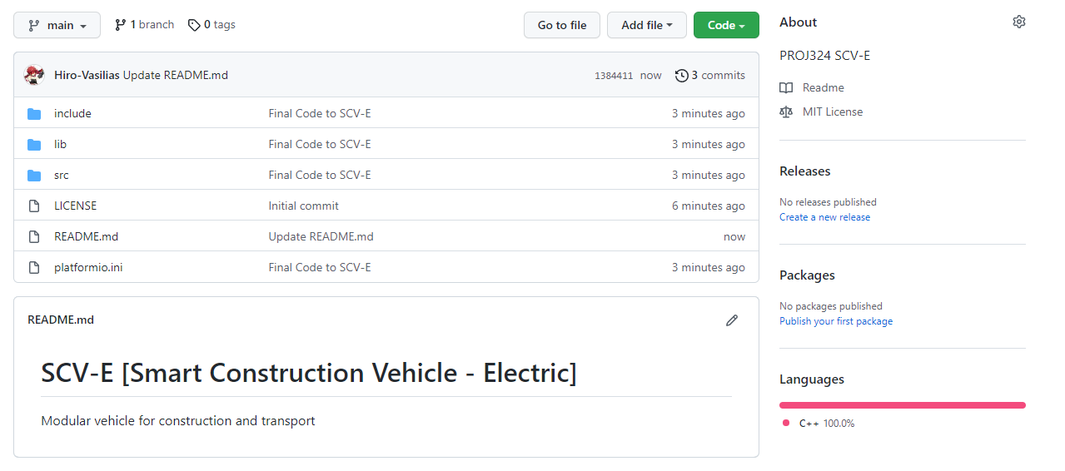

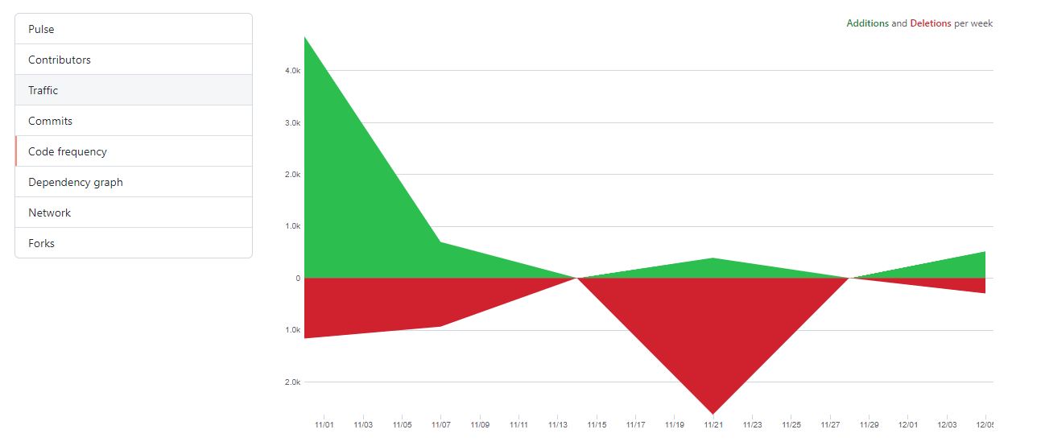

## Appendix 23 – Motor gear broken.

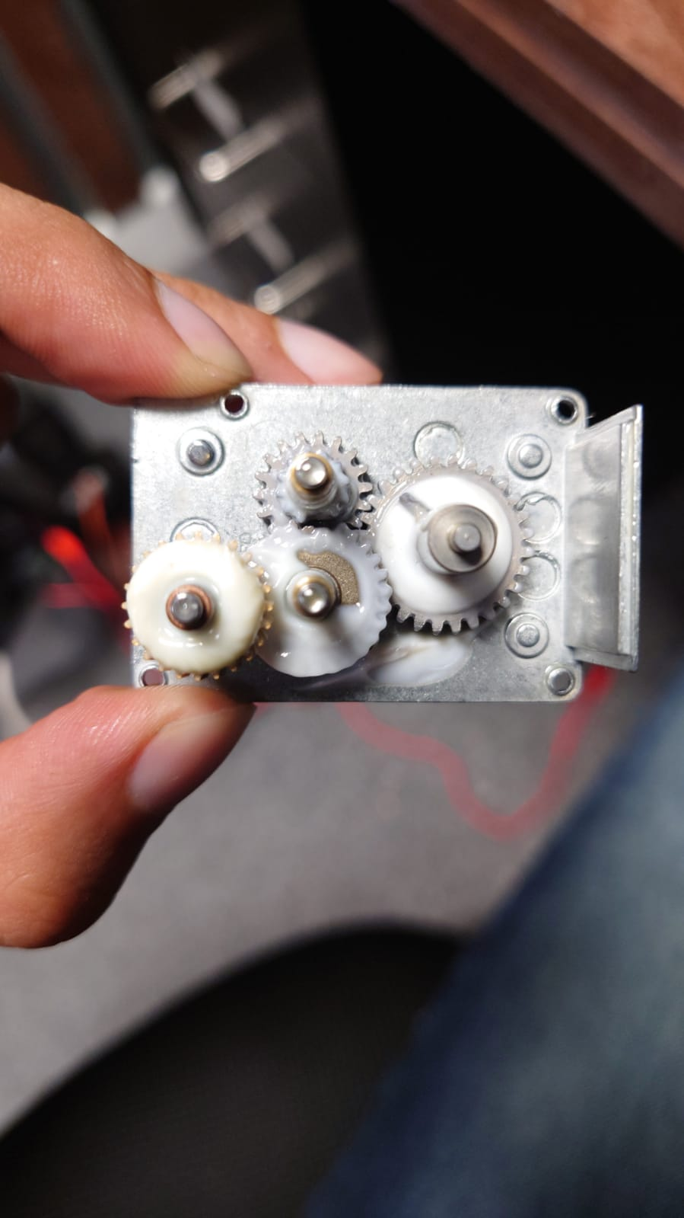

# Figures

* Figure A –
* Figure B –
* Figure C –
* Figure 1 –
* Figure 2 –

# Datasheets

## Datasheets are all stored in the folder /Datasheet

However, Links are provided here;

##### Arduino Mega 2560 R3

<https://store.arduino.cc/collections/boards/products/arduino-mega-2560-rev3>

##### Arduino Nano 33 BLE Sense

<https://store.arduino.cc/collections/boards/products/arduino-nano-33-ble-sense>

##### Arduino Nano-BLE v3

<https://gbr.grandado.com/products/for-ble-bluetooth-nano-motherboard-compatible-with-for-ble-nano-for-arduino-nano-v3-0-ble-nano-integrated-motherboard-1?msclkid=2901f7824f62145dab4b9633f1244e5c&utm_source=bing&utm_medium=cpc&utm_campaign=GBR+%7C+Smart+Shopping+%7C+All+Products+-+From+our+catalogue&utm_term=4576511009463403&utm_content=Ad+group+%231&variant=UHJvZHVjdFZhcmlhbnQ6MjYwMjExOTA5>

##### L298N Motor Driver Board

<https://www.geeetech.com/wiki/index.php/L298N_Motor_Driver_Board>

##### PCA9865 – Servo LED Controller

<https://learn.adafruit.com/16-channel-pwm-servo-driver?view=all>

##### Samsung 30T 21700 Lithium-Ion cells

<https://www.dnkpower.com/wp-content/uploads/2019/02/SAMSUNG-INR21700-30T-Datasheet.pdf>

<https://www.batemo.de/products/batemo-cell-library/inr21700-30t/> [Link only]

##### ATE Subminiature Toggle Switch A7000

https://docs.rs-online.com/5808/0900766b8137f3d6.pdf

##### 2.4GHz Transceiver nRF24L01+

<https://www.sparkfun.com/datasheets/Components/nRF24L01_prelim_prod_spec_1_2.pdf>

##### HC-05 Bluetooth Module

<https://components101.com/sites/default/files/component_datasheet/HC-05%20Datasheet.pdf>

##### 360 Degree 30kg Servo

<https://www.aliexpress.com/item/32955240479.html?spm=a2g0s.9042311.0.0.27424c4dpEmVXl>

##### DS3218 Servo 180 Degree

<https://www.dsservo.com/en/d_file/DS3218%20datasheet.pdf>

##### L780X Series Regulator

<https://pdf1.alldatasheet.com/datasheet-pdf/view/22615/STMICROELECTRONICS/L7805.html>

##### PS2 Joystick

<https://learn.sparkfun.com/tutorials/thumb-joystick-hookup-guide/all>

##### BMS - Battery Management System

<https://www.aliexpress.com/item/32949623871.html?spm=a2g0s.9042311.0.0.27424c4d1P75nc>

# Meetings

## Meeting 1 – Shakil Awan

Introduction to the project and expectations to complete risk assessment and project proposal

## Meeting 2 – James Rogers

Discussion regarding project topic and setting idealistic goals, further discussing possible option on management and lab access.

## Meeting 3 – James Rogers

Discussion regarding Battery management and power delivery, further on discussion regarding controller schematic approval. Further 5 meetings were regarding schematic.

## Meeting 4 – Nicholas Outram

Discussion regarding 5.8GHz and 2.4GHz communication, Mr. Outram has advised to look into Lora-wan as other possible long-range communications are not accessible due to military equipment restriction on the market.

## Meeting 5 – Shakil Awan

Approval of project and permission to order parts from budget.

## Meeting 6 – Shakil Awan

Update regarding project state and status. PowerPoint Presentation submitted

## Meeting 7 – Shakil Awan

Regarding Submission in May 2021, Due to Circumstance Applied for 2nd EC of the year.  
Regarding project – Not completed, only chassis, base station frame was done. Controller had errors.

## Meeting 8 – Shakil Awan

Regarding Submission in August 2021, Another EC applied due to family death.  
Regarding state of project – Crane was redone, Controller diagnosed with errors.  
No circuits and components were fixed to SCV-E.

## Meeting 9 – James Roger

Discussion regarding makeshift controller due to controller pcb issues.

## Meeting 10 – Shakil Awan

Regarding new expectations for December submission, expectations were lowered due to placement year being unable to go to university.

## Meeting 11 – Shakil Awan

Discussion regarding project state and simulation being acceptable. This meeting took place on 24/11/2021

# References

1. Ketiknews.com. 2021. *Caterpillar 6090 FS Excavator*. [online] Available at: <https://www.ketiknews.com/2020/07/caterpillar-6090-fs-excavator.html> [Accessed 9 December 2021].
2. Cranepedia. 2021. *Liebherr LTM11200-9.1 Mobile Crane Load Chart | Cranepedia*. [online] Available at: <https://cranepedia.com/spec/all-terrain-crane/liebherr-ltm11200-9-1/> [Accessed 9 December 2021].
3. Liebherr.com. 2021. *T 284*. [online] Available at: <https://www.liebherr.com/en/usa/products/mining-equipment/mining-trucks/details/t284.html> [Accessed 9 December 2021].
4. Statista. 2021. *Diesel price UK 2021 | Statista*. [online] Available at: <https://www.statista.com/statistics/299552/average-price-of-diesel-in-the-united-kingdom/> [Accessed 9 December 2021].
5. ConstructionGlobal. 2021. [online] Available at: <https://constructionglobal.com/top10/top-10-largest-construction-vehicles-world/largest-dumper-truck-belaz-75710> [Accessed 9 December 2021].
6. engineering, t., process, c., reactions, c., effects, c., storage, i., conditioning, a., reaction, c., treatment, h., method, s., reaction, s., transmission, b., effect, i. and reaction, m., 2021. *US6059058A - Modular vehicle construction and transportation system - Google Patents*. [online] Patents.google.com. Available at: <https://patents.google.com/patent/US6059058A/en> [Accessed 9 December 2021].
7. opensource.google. 2021. *Why Open Source? – opensource.google*. [online] Available at: <https://opensource.google/docs/why/> [Accessed 9 December 2021].
8. Products, E., 2021. *What is the best type of battery? - Electronic Products*. [online] Electronic Products. Available at: <https://www.electronicproducts.com/what-is-the-best-type-of-battery/> [Accessed 9 December 2021].
9. Harvard Gazette. 2021. *Researchers design long-lasting, solid-state lithium battery*. [online] Available at: <https://news.harvard.edu/gazette/story/2021/05/researchers-design-long-lasting-solid-state-lithium-battery/> [Accessed 9 December 2021].
10. MIT News Office, D., 2021. *The reasons behind lithium-ion batteries’ rapid cost decline*. [online] MIT News | Massachusetts Institute of Technology. Available at: <https://news.mit.edu/2021/lithium-ion-battery-cost-1122> [Accessed 9 December 2021].
11. RAVPower. 2021. *All You Need to Know About USB Power Delivery (PD)*. [online] Available at: <https://blog.ravpower.com/2018/02/all-about-usb-power-delivery/> [Accessed 9 December 2021].
12. Coefficient of Friction Equation and Table Chart - Engineers Edge. Engineers Edge:  
    <https://www.engineersedge.com/coeffients_of_friction.html> [Accessed 16 December 2021]